**Game Deployment**

**Step 1 : Create AWS Account**

**Step 2 : Create IAM User and Roles**

**Step 3 : Create Virtual Private Cloud(VPC)**

**Step 4 : Configure Application Load Balancer with 2 Target Group Rule**

**Step 5 : Configure EC2 Instance**

**Step 6 : Installing Node.js**

**Step 7 : Install and Configure RabbitMQ Server**

**Step 8 : Install and Configure Redis Server**

**Step 9 : Install and Configure Mongodb Server**

**Step 10 : Install and Start Docker**

**Step 11: To Change Some IMP File and Create Docker file**

1. **Edit Socket File**
2. **Edit Web File**
3. **Edit Socket Connect File (ex: /game/view/HTML/js/custom.js)**
4. **Edit Config.json file**
5. **Create one Dockerfile**

**Step 12 : Create Repository and Pull Docker image To ECR**

**Step 13 : Create and Configure Cluster, Task Definition, Service and Monitor For ECS Fargate Services**

**Step 14 : Create CodeCommit, CodeBuild, CodeDeploy and CodePipeline**

**1. Create Buildspec.yml For ECR Image Update**

**2. Create appspec.yaml, taskdef.yml for Blue Green Deployment.**

**3. Create CodeCommit**

**4. Create and Configure CodePipeline**

**5. Check and Verify CodePipeline**

|  |
| --- |
| **IMPORTANT NOTE: PLEASE FOLLOW THE INSTRUCTIONS CAREFULLY WHICH ARE MARK IN RED** |

**Step 1 : Create AWS Account**

[**https://console.aws.amazon.com**](https://console.aws.amazon.com/iam/)

**Step2 : Create IAM User and Roles**

**1. Sign in to the AWS Management Console and open the IAM console at**

[**https://console.aws.amazon.com/iam/**](https://console.aws.amazon.com/iam/)

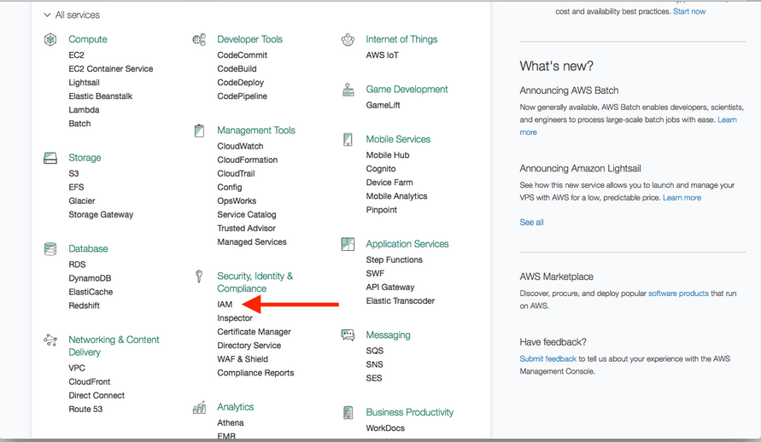

**2. Select User**

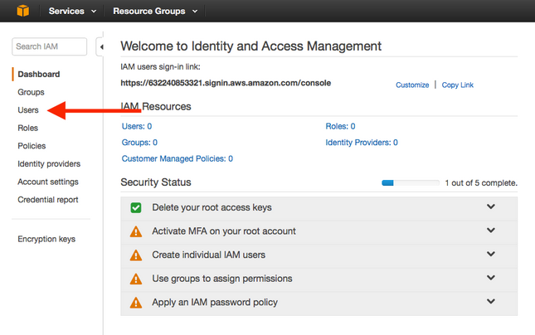

**3. Select Add User.**

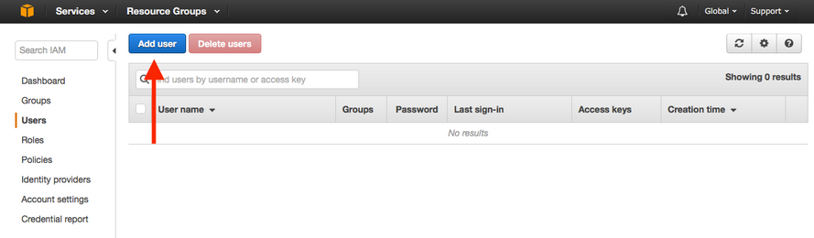

**4. Enter a User name and check Programmatic access, then select Next: Permissions**

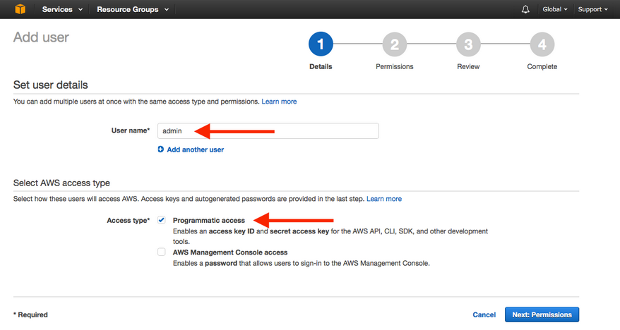

**5. Select Attach existing policies directly.**

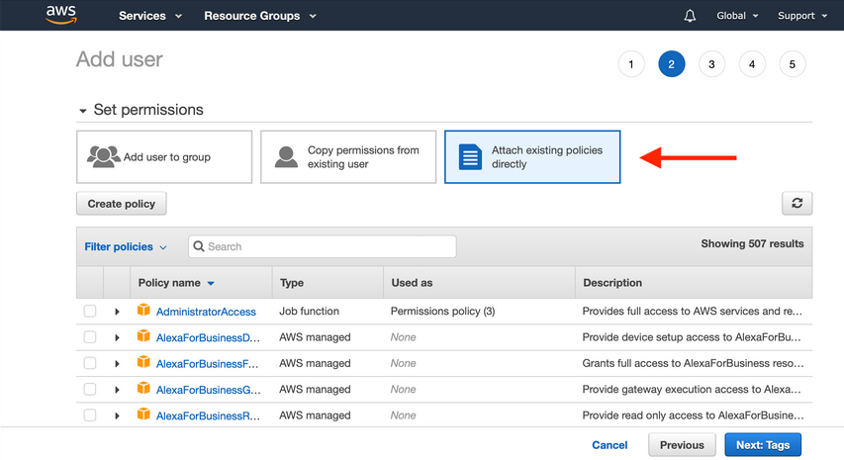

**6. Search policies from down below and select the policy, then select Next: Tags.**

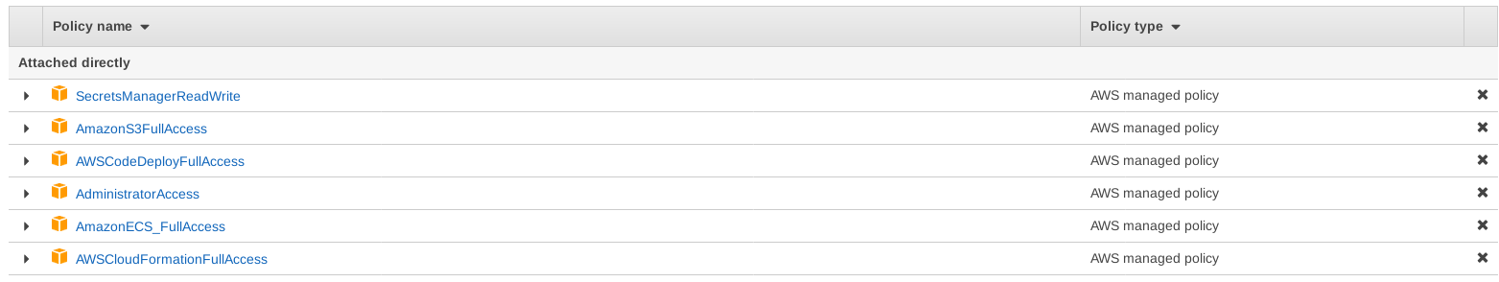

**7. We can optionally add some info to our IAM user. But we’ll skip this for now. Click Next: Review.**

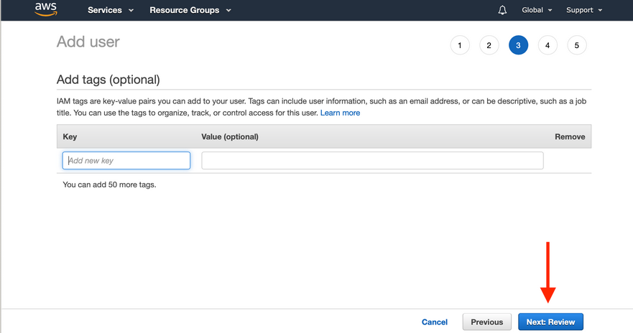

**8. Select Create User.**

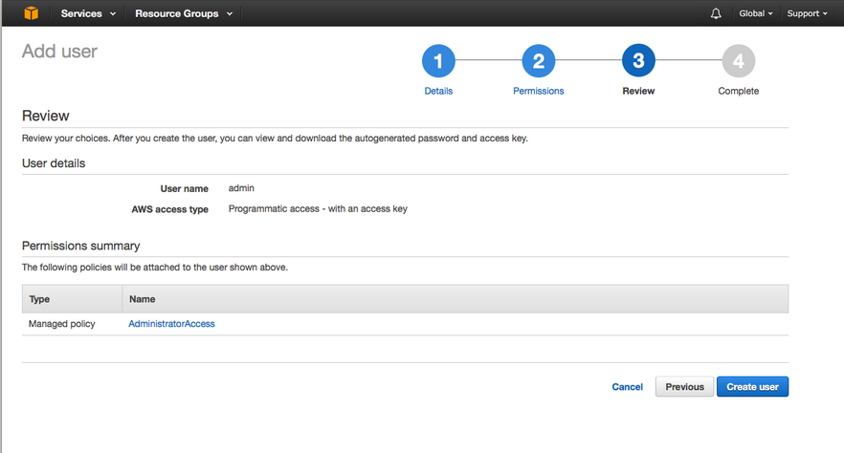

**9. Select Show to reveal Secret access key.**

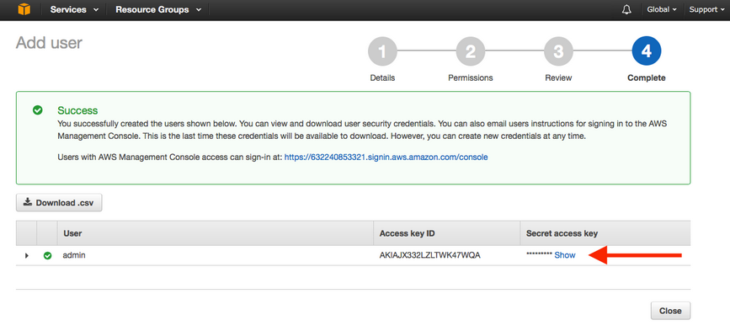

**10. Take a note of the Access key ID and Secret access key. We will be needing this later.**

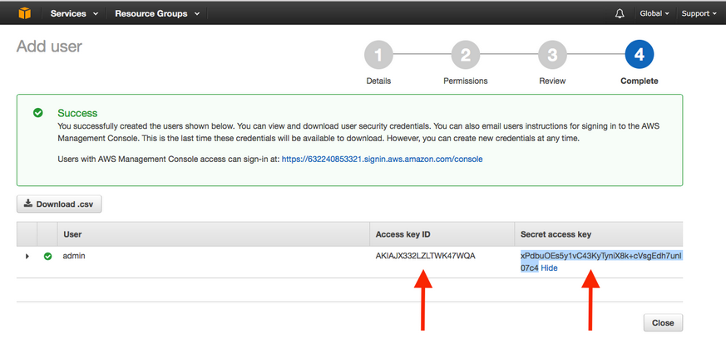

**Creating IAM Roles for a Service**

**1. Creating IAM Roles for a Service**

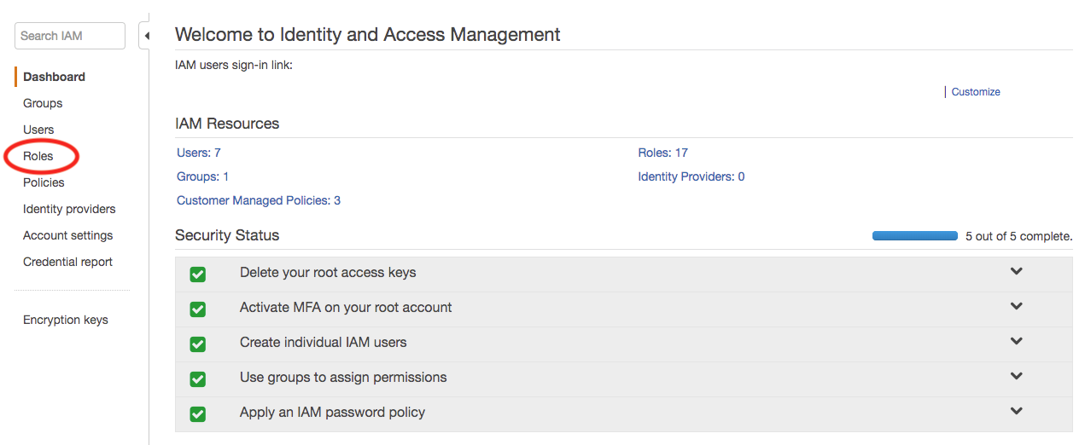

**2. Click on "Create Role"**

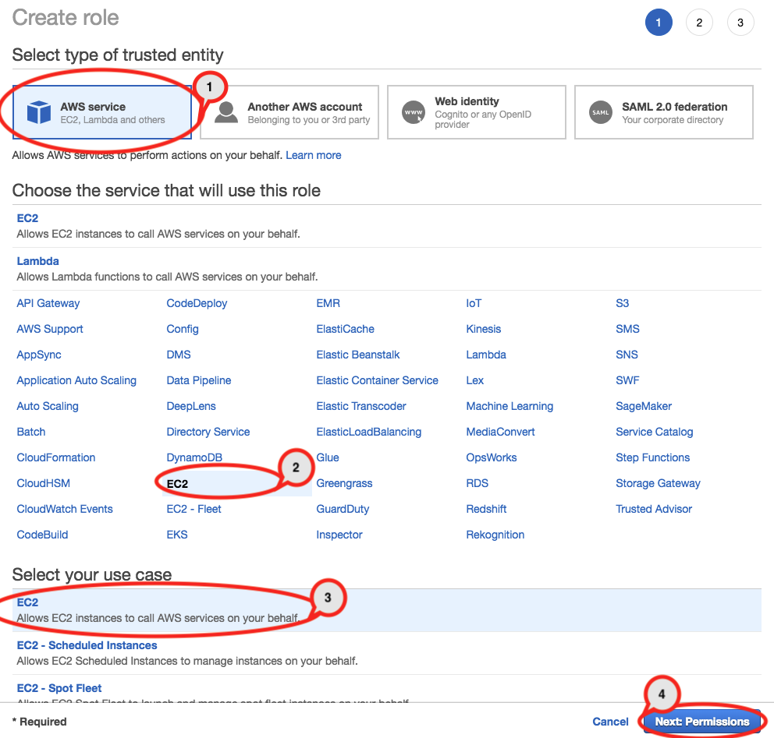

**3. Choose Policies:**

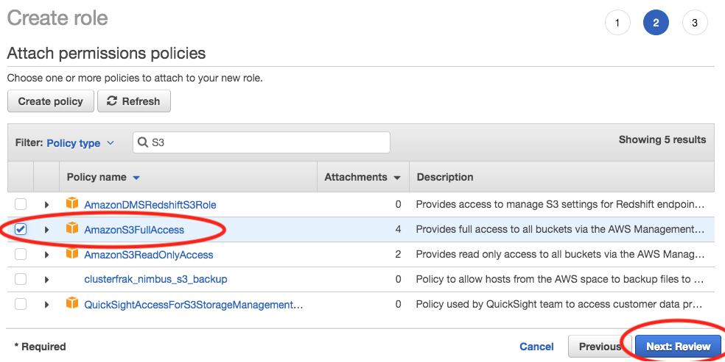

**4. Review Role**

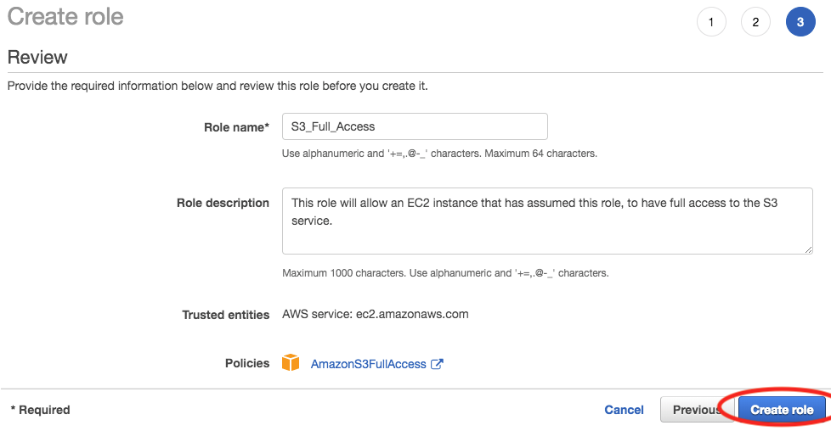

**Creating Different Role With Above 4 Steps**

**Role 1: CodeDeploy**

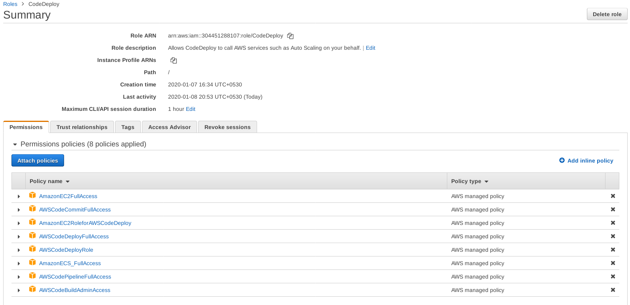

**Role 2:** [**EC2ECSRole**](https://console.aws.amazon.com/iam/home?region=ap-south-1#/roles/EC2ECSRole)

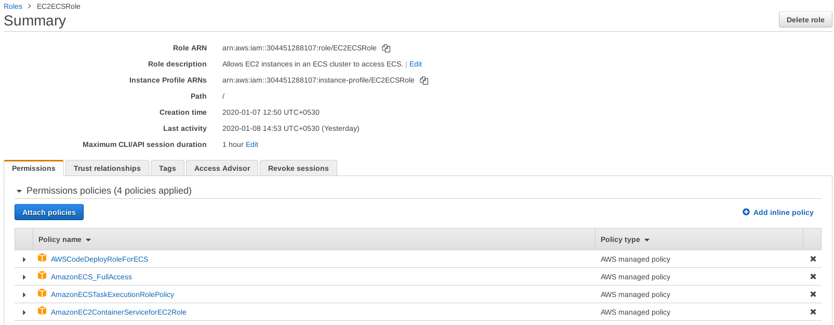

**Role 3: C**[**odebuild-build-Service-Role**](https://console.aws.amazon.com/iam/home?region=ap-south-1#/roles/codebuild-ec2buildd-service-role)

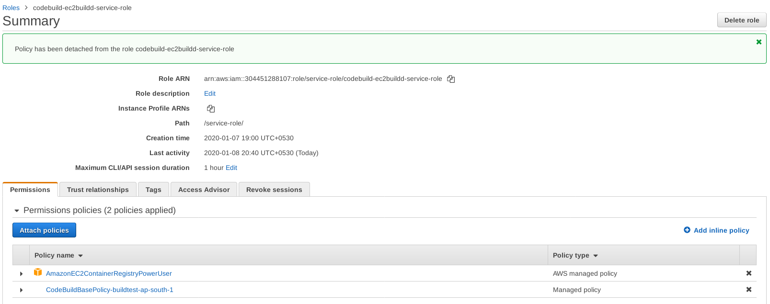

**Edit User Security Credential**

**1. Select User**

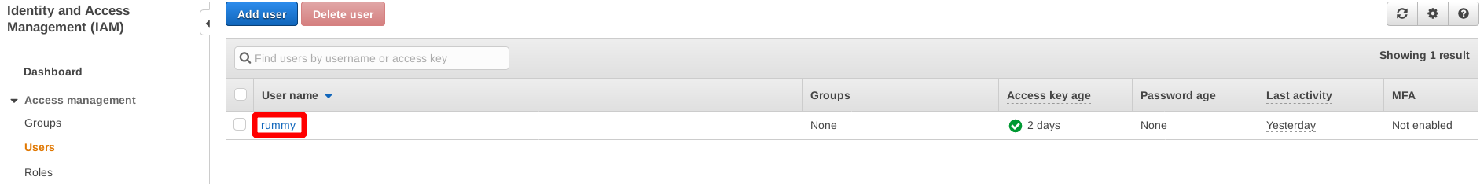

**2. Select Security Credential**

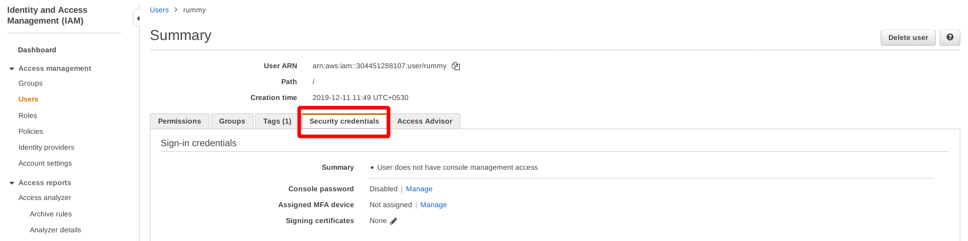

**3. Select HTTPS Git credentials for AWS CodeCommit and Generate credentials**

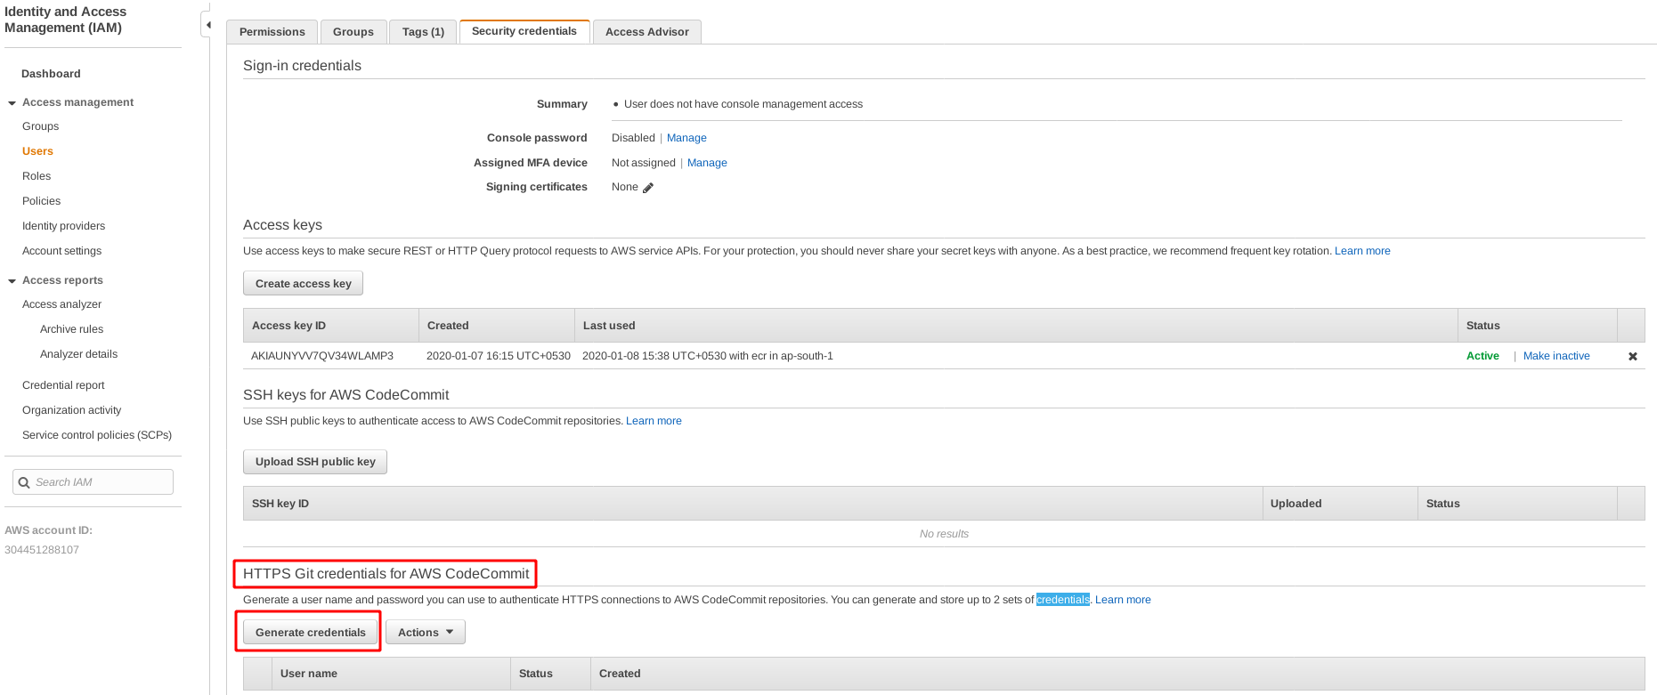

4.**Take a note of the git user and password. We will be needing this later.**

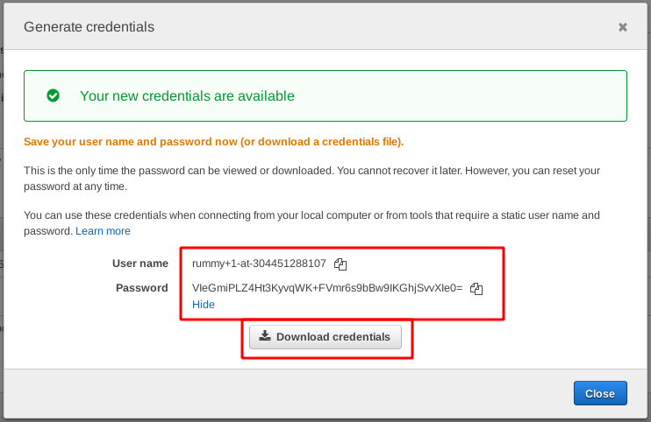

**Step 3 : Create Virtual Private Cloud(VPC)**

**1. AWS Management Console, on the search bar, type VPC, from the drop-down click on VPC.**

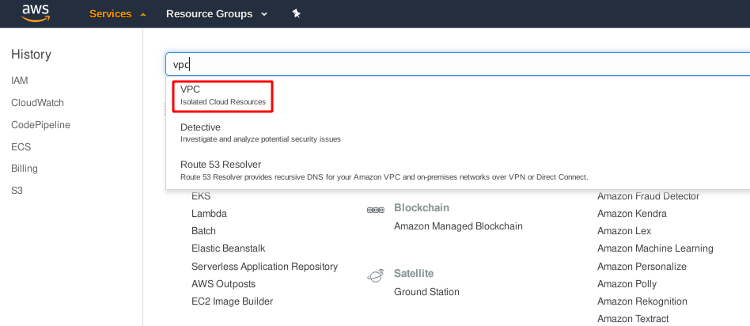

**2.In the navigation pane on the left, click Your VPCs on the VPC dashboard and Select Your VPC**

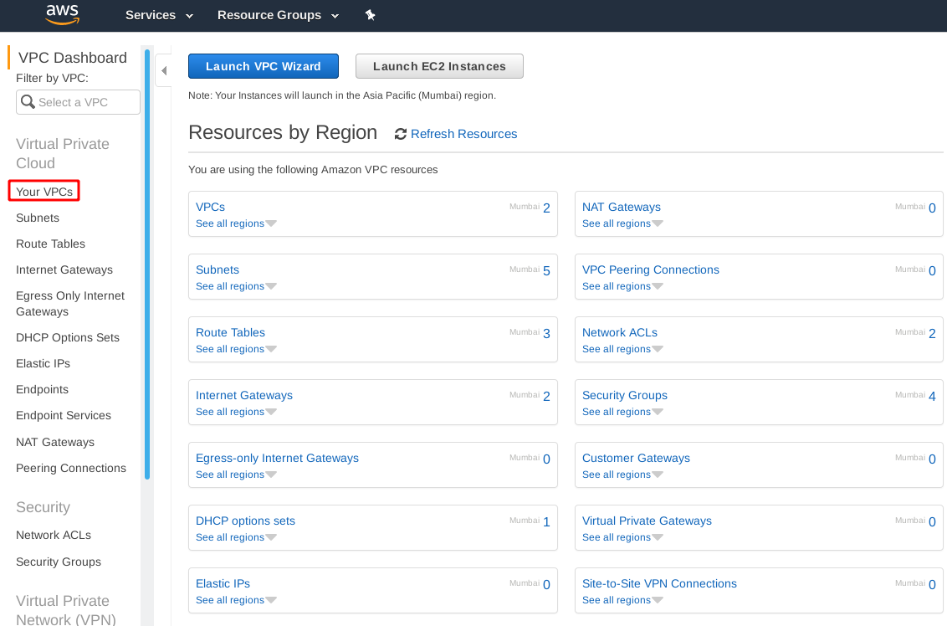

**3. Click Create VPC.**

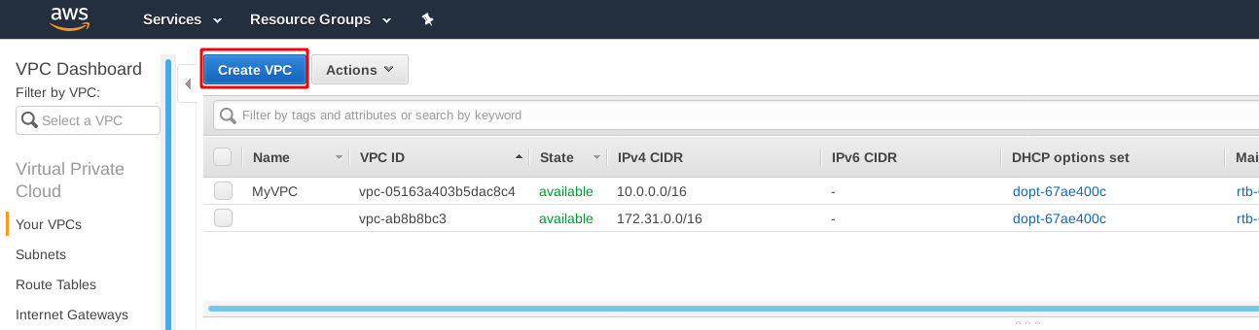

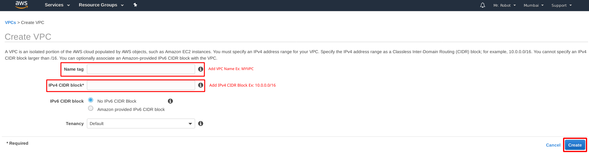

**4. Create a Private and Public Subnet**

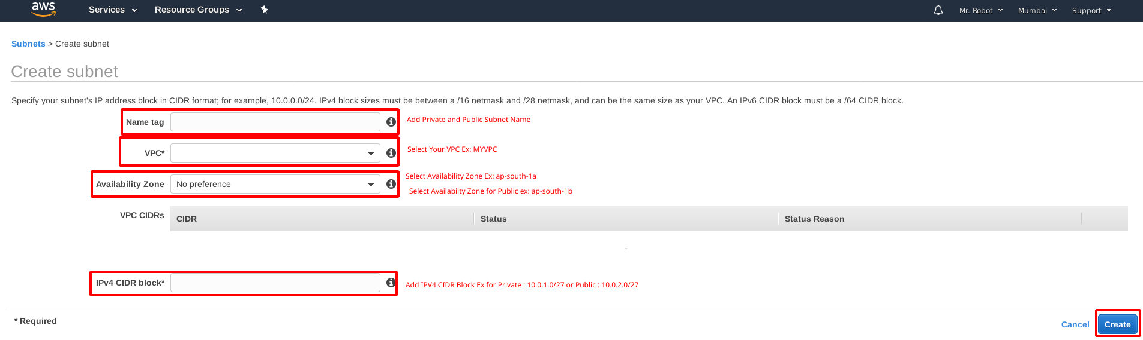

**5. Create an Internet Gateway and Attach to Your VPC**

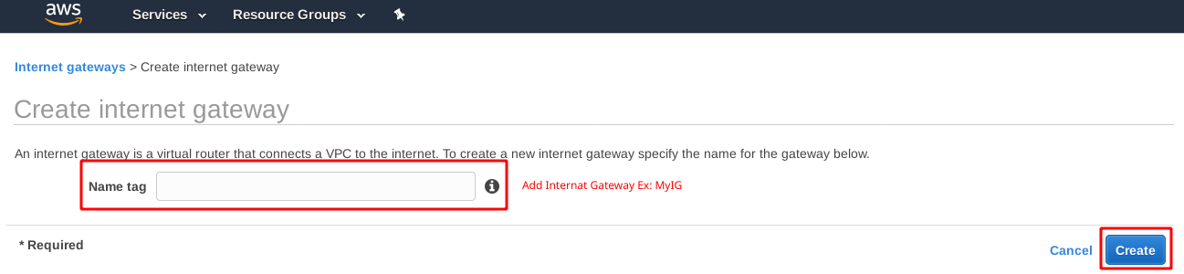

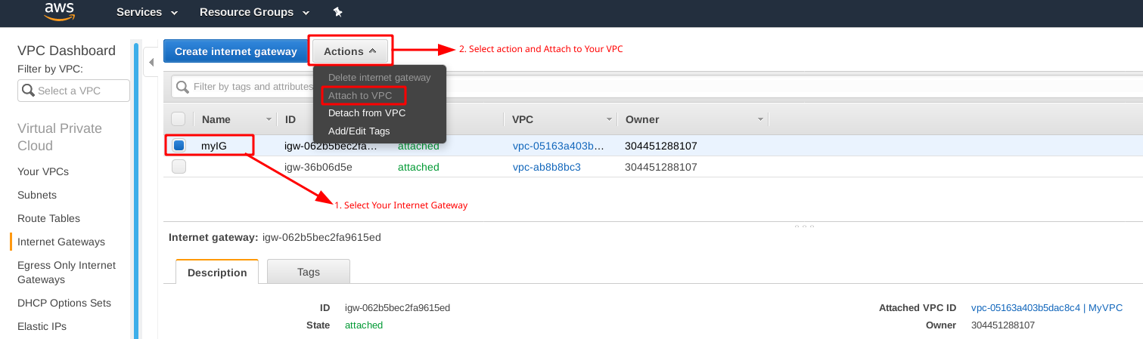

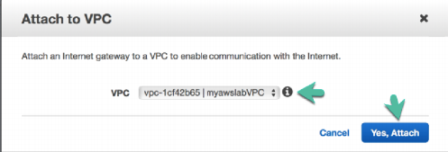

**6. Route Tables and Routes**

In the navigation pane on the left, click **Route Tables**.Select Create **Route Tables.**

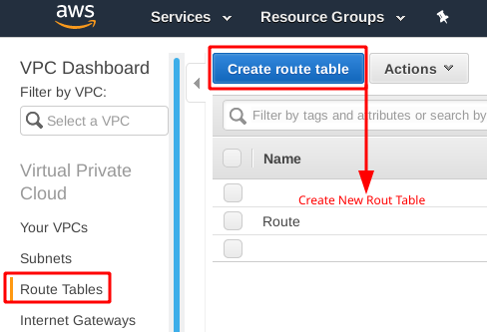

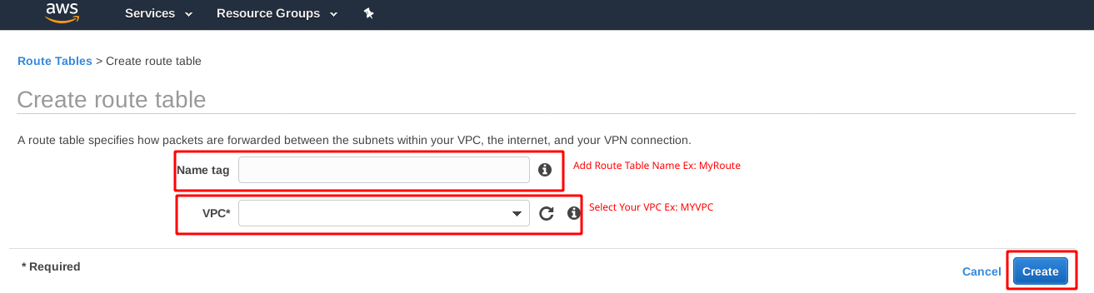

Select the route table that is associated with **MyRoute**

Click the **Subnets Associations Tab and** Edit **Subnet Associations.**

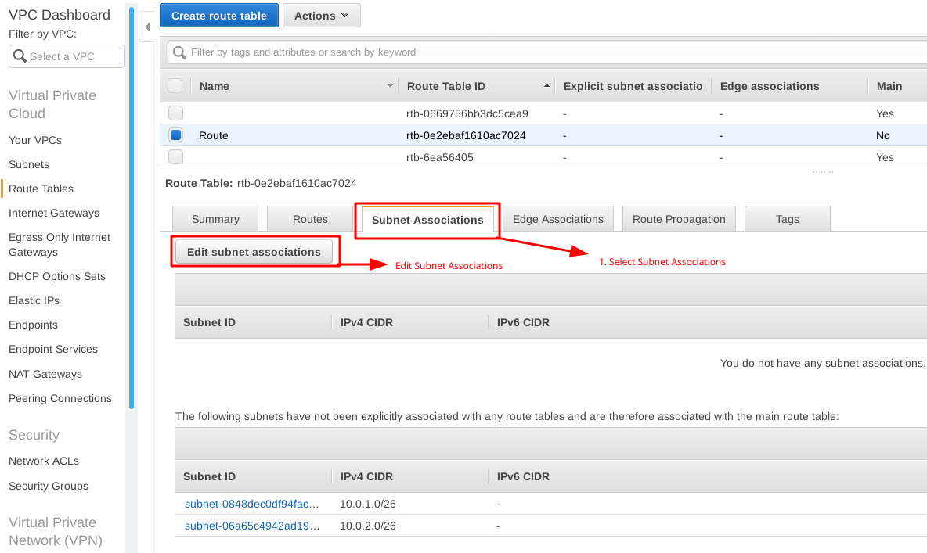

Edit **Subnet Associations,** Select **Subnet** and **Save.**

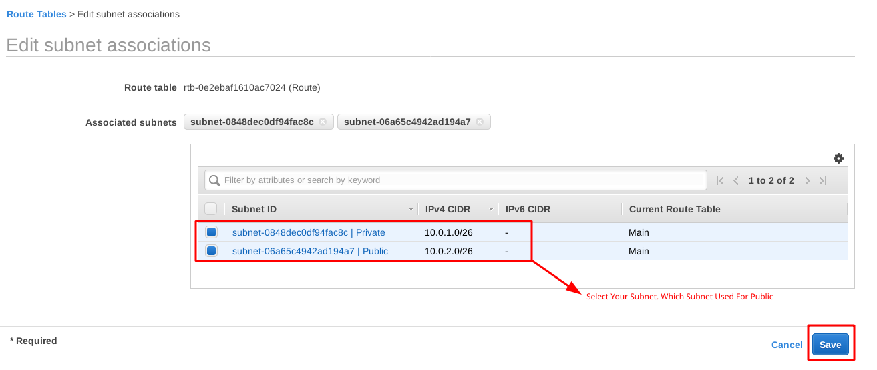

Select the Route Table (**Route**) and Select **Route Tab**

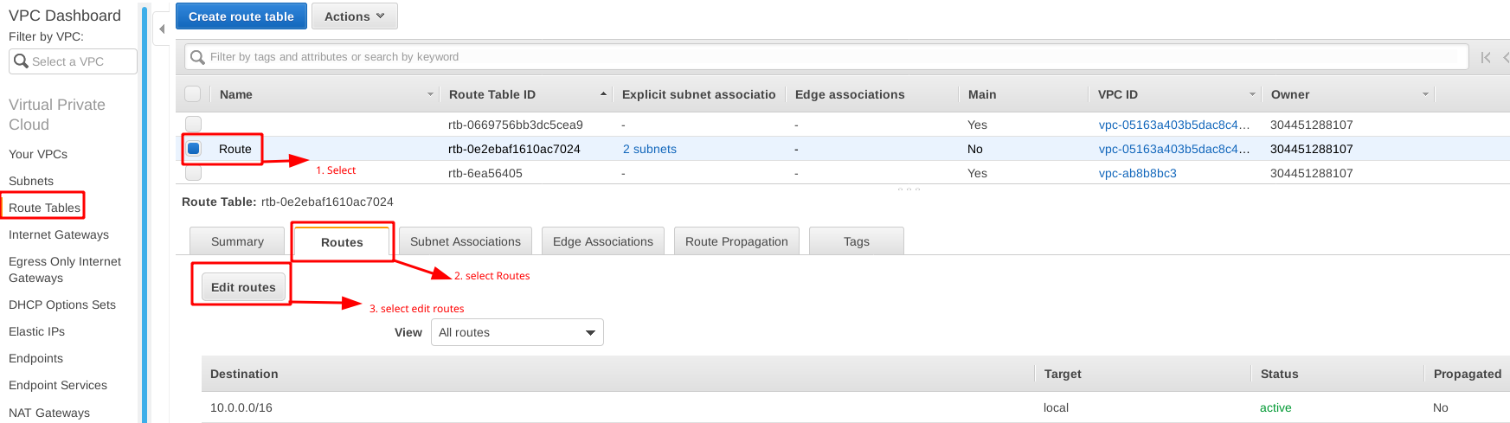

**Edit Route**

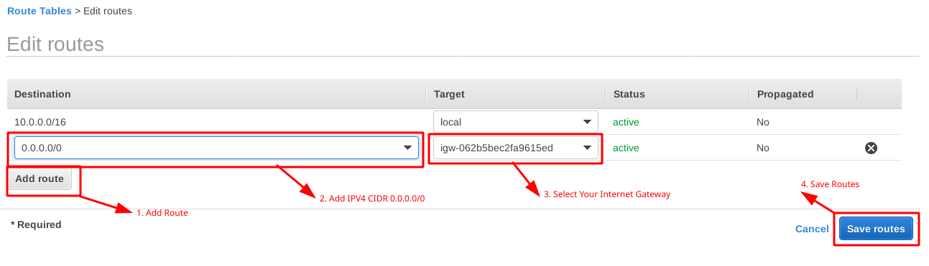

**Step 4 : Configure Application Load Balancer with 2 Target Group Rule**

**1. Configure a Load Balancer and a Listener**

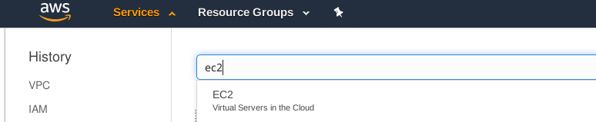

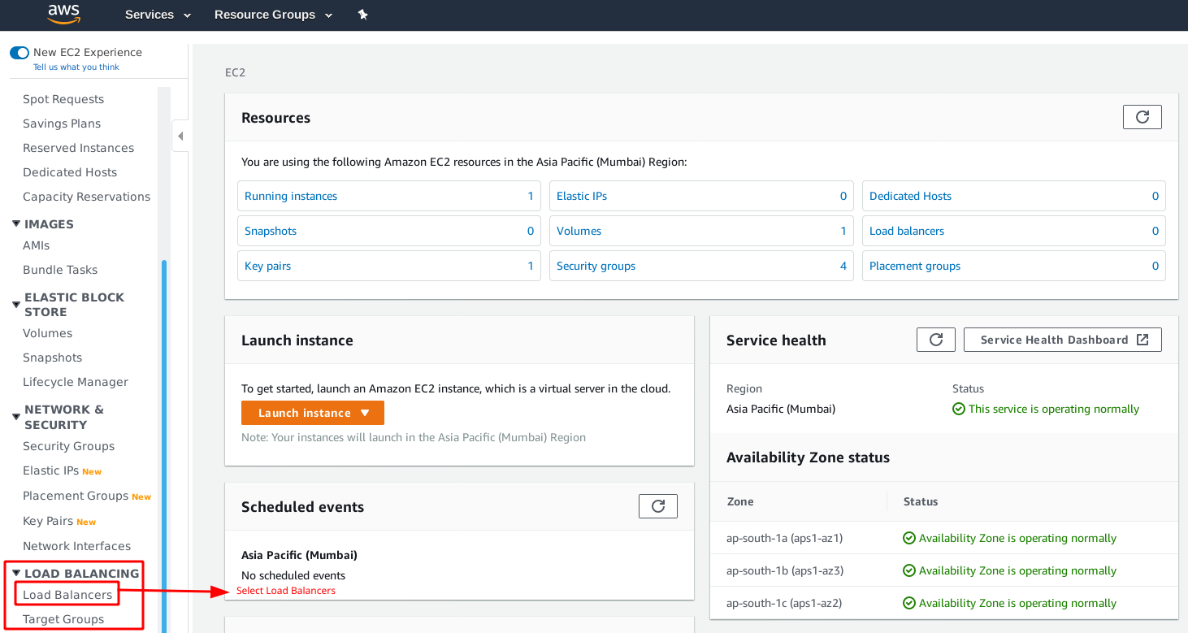

**2. Create Load Balancer**

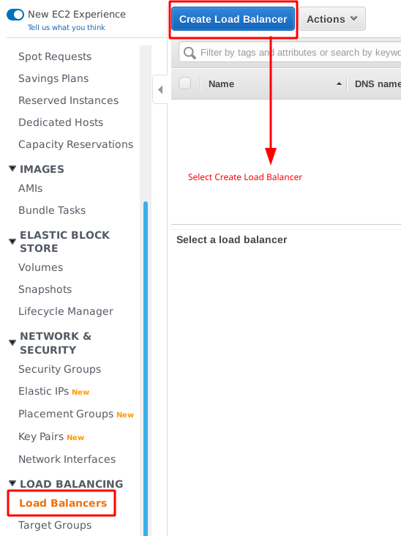

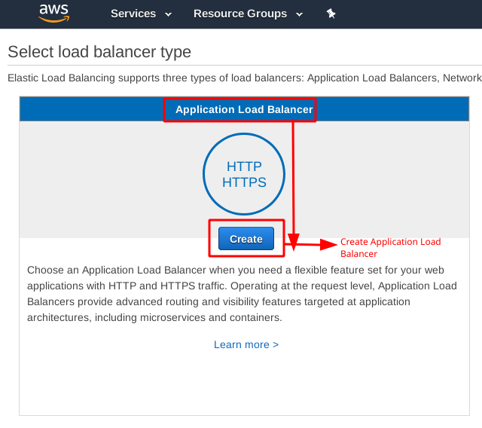

**Configure the Load Balancer.**

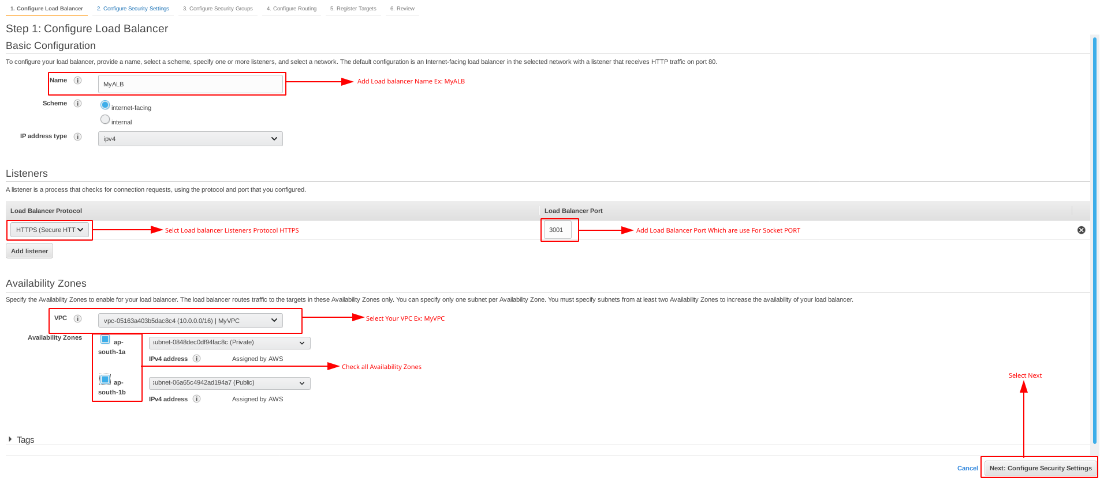

**Configure Security Settings.**

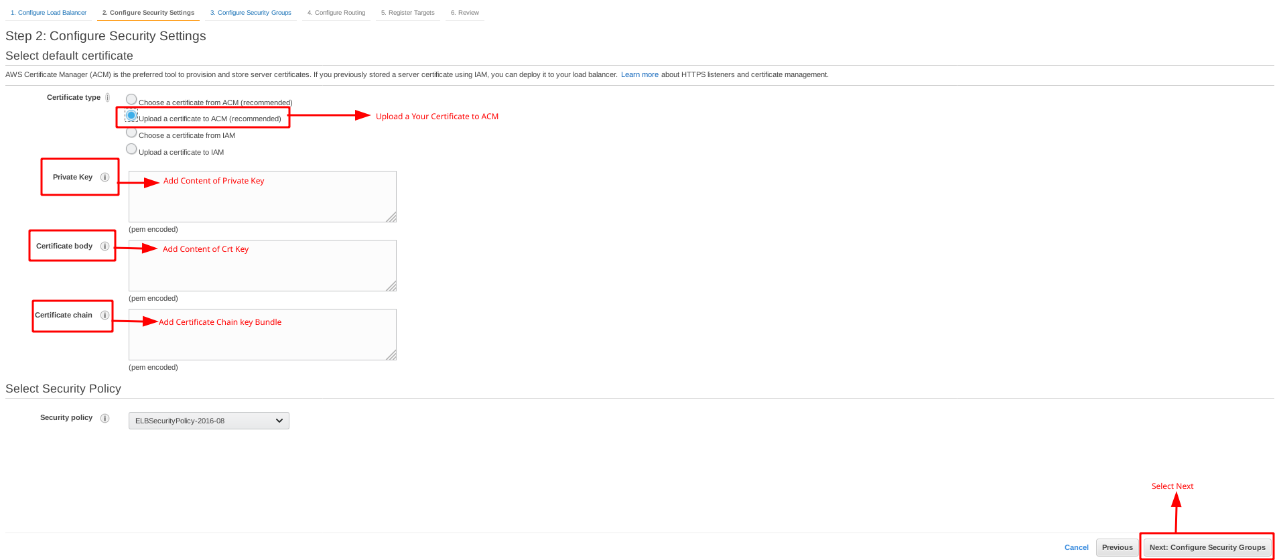

**Configure Security Group**

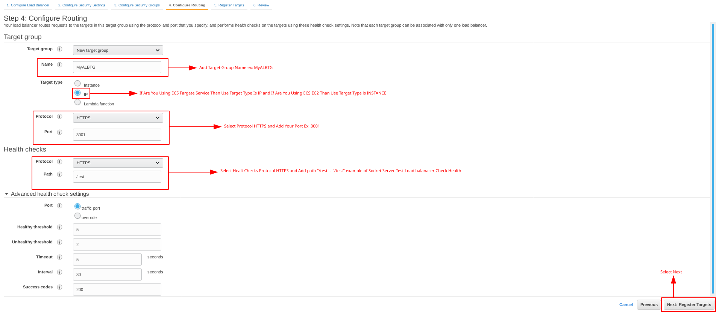

**Skip Register Targets and Select Next**

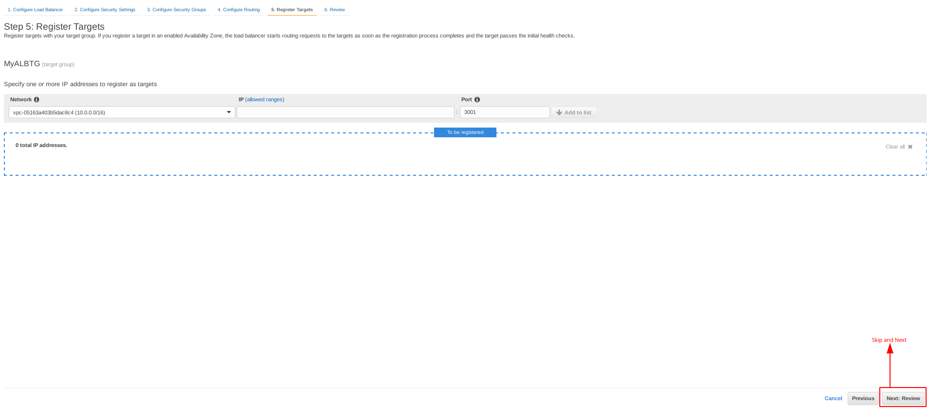

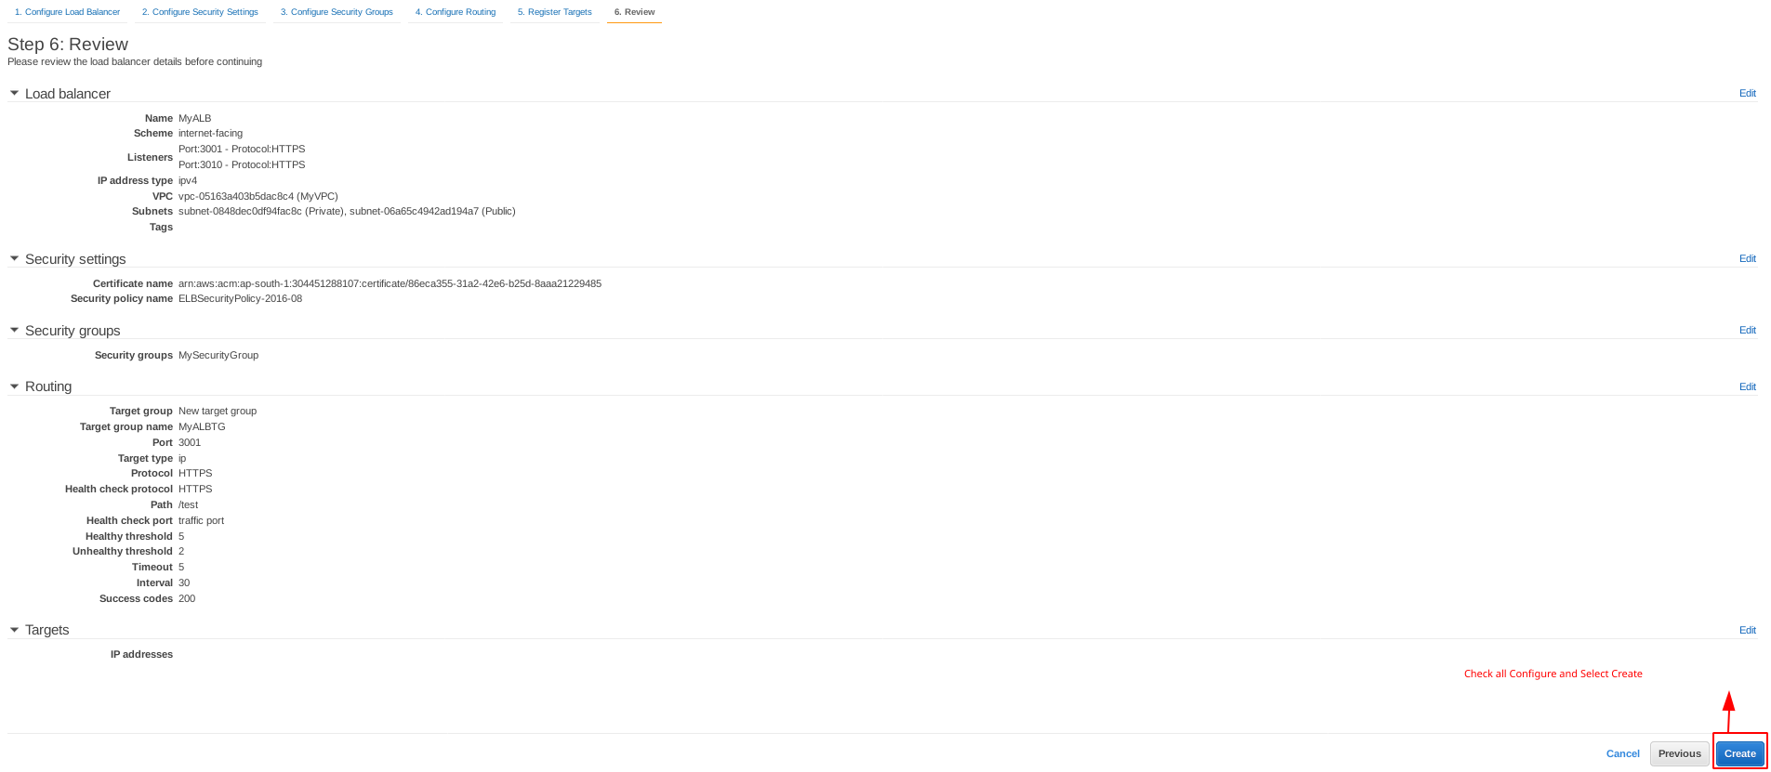

**Create New Target Group With Different Port and Attach Listener rule for Your ALB**

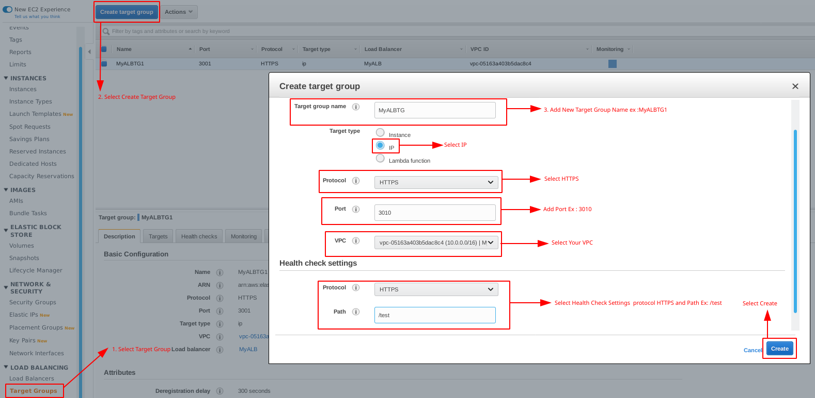

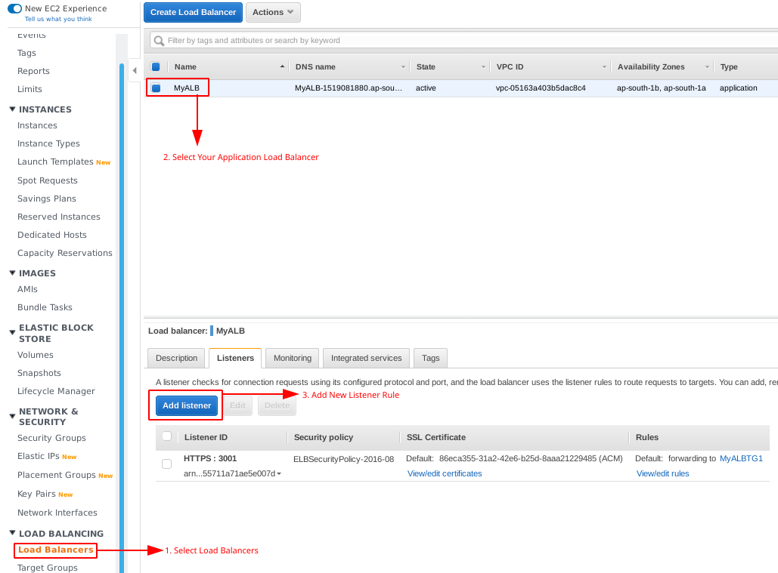

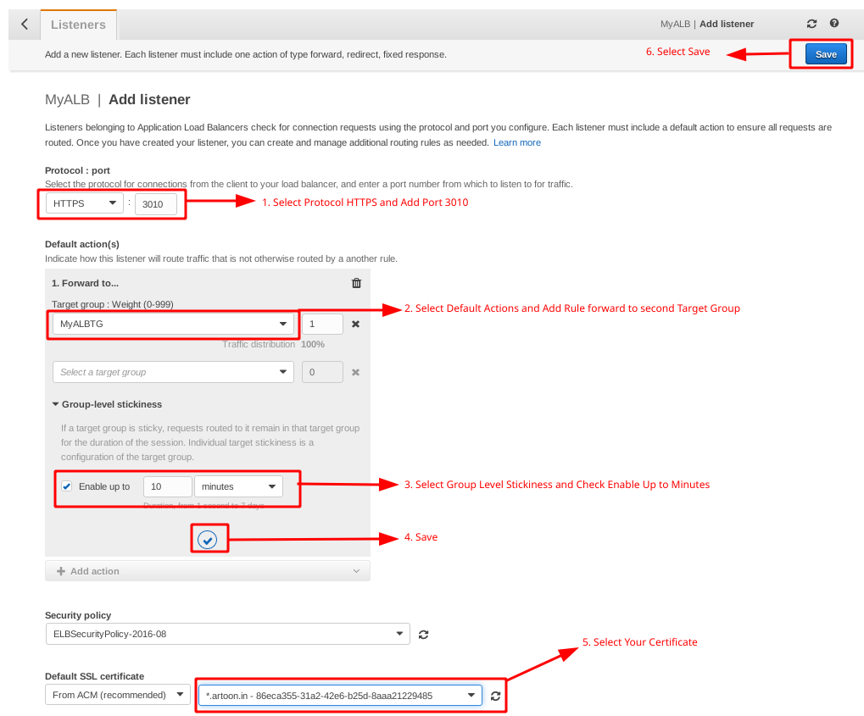

**Step 5 : Configure EC2 Instance.**

**1. Open all the services and click on EC2 under Compute services**



**2. Create New Instances**

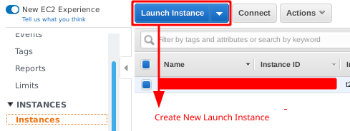

**3. Choose AMI**

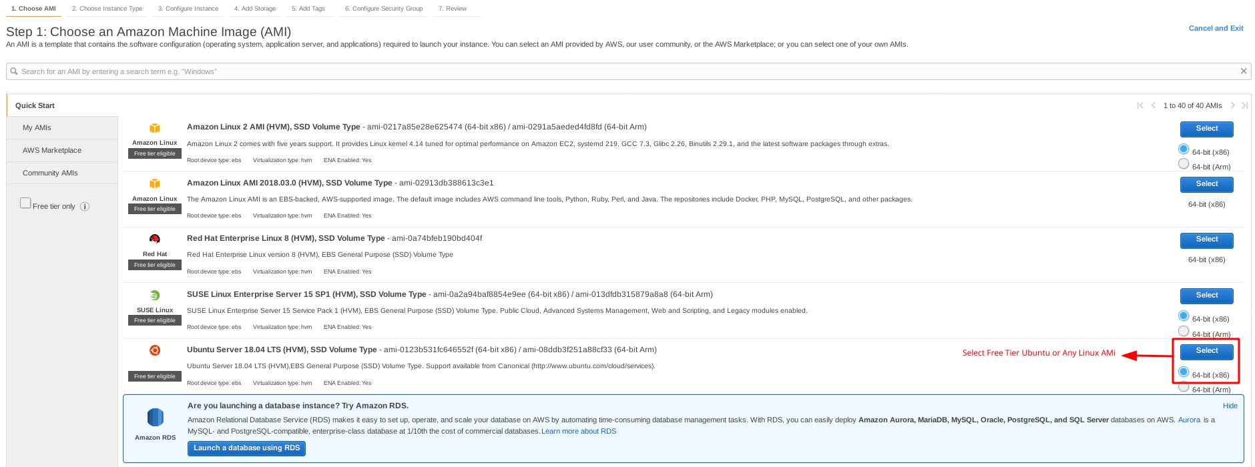

**4. Choose EC2 Instance Types**

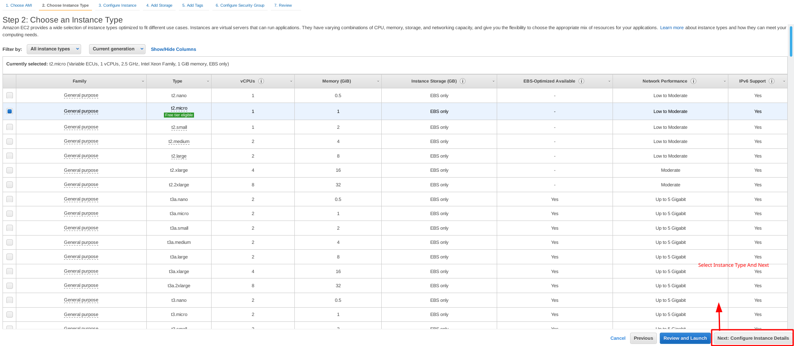

**5.Configure Instance**

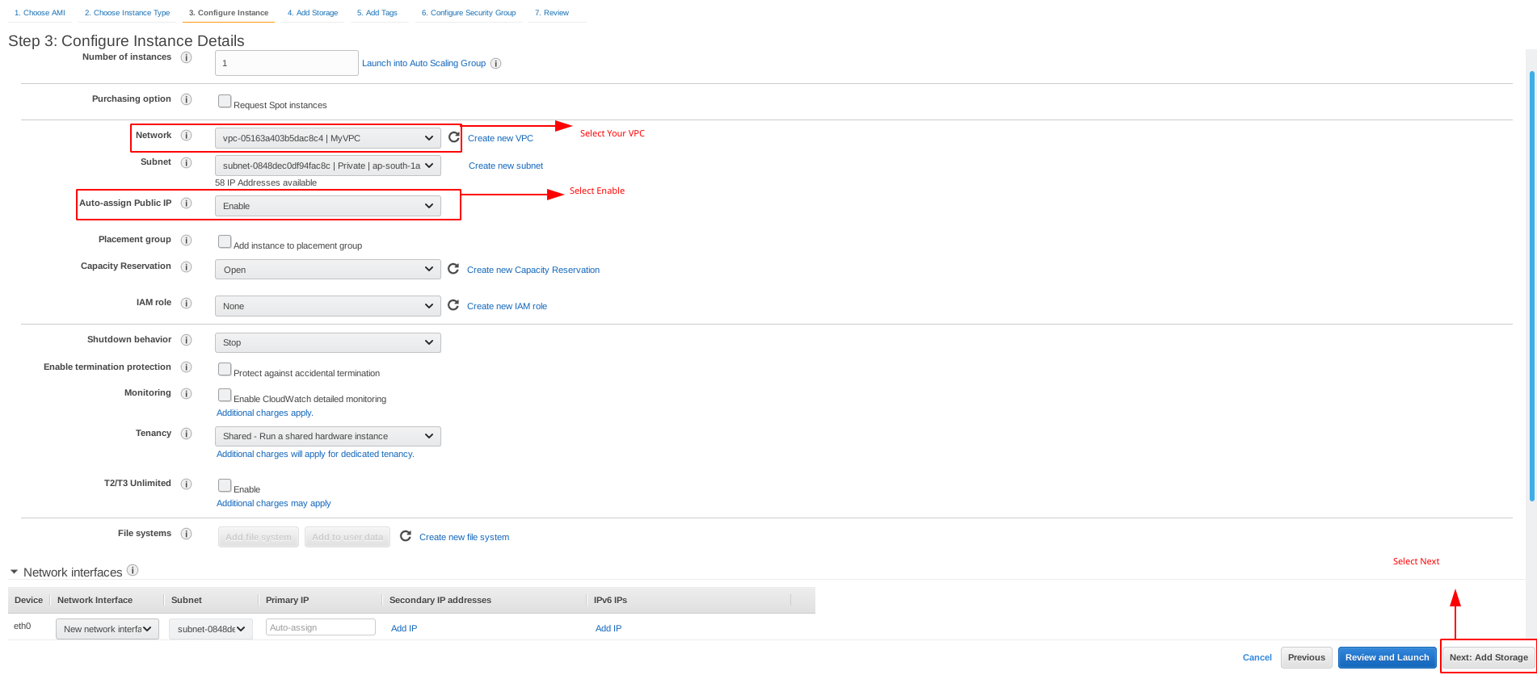

**6. Add Storage**

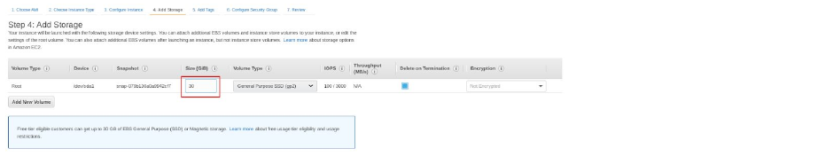



**7. Tag Instance**

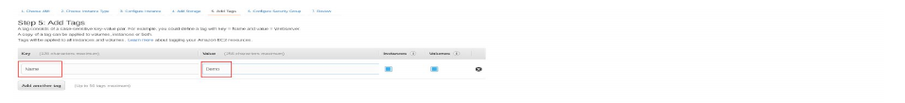



**8.Configure Security Groups**

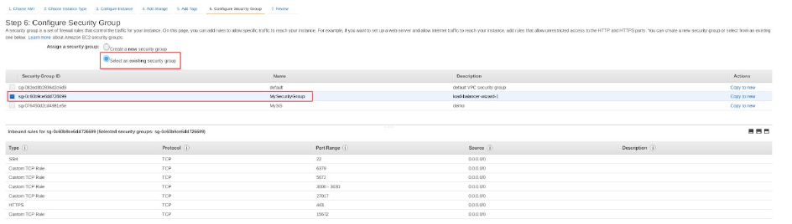



**9. Review Instances**

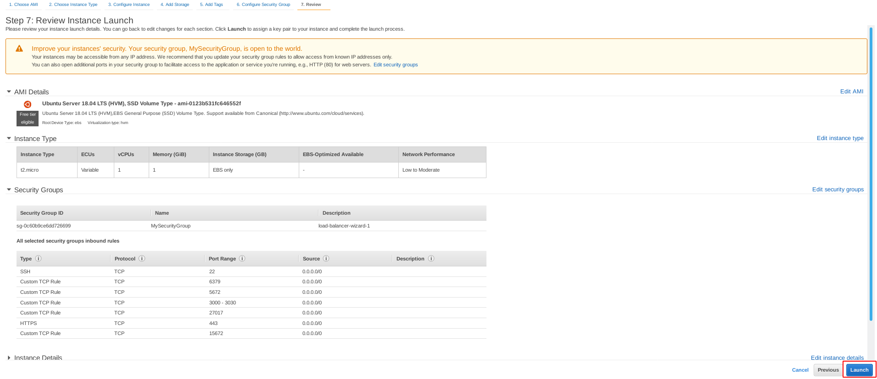

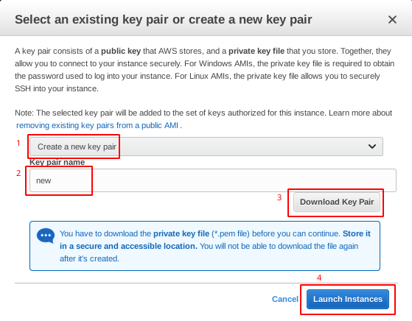

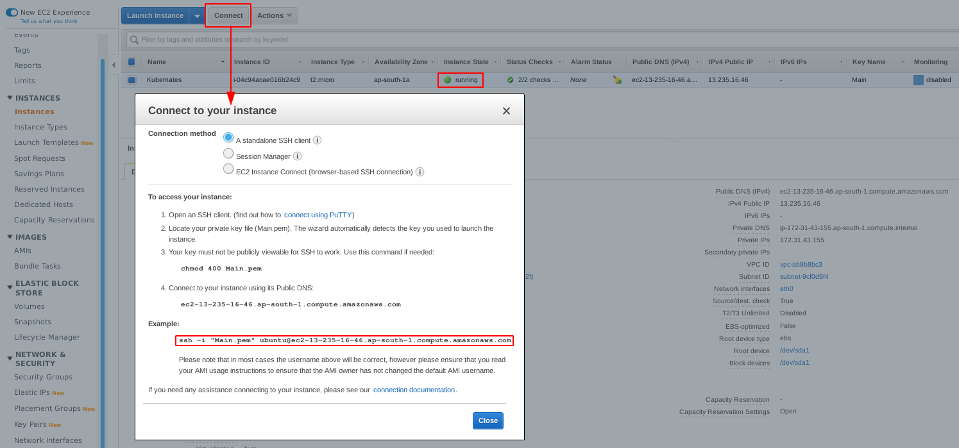

**Step 6 : Installing Node.js**

**Use this repository if you need to install a specific version of Node.js. At the time of writing, NodeSource repository provides the following versions - v12.x, v11.x, v10.x, and v8.x.**

**1. To install Node.js and npm from the Node Source repository**

|  |
| --- |
| $ curl -sL https://deb.nodesource.com/setup_10.x | sudo -E bash - |

(Specify the version here)

(If you need to install another version, for example 12.x, just change setup_10.x with setup_12.x)

**2. Once the NodeSource repository is enabled, install Node.js and npm by typing:**

|  |
| --- |
| $ sudo apt install nodejs -y |

**3. Verify that the Node.js and npm were successfully installed by printing their versions:**

|  |
| --- |
| $ node --version  Output : v10.16.3 |

|  |
| --- |
| $ npm --version  Output: 6.9.0 |

**Step 7 : Install and Configure RabbitMQ Server**

**1. Enable RabbitMQ PPA repository on your system. Also, import rabbitmq signing key on your system.**

|  |
| --- |
| **$ echo 'deb http://www.rabbitmq.com/debian/ testing main' | sudo tee /etc/apt/sources.list.d/rabbitmq.list**  **$ wget -O- https://www.rabbitmq.com/rabbitmq-release-signing-key.asc | sudo apt-key add -** |

**2. Update apt cache and install RabbitMQ server.**

|  |
| --- |
| **$ sudo apt-get update -y**  **$ sudo apt-get install rabbitmq-server -y** |

**3. Enable and Start the RabbitMQ service**

### **Using Init –**

|  |
| --- |
| **$ sudo update-rc.d rabbitmq-server defaults**  **$ sudo service rabbitmq-server start** |

### **Using Systemctl –**

|  |
| --- |
| **$ sudo systemctl enable rabbitmq-server**  **$ sudo systemctl start rabbitmq-server** |

**4. By default rabbitmq creates a user named “guest” with password “guest”. You can also create your own administrator account on RabbitMQ server.**

|  |
| --- |
| **$ sudo rabbitmqctl add_user admin password**  **$ sudo rabbitmqctl set_user_tags admin administrator**  **$ sudo rabbitmqctl set_permissions -p / admin ".*" ".*" ".*"** |

(Change password with your own password)

**5. RabbitMQ also provides a web management console for managing the entire RabbitMQ. To enable web management console.The web management console helps you with managing the RabbitMQ server.**

|  |
| --- |
| **$ sudo rabbitmq-plugins enable rabbitmq_management** |

## **6. RabbitMQ Add and Assign Virtual Hosts to Users Command Line**

|  |
| --- |
| **$ sudo rabbitmqctl add_user virtualuser password#**  **$ sudo rabbitmqctl set_user_tags virtualuser administrator**  **$ rabbitmqctl add_vhost demohost**  **$ rabbitmqctl set_permissions -p demohost virtualuser ".*" ".*" ".*"** |

**(OR)**

**6. RabbitMQ dashboard starts on port 5672 and 15672**

**Access it by opening the URL**

**http://[server IP|Hostname]:15672**

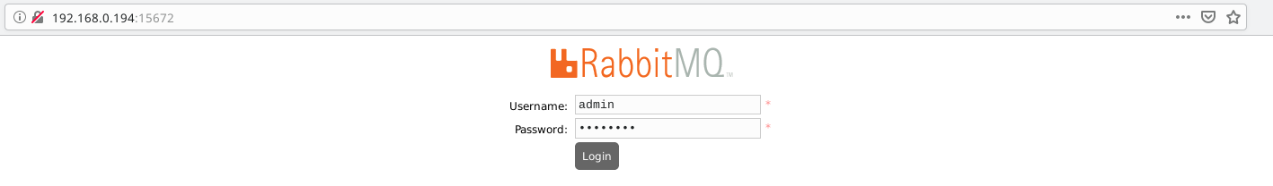

**Create Virtual Host**

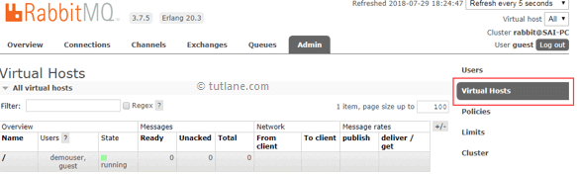

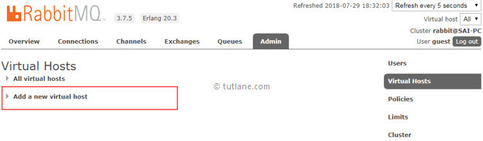

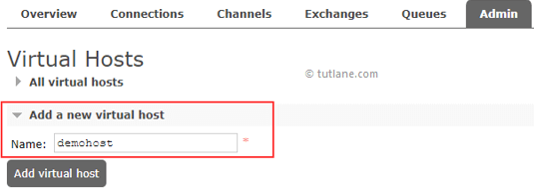

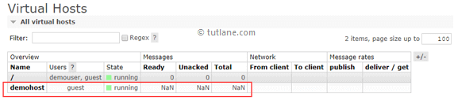

## **RabbitMQ Assign Virtual Hosts to Users**

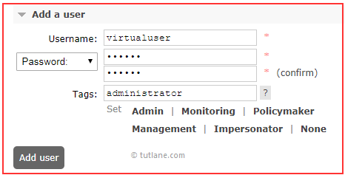

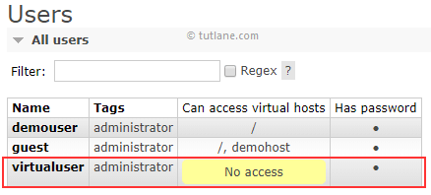

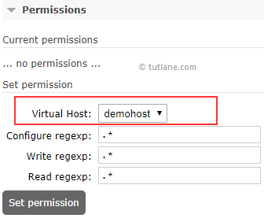

**RabbitMQ Set Privilege to Access Virtual Hosts**



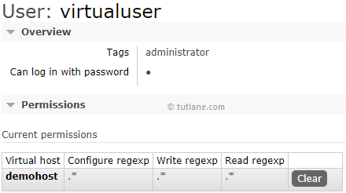



**Ref:** [**https://www.tutlane.com/tutorial/rabbitmq/rabbitmq-virtual-hosts**](https://www.tutlane.com/tutorial/rabbitmq/rabbitmq-virtual-hosts)

[**https://tecadmin.net/install-rabbitmq-server-on-ubuntu/**](https://tecadmin.net/install-rabbitmq-server-on-ubuntu/)

Note: Remove Guest User By Your Security

**Step 8 : Install and Configure Redis Server**

**1. The Redis packages are available under the default apt repository.**

|  |
| --- |
| **$ sudo apt-get install redis-server -y** |

**2. Enable and Start the Redis service**

|  |
| --- |
| **$ sudo systemctl enable redis-server.service**  **$ sudo systemctl start redis-server.service** |

**3. Configure Redis service**

**Redis can be started without a configuration file using a built-in default configuration. But to make any extra parameter changes you can use its configuration file: /etc/redis/redis.conf**

|  |
| --- |
| **$ sudo vim /etc/redis/redis.conf**  **Edit File**  **bind 0.0.0.0**  **#requirepass foodared (if require than set password remove # and add password)**  **maxmemory 256mb**  **maxmemory-policy allkeys-lru** |

**4. Restart the Redis service**

|  |
| --- |
| **$ sudo systemctl restart redis-server.service** |

**5. Install Redis PHP Extension**

|  |
| --- |
| **$ sudo apt-get install php-redis** |

**6. Test Connection to Redis Server**

|  |
| --- |
| **$redis-cli**  **127.0.0.1:6379> ping**  **PONG**  **127.0.0.1:6379>**  **$ redis-cli info**  **$ redis-cli info stats**  **$ redis-cli info server** |

**Extra : Some Time Redis Service Problem and Extra Command**

|  |
| --- |
| **$ systemctl stop redis-server**  **$ redis-cli shutdown**  **$ redis-cli**  **127.0.0.1:6379> redis-server stop**  **127.0.0.1:6379> redis-server start**  **127.0.0.1:6379> auth password (please add your password)**  **127.0.0.1:6379> flushall**  **127.0.0.1:6379> exit** |

|  |
| --- |
| **$ systemctl enable redis-server**  **$ systemctl start redis-server**  **$ systemctl status redis-server** |

**Step 9 : Install and Configure MongoDB Server**

**1. Setup Apt Repository**

|  |
| --- |
| **$ sudo apt-key adv --keyserver hkp://keyserver.ubuntu.com:80 --recv 4B7C549A058F8B6B** |

##### **Ubuntu 18.04 LTS**

|  |
| --- |
| **$ echo "deb [ arch=amd64 ] https://repo.mongodb.org/apt/ubuntu bionic/mongodb-org/4.2 multiverse" | sudo tee /etc/apt/sources.list.d/mongodb.list** |

**2. Install MongoDB Server**

|  |
| --- |
| **$ sudo apt update**  **$ sudo apt install mongodb-org -y** |

**3. Manage MongoDB Service**

|  |
| --- |
| **$ sudo systemctl enable mongod**  **$ sudo systemctl start mongod** |

**4. Configure MongoDB Service**

**MongoDB listens to localhost by default, to make the database accessible from outside, we have to reconfigure it to listen on the server IP address too.**

**add the IP address of the server in the bind_ip line like this**

|  |
| --- |
| **$ sudo vim /etc/mongod.conf**  **Edit**  **# network interfaces**  **net:**  **port: 27017**  **bindIp: 127.0.0.1,192,168.1.100 (Change ip)**  **security: (remove #)**  **authorization: enabled** |

|  |
| --- |
| **$ sudo systemctl restart mongod**  **$ sudo systemctl status mongod** |

**Extra : SomeTime MongoDB Service Problem and Extra Command**

|  |
| --- |
| **$ mongo**  **> use admin**  **> db.auth('admin', ’yourpassword')**  **> show dbs**  **> use demo**  **>db.createUser({user:"indianrummy",pwd:"SreH438hji",roles:["readWrite","dbAdmin","dbOwner"]})**  **>exit**  **Database Dump**  **$ mongodump --db databasename --host 192.168.1.110 --port 27017 --username admin --password yourpassword --authenticationDatabase admin**  **Database Restore**  **$ mongorestore --db databasename --verbose /path/dump/<dump>** |

**Step 10 : Install and Start Docker**

**1. Install Docker on Ubuntu Using Default Repositories**

|  |
| --- |
| **$ sudo apt-get update**  **$ sudo apt install docker* -y** |

**2. Manage Docker Service**

|  |
| --- |
| **$ sudo systemctl start docker**  **$ sudo systemctl enable docker** |

**3. Install Some Extra Software**

|  |
| --- |
| **$ sudo apt install awscli gnupg2 pass -y** |

**Step 11: To Change Some IMP File and Create Docker file**

**1. EditSocket File**

**2. Edit Web File**

**3. Edit Config.json file**

**4. Edit Socket Connect File**

**5. Create one Dockerfile**

**1. Edit Socket File**

**vim http.js**

|  |
| --- |
| **SERVICE_HOST = 'IP or Hostname'; //game host url**  **SERVER_PROTO = 'https';**  **SERVER_ID = 'httpServer';**  **SERVER_PORT = 3000;**  **REDIS_DB = config.REDIS_DB;**  **RBMQ_CONFIG = { host : config.RMQ_HOST, login : config.RMQ_LOGIN, password : config.RMQ_PASSWORD, vhost : config.RMQ_VHOST};**  **REDIS_CONFIG = { host :config.RDS_HOST , password : config.RDS_AUTH, port : 6379 };** |

**2. Edit Web File**

**vim server.js**

|  |
| --- |
| **app = module.exports = express();**  **SERVICE_HOST = 'test-816061787.ap-south-1.elb.amazonaws.com';**  **SERVER_PROTO = 'https';**  **SERVER_ID = 's1_1';**  **SERVER_PORT = '3001';**  **MATRIX_PORT = process.argv[4];**  **REDIS_DB = config.REDIS_DB;**  **RBMQ_CONFIG = { host : config.RMQ_HOST, login : config.RMQ_LOGIN, password : config.RMQ_PASSWORD, vhost : config.RMQ_VHOST};**  **REDIS_CONFIG = { host :config.RDS_HOST , password : config.RDS_AUTH, port : 6379 };**  **/*=========================================================**  **Start HTTPS Server**  **===========================================================\***  **var httpsOptions = { key: fs.readFileSync('certificate/artoon.key'), cert: fs.readFileSync('certificate/artoon.crt') };**  **app = module.exports = express();**  **var secureServer = https.createServer(httpsOptions, app);**  **io = module.exports = require('socket.io').listen(secureServer,{pingTimeout: 7000, pingInterval: 10000});**  **secureServer.listen(SERVER_PORT);**  **console.log("Server listening on port : "+ SERVER_PORT + " - " + new Date());**  **/*app.get('/crossdomain.xml', function(req,res){ //used for flash game**  **res.sendFile('crossdomain.xml');**  **});*/**  **app.get("/test", (req, res) => {**  **res.send("OK");**  **});**  **/*=========================================================**  **End HTTPS Server starting**  **===========================================================*/**  **/*=========================================================**  **Redis server configuration start here..**  **===========================================================*/**  **rClient = redis.createClient(REDIS_CONFIG.port, REDIS_CONFIG.host);**  **rClient.auth(REDIS_CONFIG.password, function () { }); //redis authentication**  **rClient.select(REDIS_DB);**  **rClient.on("connect", function () {**  **c("Redis running....");**  **rClient.GET("lastPrefix", function (err, s_id) {**  **c("Redis running..1 ..", s_id);**  **if (s_id) {**  **SERVER_ID = s_id[0] + s_id[1] + s_id[2] + (Number(s_id[3]) + 1);**  **rClient.SET("lastPrefix", SERVER_ID);**  **}**  **else {**  **rClient.SET("lastPrefix", SERVER_ID);**  **}**  **});**  **});**  **rClient.on('error', function (err) {**  **console.log('redis::::::::::::Error: ', err)**  **});** |

**3. Edit config.json File**

**vim config.json**

|  |
| --- |
| **"MAIL_RECV": "admin@artoon.in",**  **"SERVER": "s1_*",**    **"BU": "https://ip:httpport/",**  **"RABU": "",**    **"GAME_NAME": "DemoTest",**    **"DB_HOST": " mongodb server host or ip",**  **"DB_PORT": 27017,**  **"DB_USERNAME": "database username",**  **"DB_PASSWORD": "database password",**  **"DB_NAME": "database name",**    **"RDS_HOST": "redis server host or ip",**  **"RDS_AUTH": "redis password",**  **"REDIS_DB": 0,**    **"RMQ_HOST": "13.235.16.46",**  **"RMQ_LOGIN": "username",**  **"RMQ_PASSWORD": "your password",**  **"RMQ_VHOST": "virtual hostname",** |

**4. Edit Socket Connection File**

**vim views/HTML5/js/custom.js**

**Search Socket Connection and Change io.connect Link**

|  |
| --- |
| **// socket connection**  **app.factory('socket', ['$rootScope', function($rootScope) {**  **// socket = io.connect(getServer_data.proto + '://' + getServer_data.host + ':' + getServer_data.port);**  **socket = io.connect('**[**https://rummy11socket.artoon.in:3001**](https://rummy11socket.artoon.in:3001)**');** |

**5. Create one Dockerfile**

**Vim Dockerfile**

|  |
| --- |
| **FROM node:10.18.0 RUN apt-get update -y > /dev/null**  **RUN DEBIAN_FRONTEND=noninteractive apt-get -y --no-install-recommends install build-essential > /dev/null**  **RUN apt-get upgrade -y > /dev/null**  **Run apt-get install vim curl net-tools lsof -y > /dev/null**  **RUN npm install -g forever**  **RUN mkdir -p /usr/scr/app**  **RUN chown -R node:node /usr/scr/app**  **WORKDIR /usr/scr/app**  **COPY package*.json ./**  **USER node**  **RUN npm install --no-optional && npm cache clean --force && npm audit fix**  **COPY --chown=node:node . .**  **#EXPOSE 3000**  **#CMD [ "node", "http.js", "3000" ]**  **EXPOSE 3001**  **CMD [ "node", "server.js", "s1_1", "3001" ]** |

**Step 12: To Create Repository and Pull Docker image To ECR te Services**

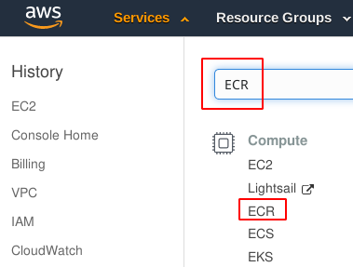

**2. Create an Amazon ECR repository to store your demo image.**

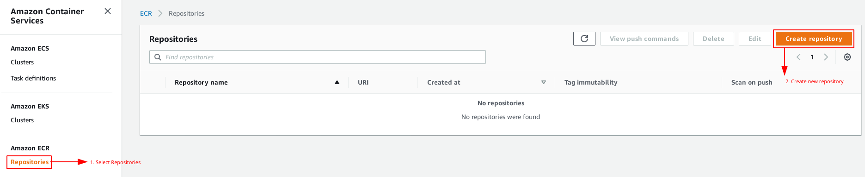

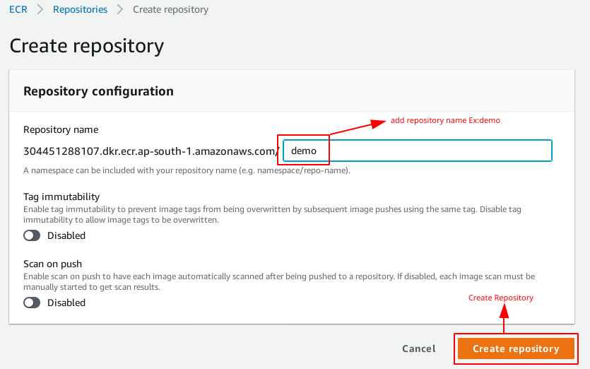

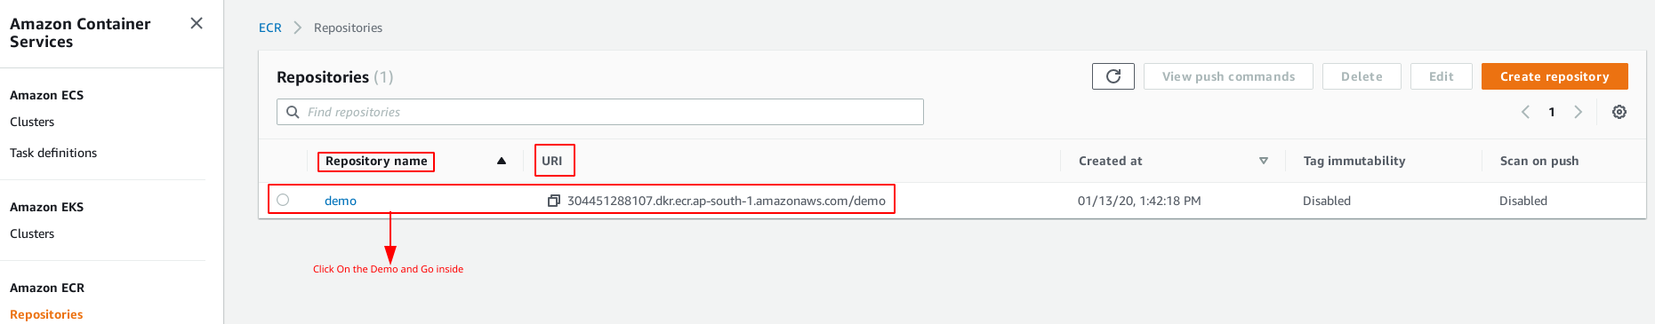

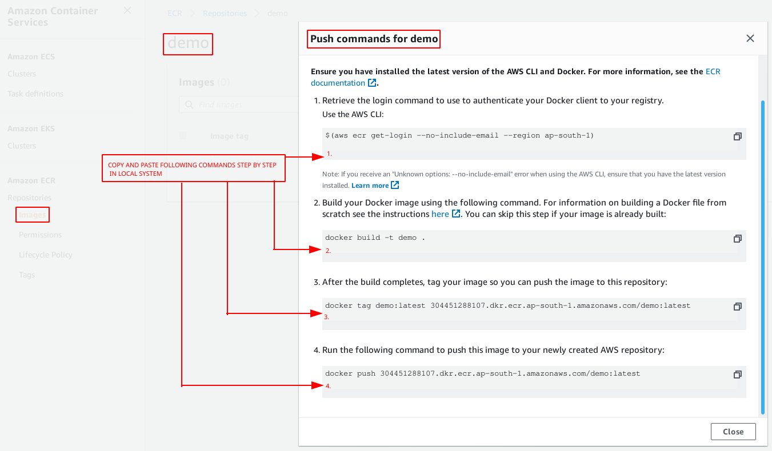

|  |
| --- |
| **$(aws ecr get-login --no-include-email --region ap-south-1)** |

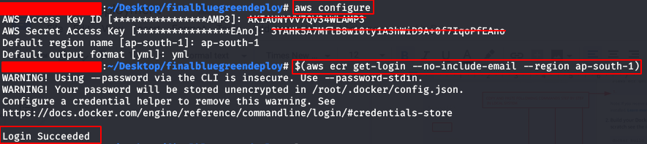

|  |
| --- |
| **$ ls**  **$ docker images**  **$ docker ps** |

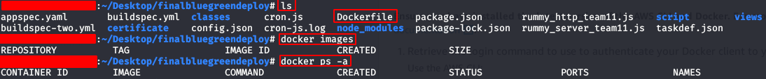

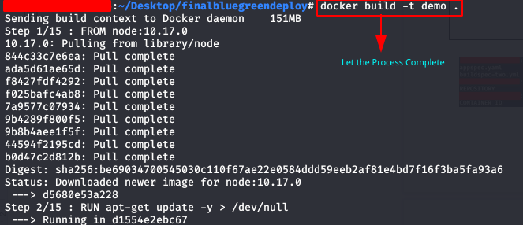

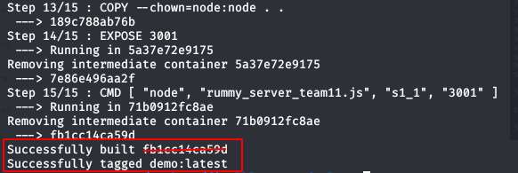

|  |
| --- |
| **$ docker tag demo:latest 304451288107.dkr.ecr.ap-south-1.amazonaws.com/demo:latest**  **$ docker push 304451288107.dkr.ecr.ap-south-1.amazonaws.com/demo:latest** |

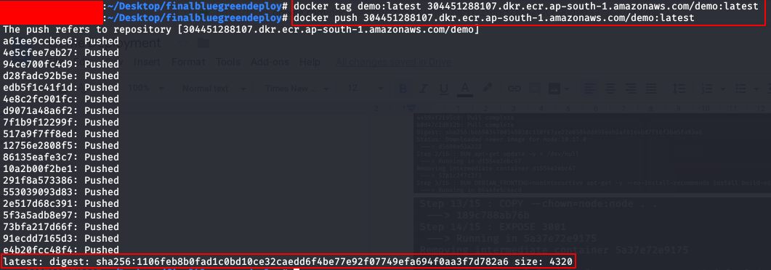



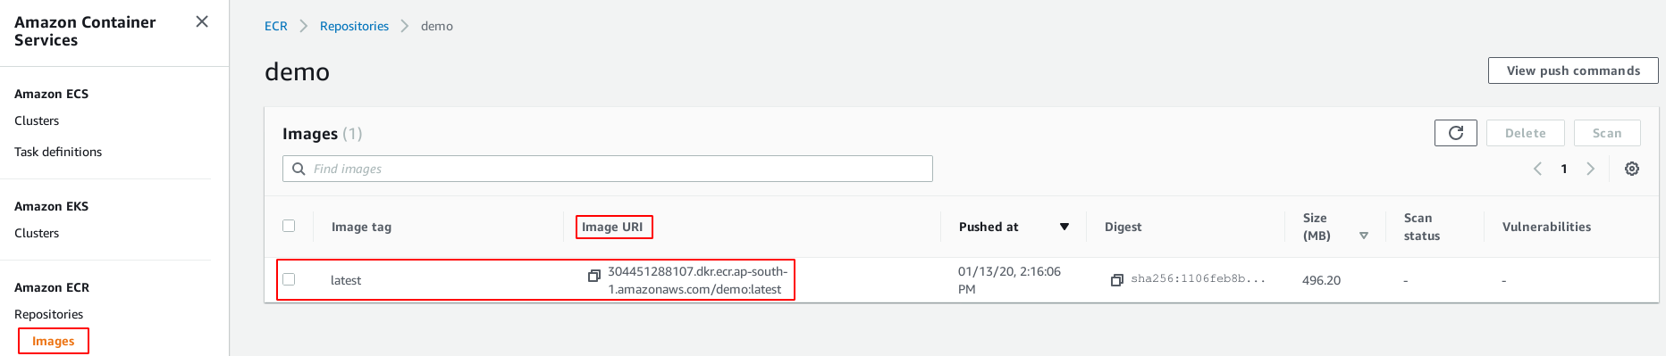

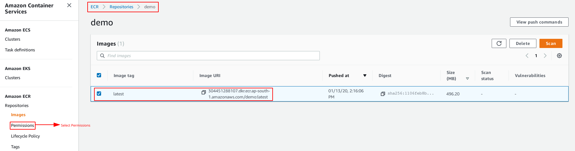

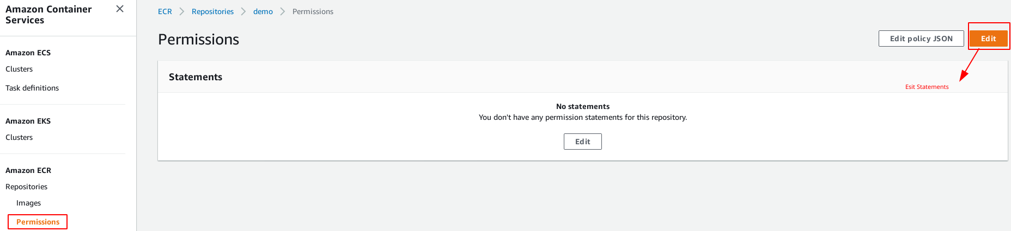

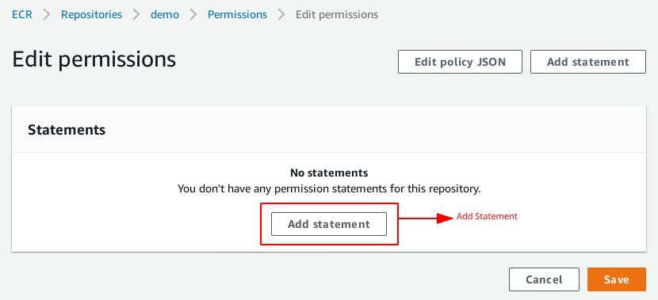

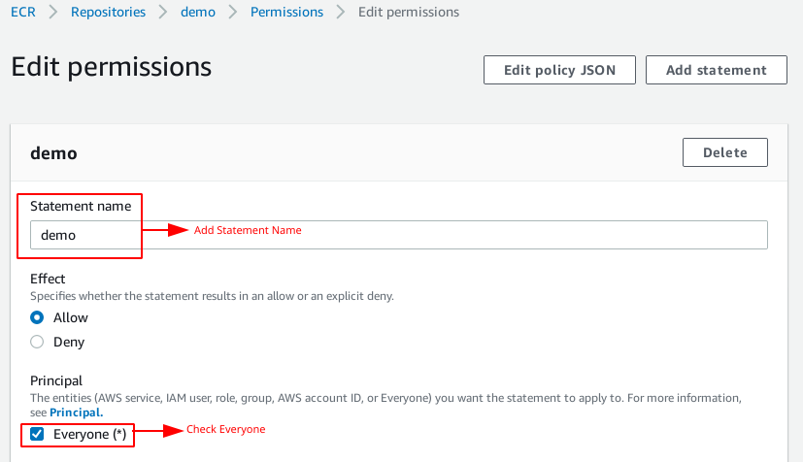

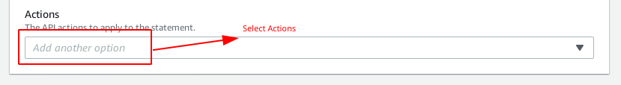

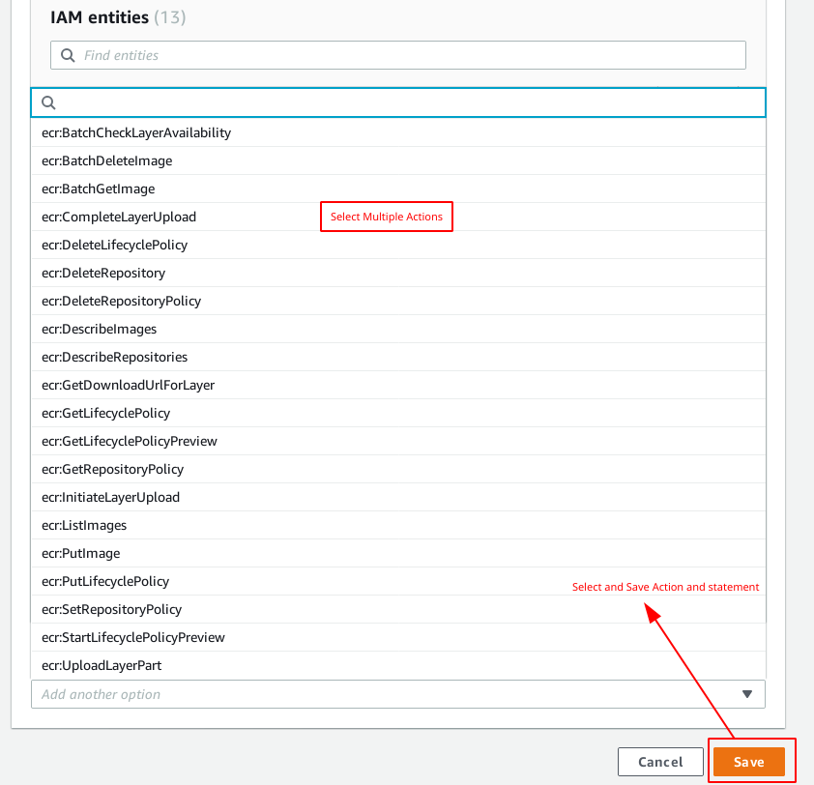

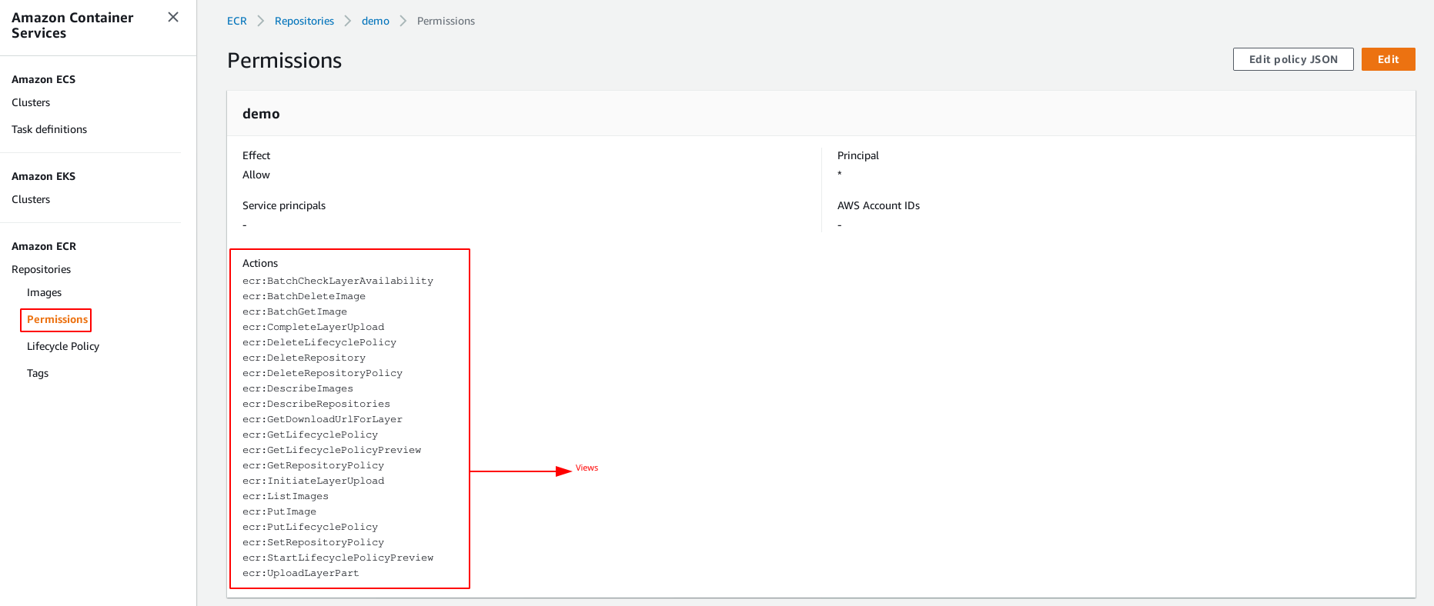

**Step 13: Create and Configure Cluster, Task Definition, Service and Monitor For ECS Fargate Services**

**1. Open all the services and click on ECS under Compute Services**

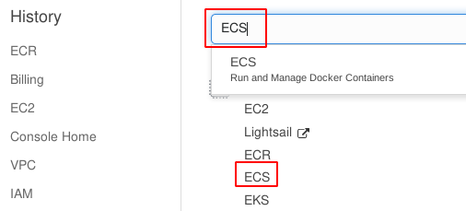

**2. Create Cluster**

**Note: Cluster Won’t Create Without Creating Role. Check Step 1**

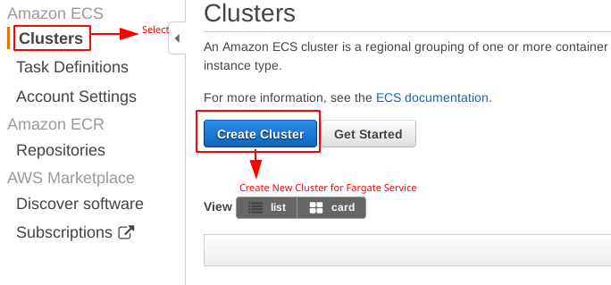

**3. Here you will immediately get three options and since we will be running our image on Fargate, choose “Networking only”.**

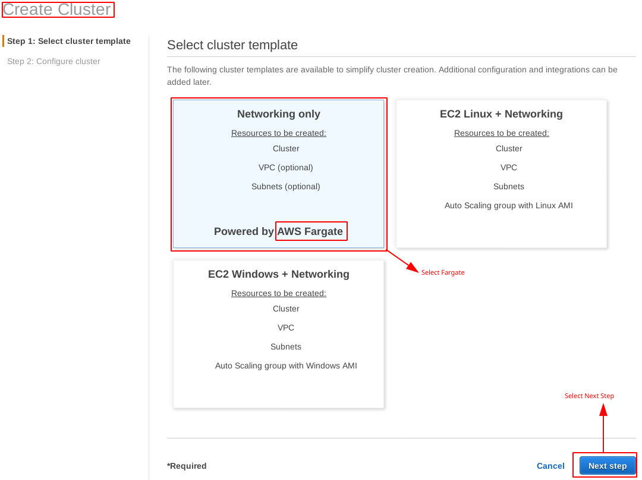

**4. Configure Cluster**

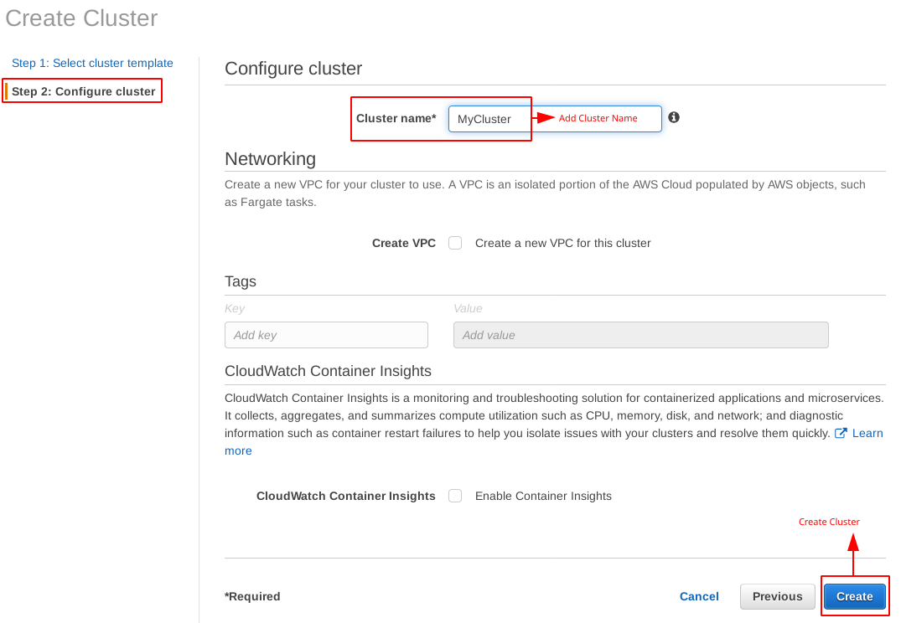

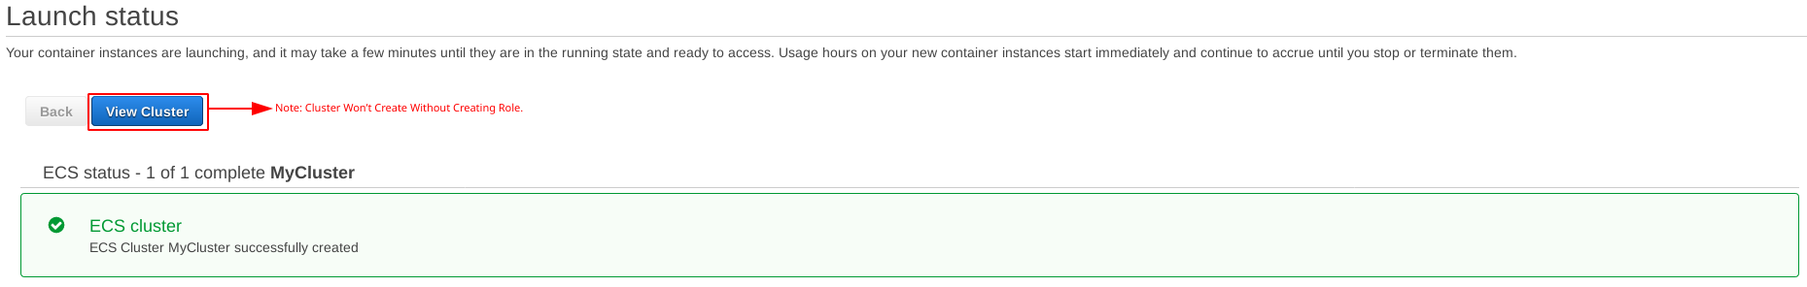

**5. Create a Task Definition.The task definition defines what docker image to run and how to run it.**

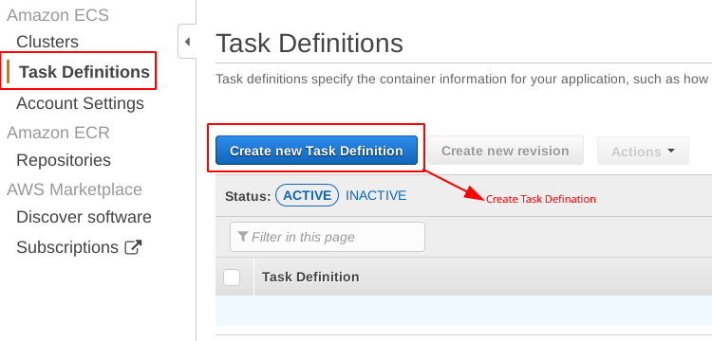

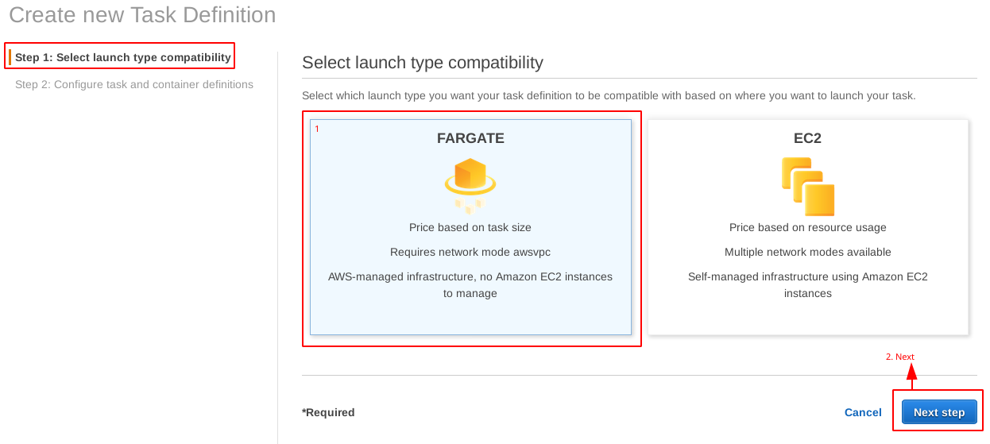

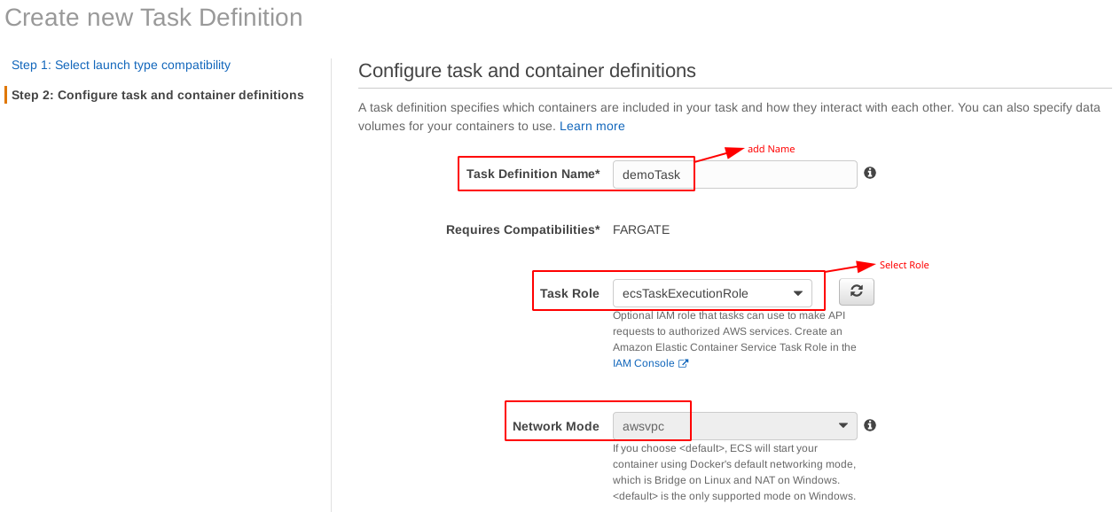

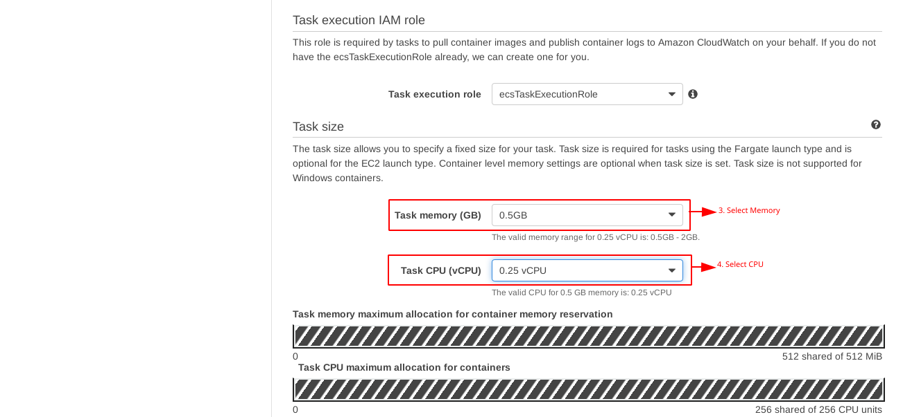

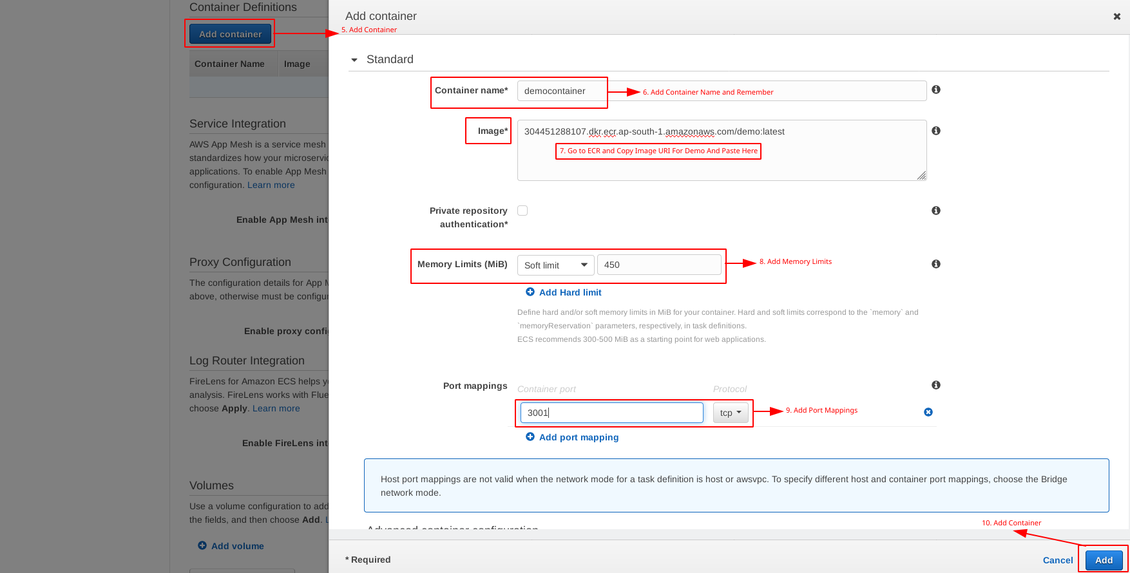



**6. View Launch Status**

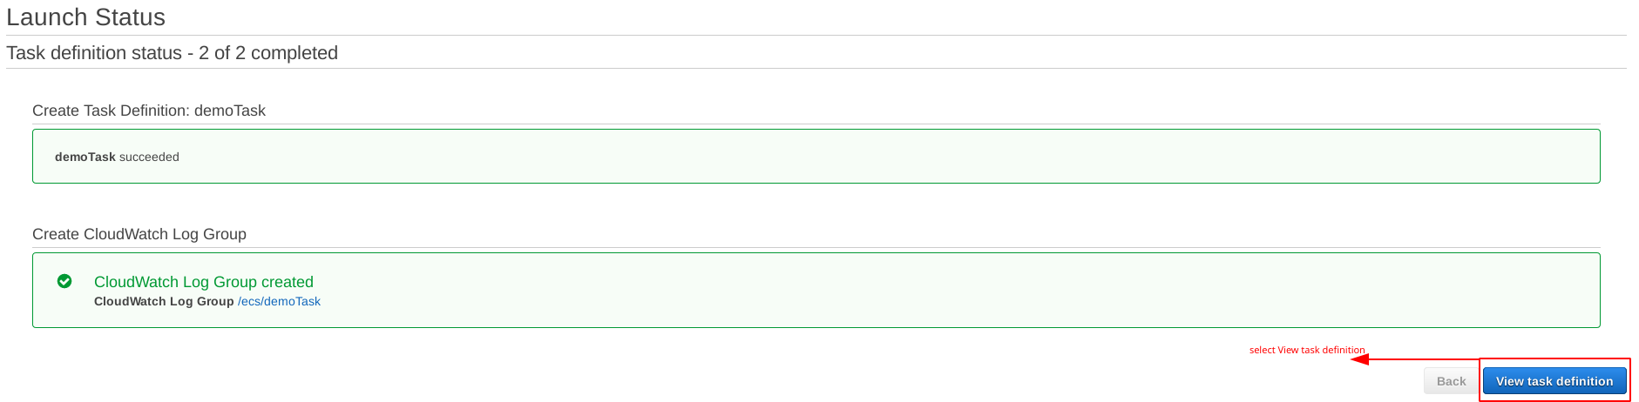

**7. View Clusters Dashboard**

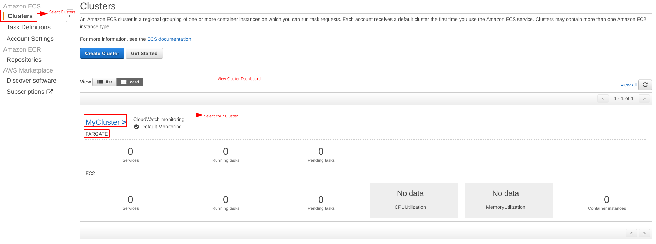

**8. Create and Configure a Service**

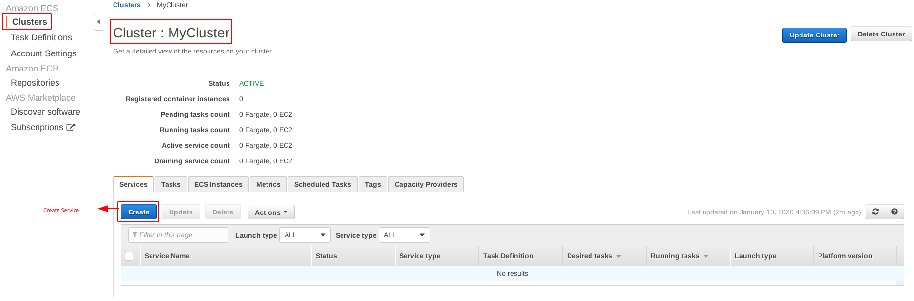

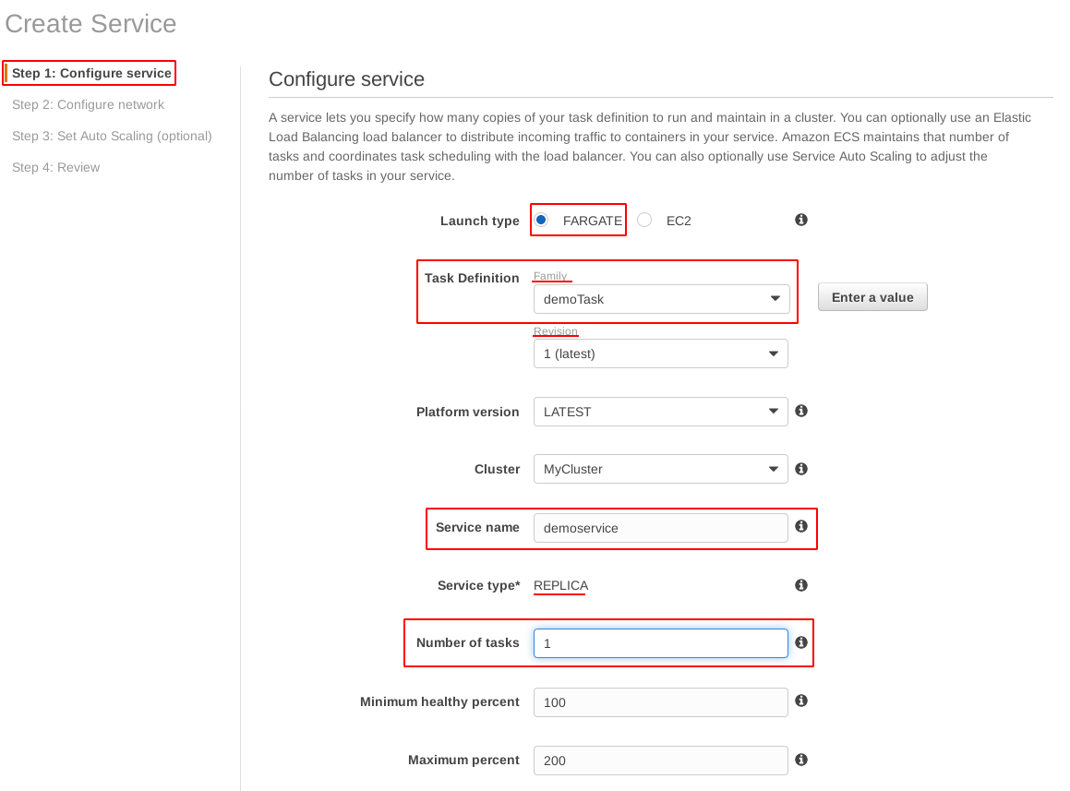

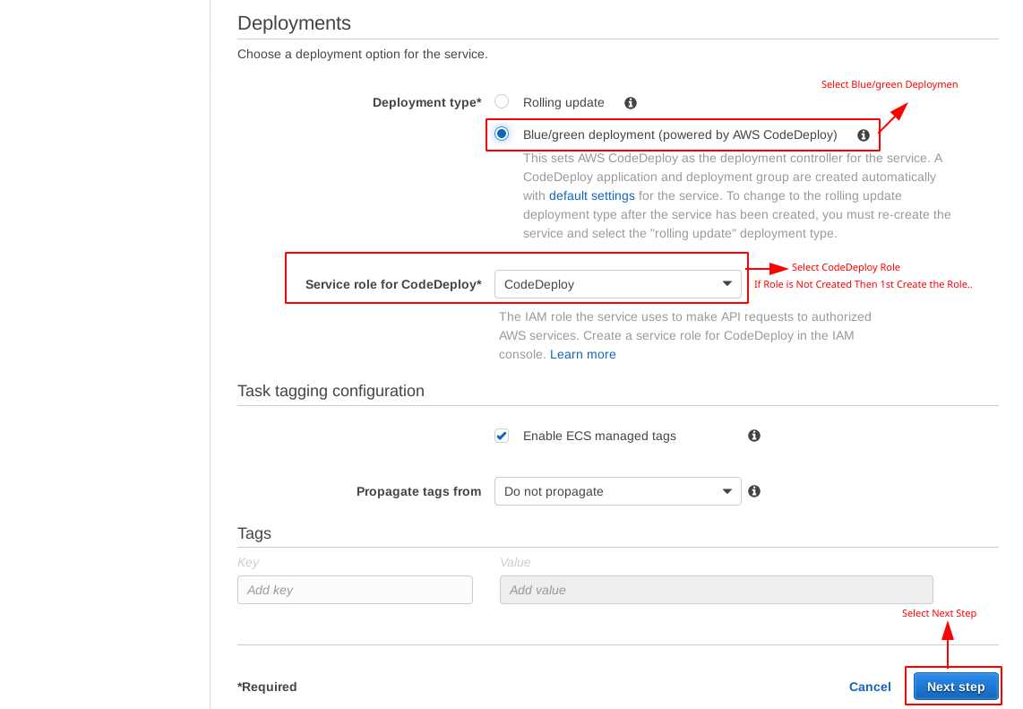

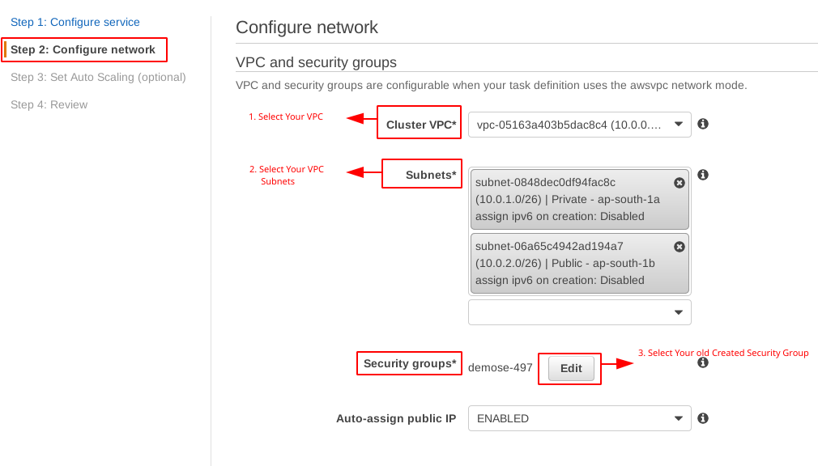

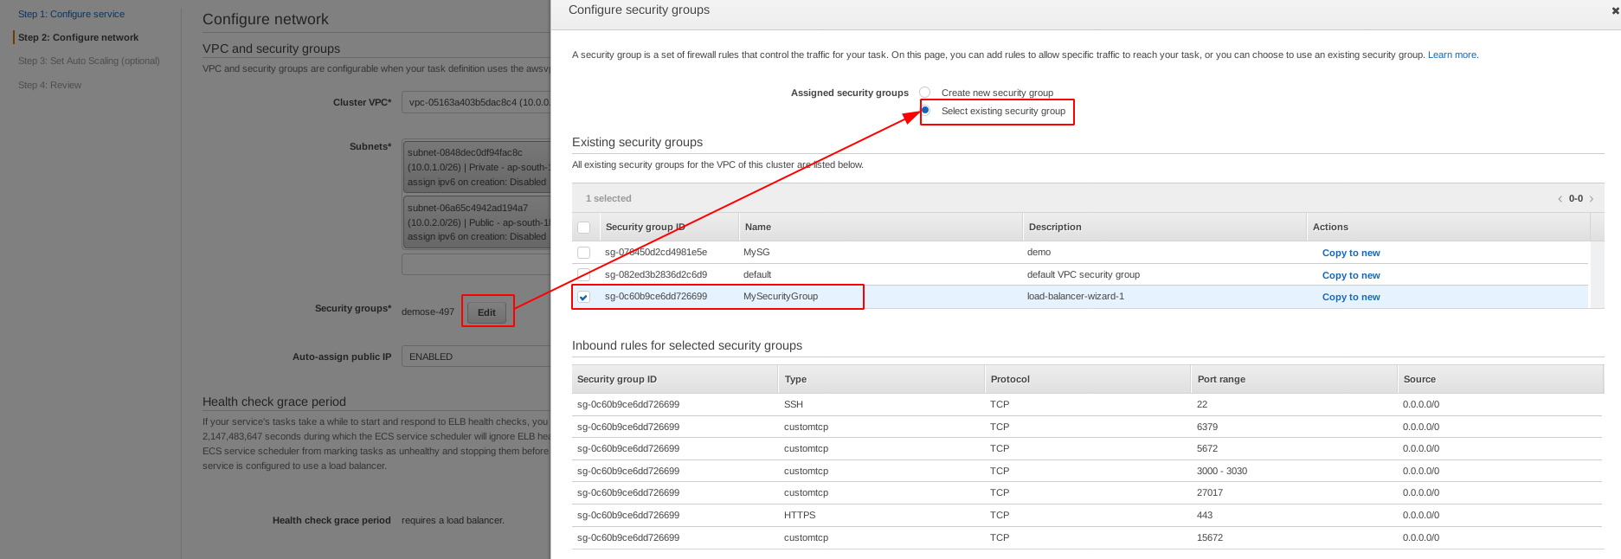

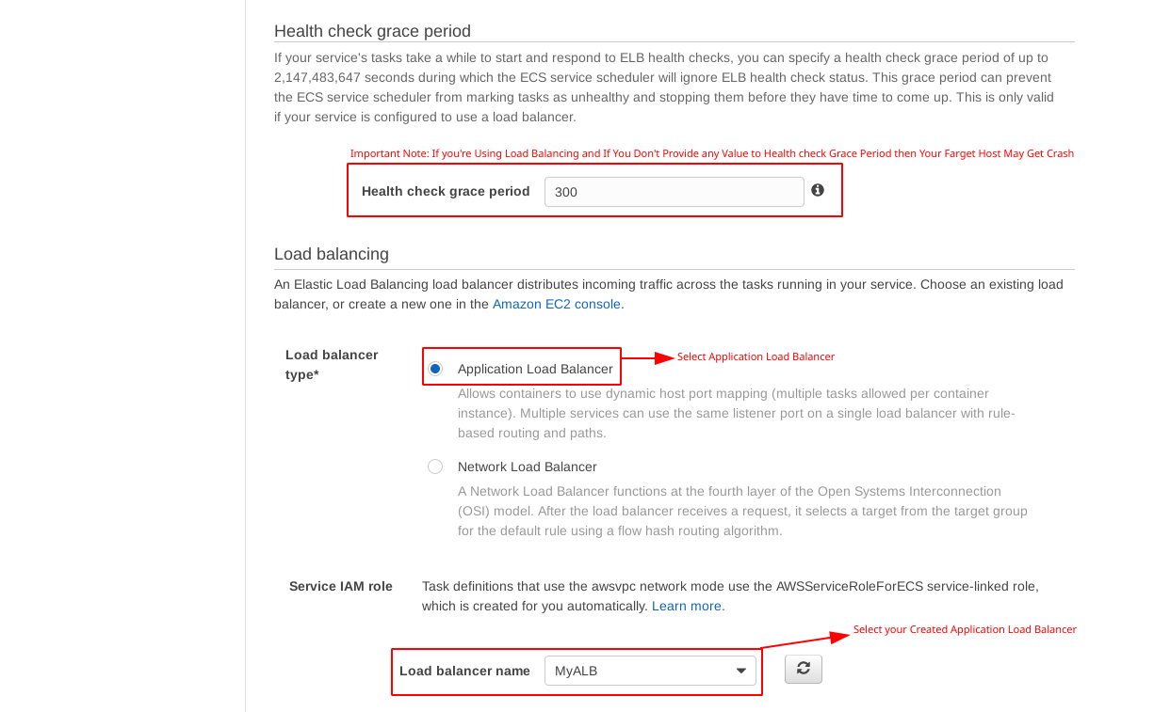

|  |
| --- |
| **Important Note:** If you're using load balancing and if you don't give any value to health check grace period then your fargate host may get crash |



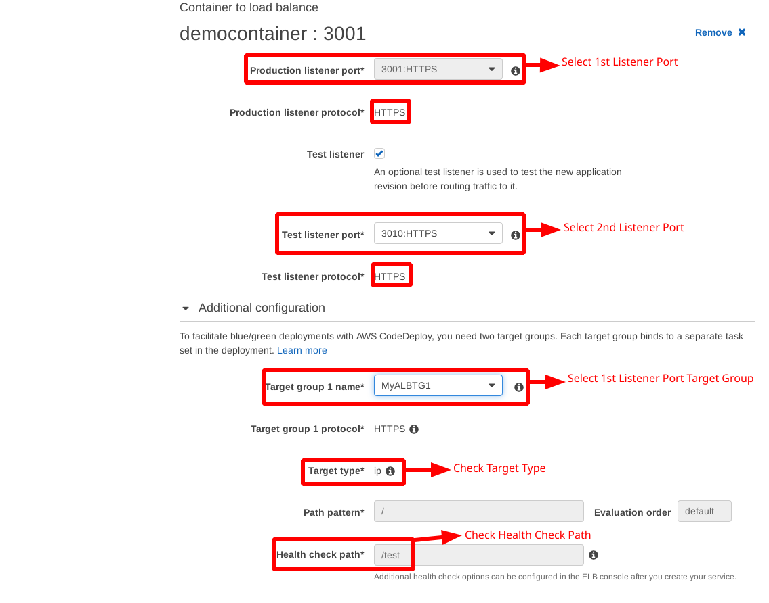

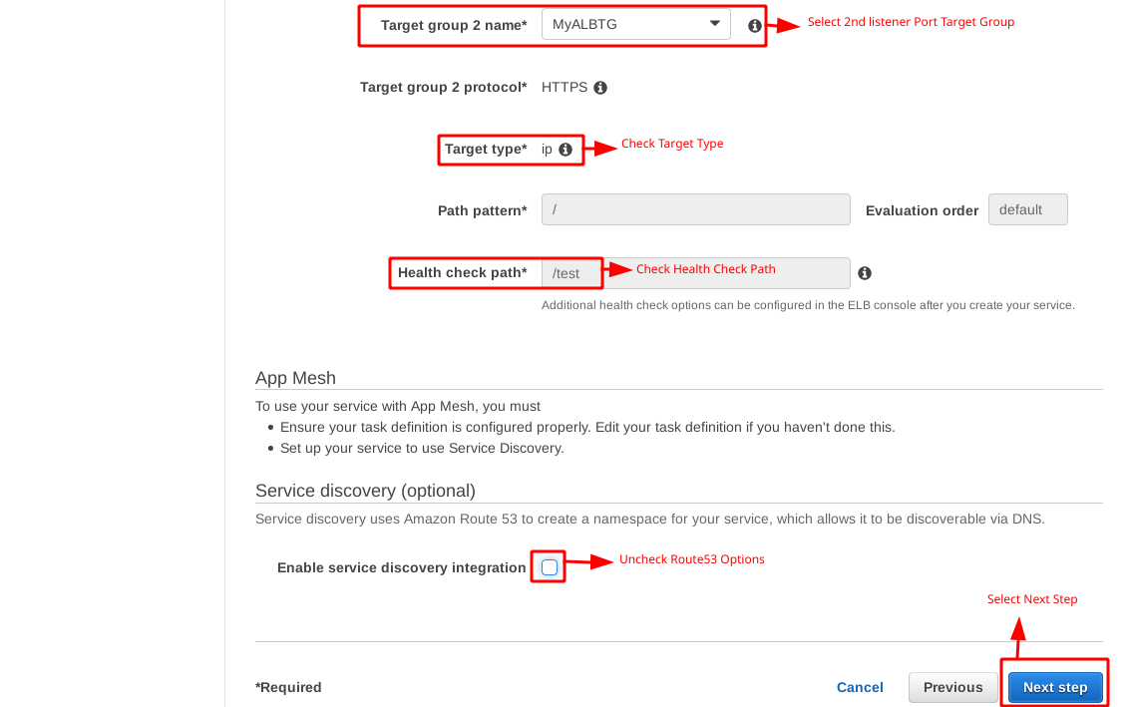

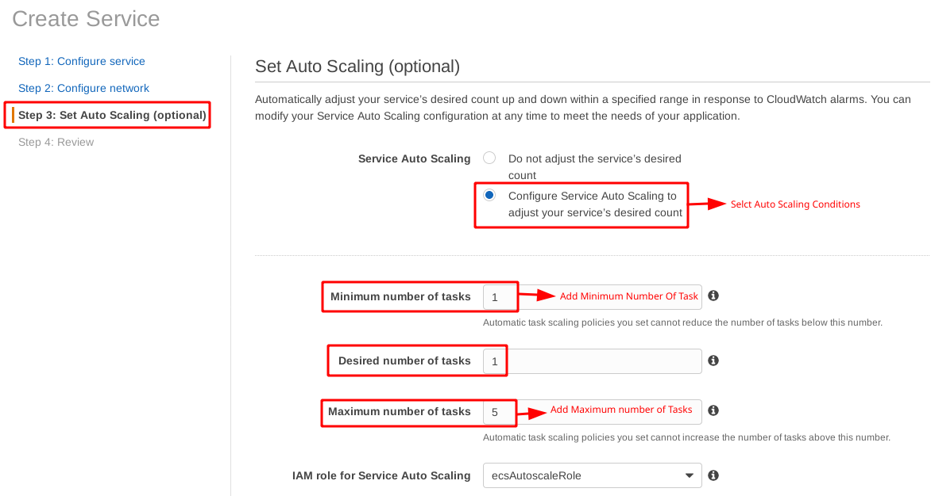

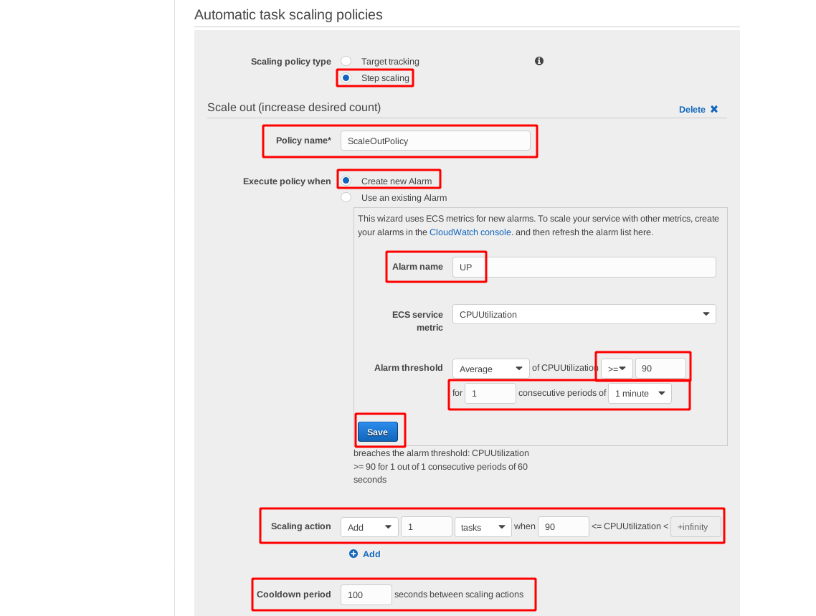

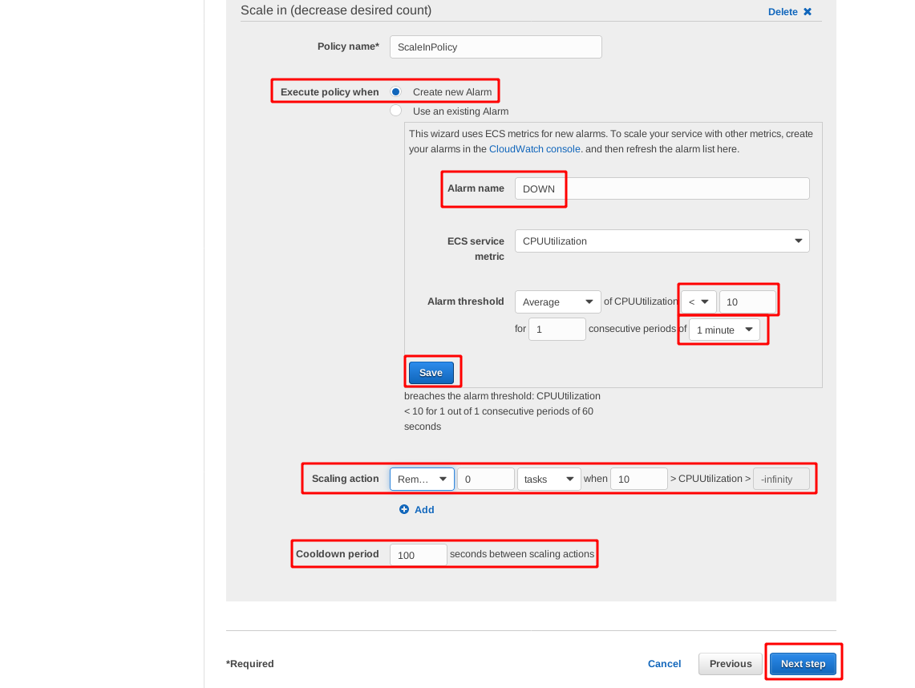

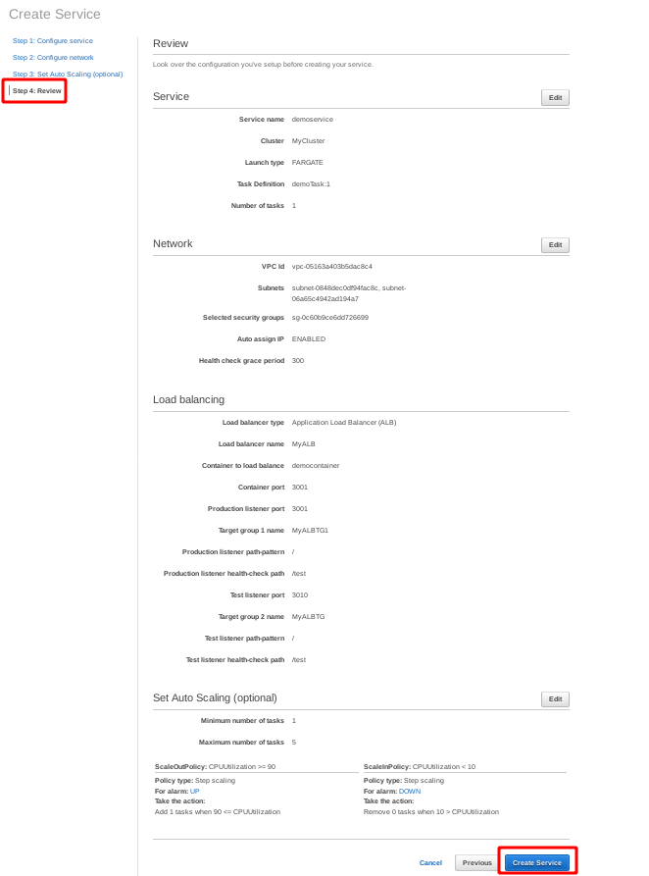

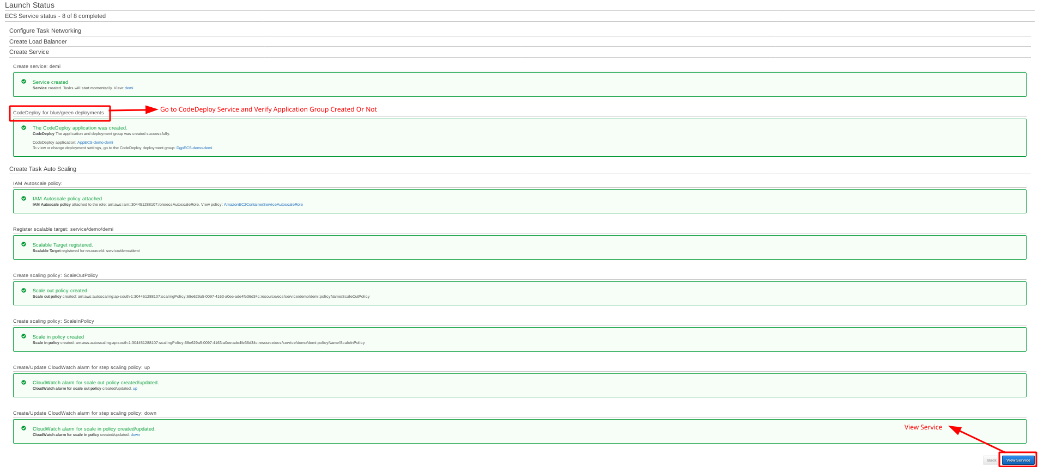

**9. View and Monitor Configure Farget Service**

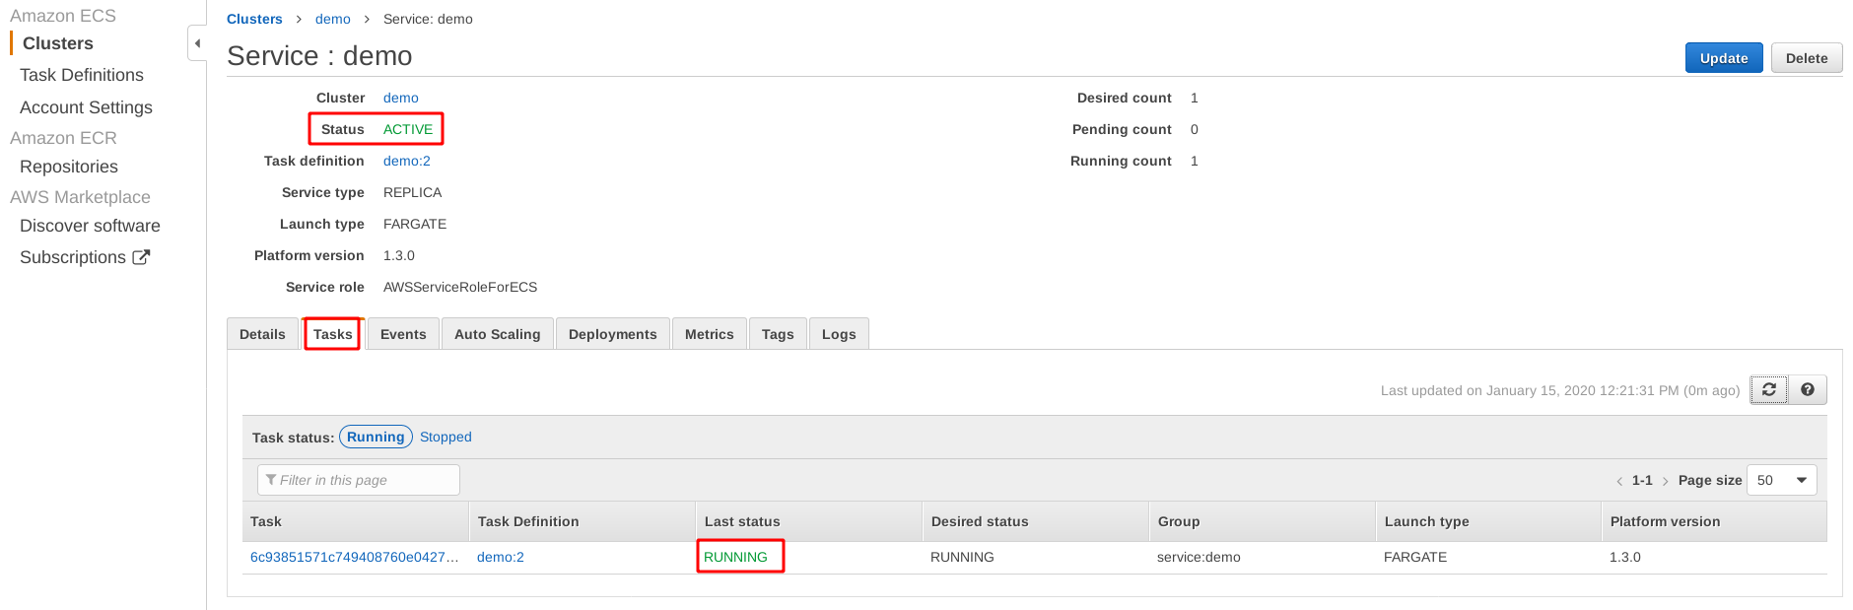

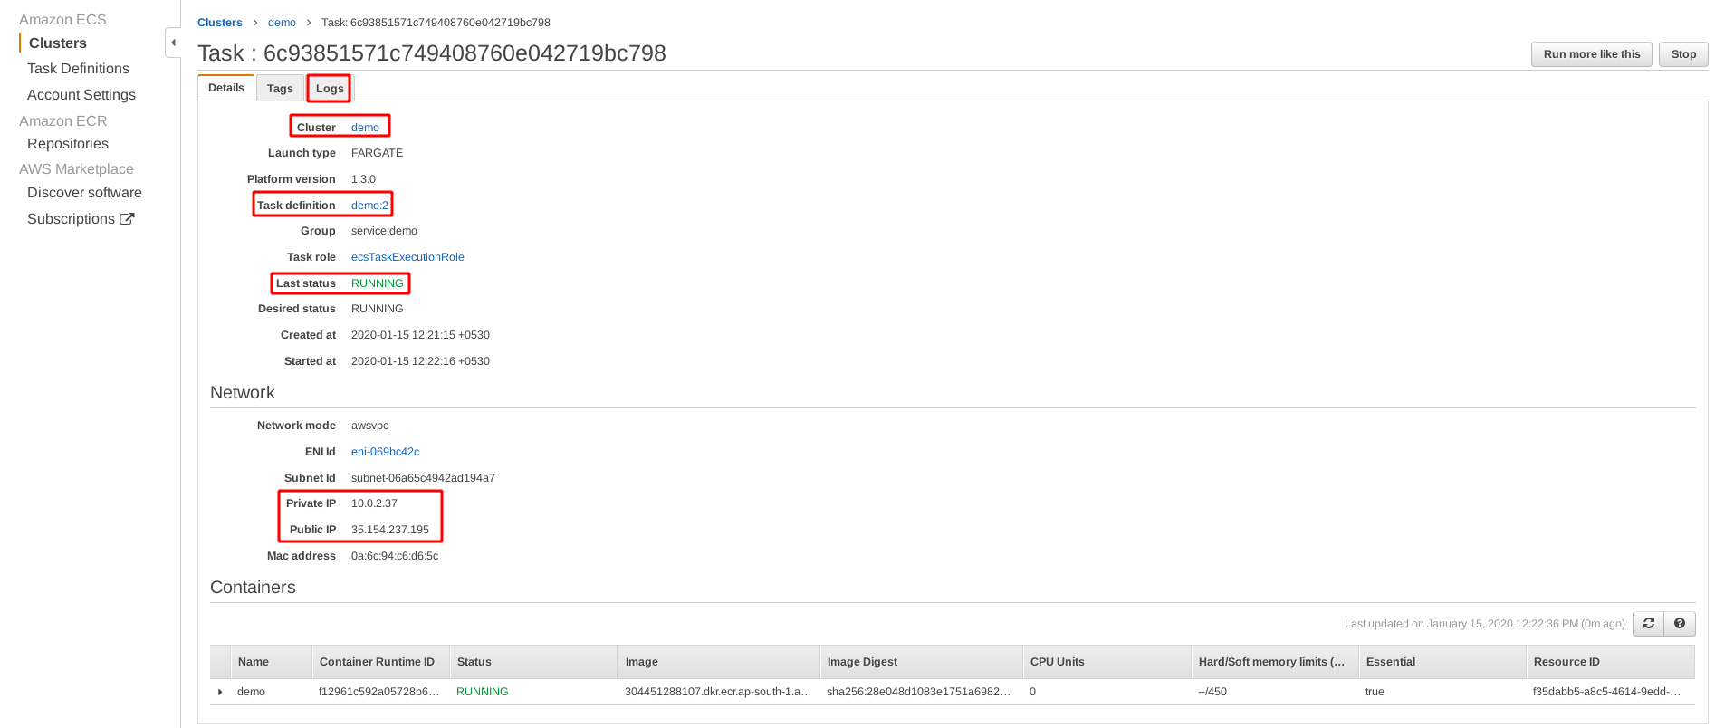

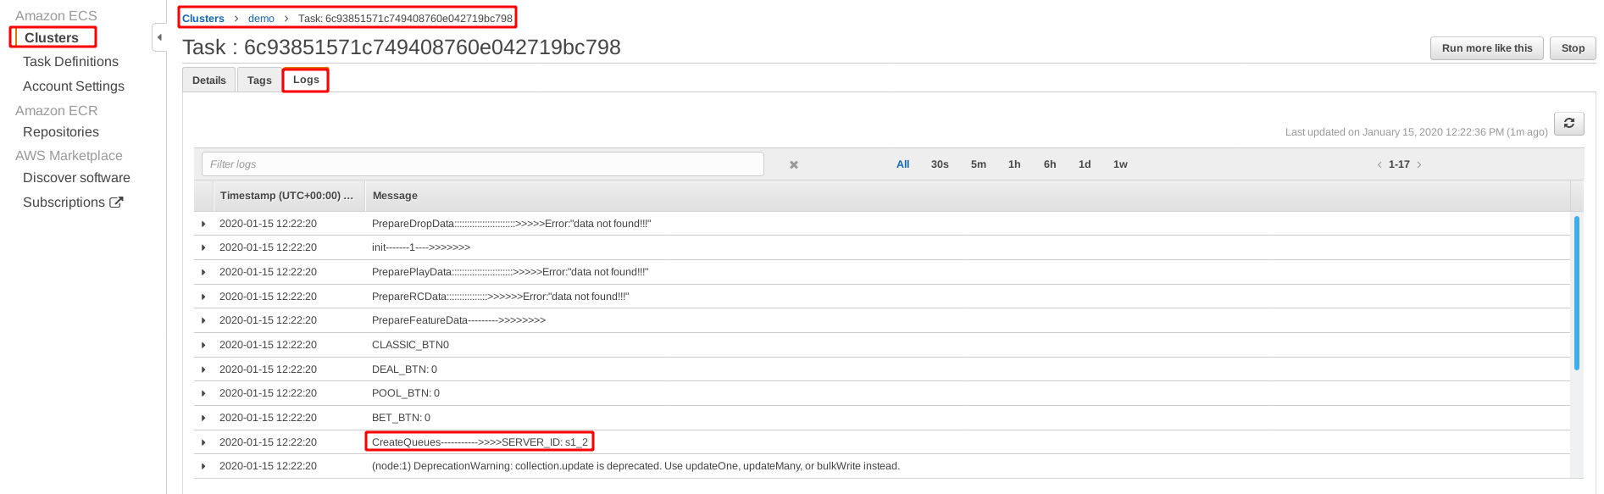

**10. Check CloudWatch Service**

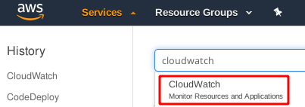

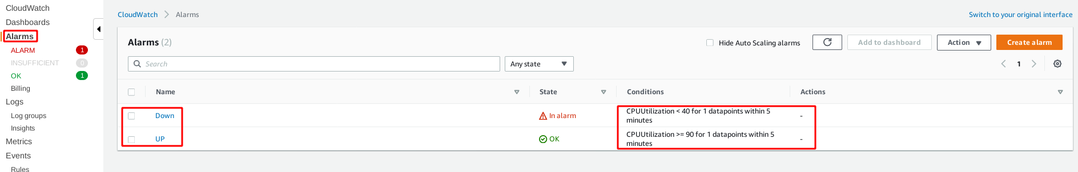

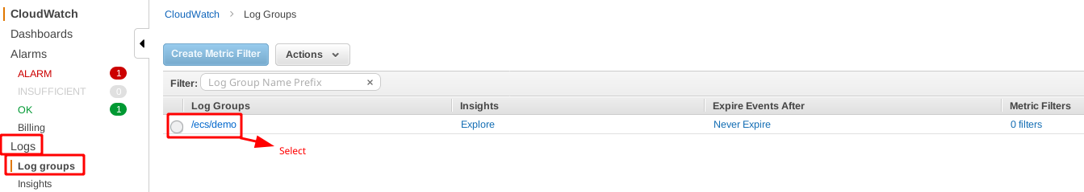

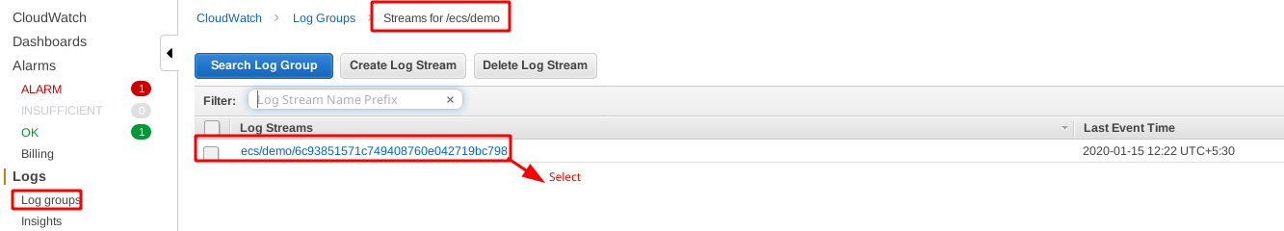

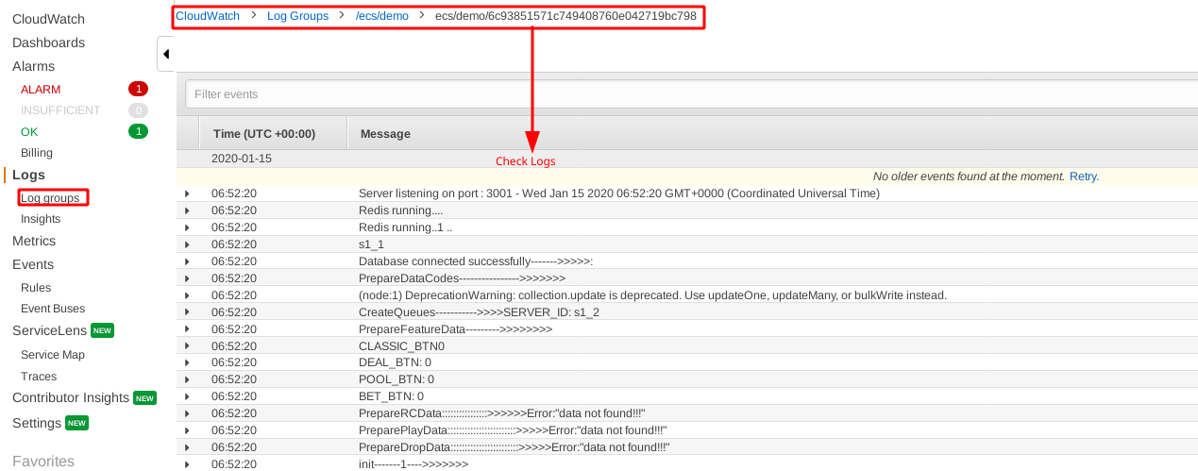

**11. Check CodeDeploy Service**

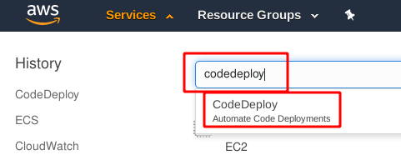

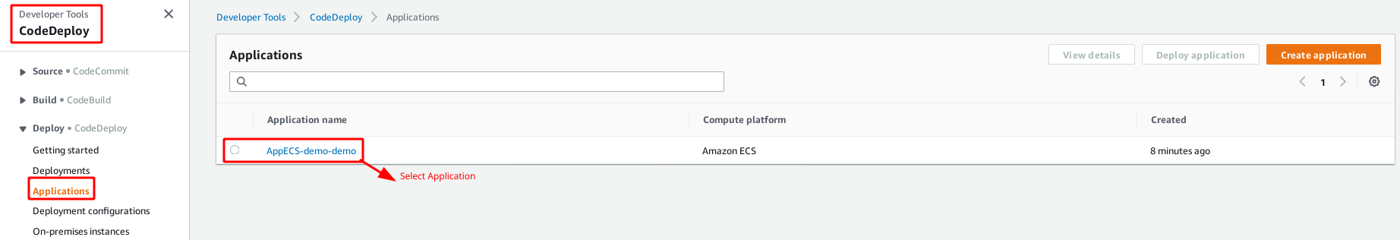

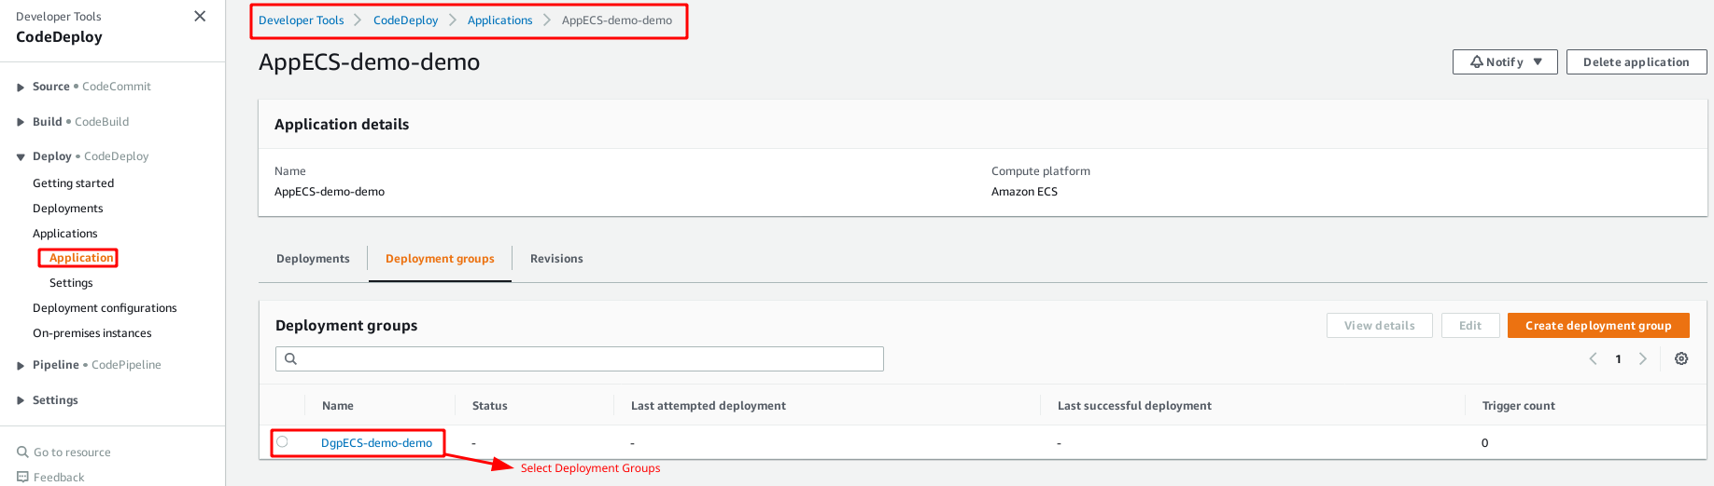

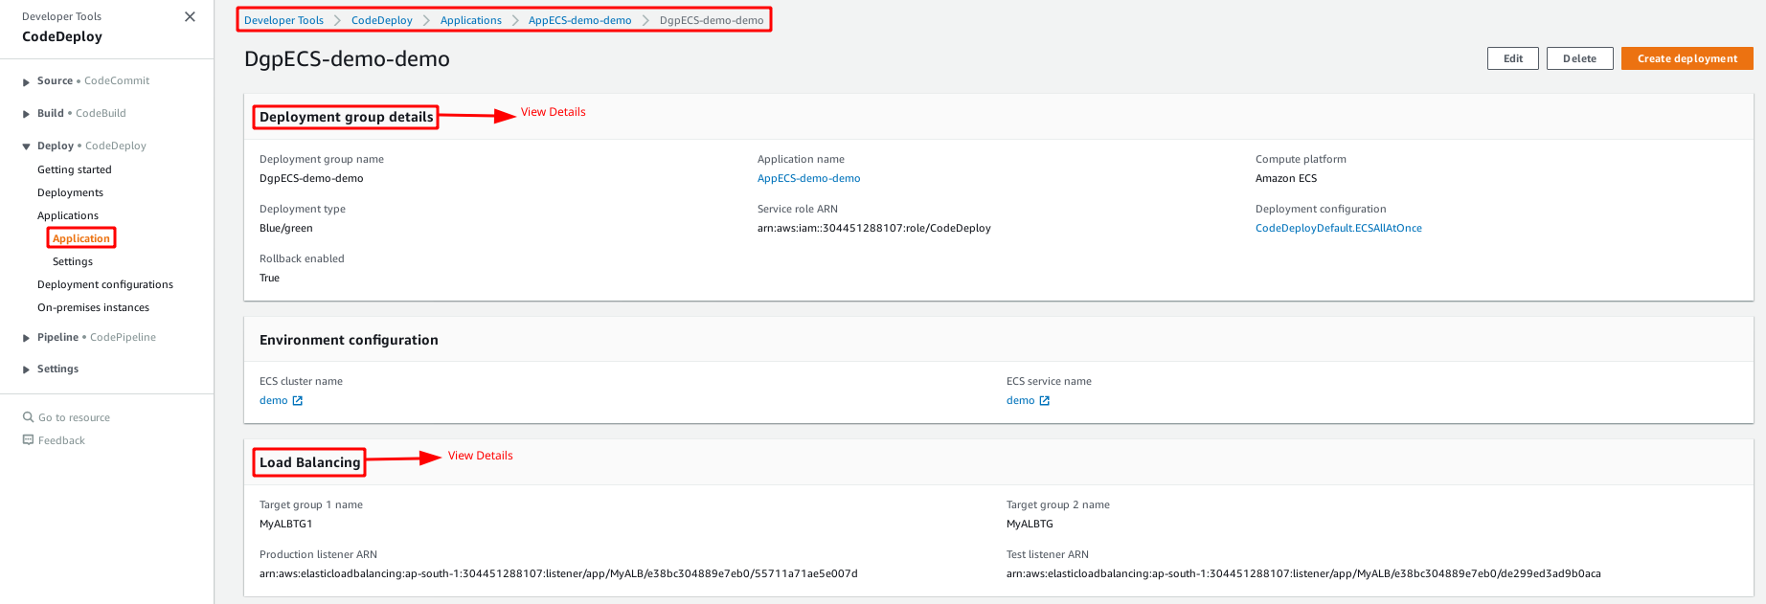

**12. Check EC2 Load Balancing and Target Group**

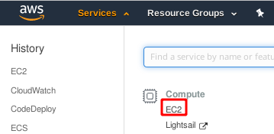

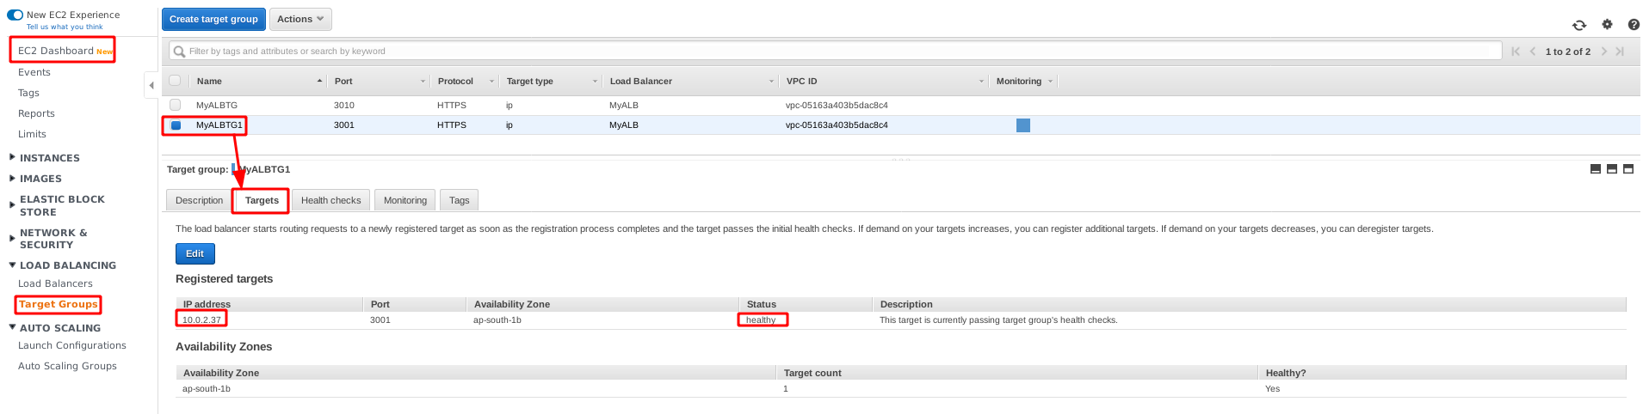

**Step 14 : Create CodeCommit, CodeBuild, CodeDeploy and CodePipeline**

**1. Create Buildspec.yml For ECR Image Update**

**vim buildspec.yml**

|  |
| --- |
| **# Changes REPOSITORY_URI and printf '[{"name":"webauto","imageUri":"%s"}] = "name" : "containername"**  **version: 0.2**  **phases:**  **install:**  **runtime-versions:**  **docker: 18**  **pre_build:**  **commands:**  **- echo Logging in to Amazon ECR...**  **# - aws --version**  **- $(aws ecr get-login --no-include-email --region ap-south-1)**  **- REPOSITORY_URI=653751857729.dkr.ecr.ap-south-1.amazonaws.com/serhealth #Define ECR repository URI**  **- COMMIT_HASH=$(echo $CODEBUILD_RESOLVED_SOURCE_VERSION | cut -c 1-7)**  **# - IMAGE_TAG=${COMMIT_HASH:=latest}**  **- IMAGE_TAG=build-$(echo $CODEBUILD_BUILD_ID | awk -F":" '{print $2}')**  **build:**  **commands:**  **- echo Build started on `date`**  **- echo Building the Docker image...**  **- docker build -t $REPOSITORY_URI:latest .**  **- docker tag $REPOSITORY_URI:latest $REPOSITORY_URI:$IMAGE_TAG**  **post_build:**  **commands:**  **- echo Build completed on `date`**  **- echo Pushing the Docker images...**  **- docker push $REPOSITORY_URI:latest**  **- docker push $REPOSITORY_URI:$IMAGE_TAG**  **- echo Writing image definitions file...**  **- printf '[{"name":"final","imageUri":"%s"}]' $REPOSITORY_URI:$IMAGE_TAG > imageDetail.json # Define "name" : "Container Name"**  **- cat imageDetail.json**  **artifacts:**  **files:**  **- imageDetail.json**  **- taskdef.json**  **- appspec.yaml** |

**2. Create appspec.yaml, taskdef.yml for Blue Green Deployment.**

**vim appspec.yaml**

|  |
| --- |
| **version: 1**  **Resources:**  **- TargetService:**  **Type: AWS::ECS::Service**  **Properties:**  **TaskDefinition: "arn:aws:ecs:ap-south-1:653751857729:task-definition/final:5"**  **LoadBalancerInfo:**  **ContainerName: "final"**  **ContainerPort: 3001** |

**vim taskdef.json**

|  |
| --- |
| **{**  **"executionRoleArn": "arn:aws:iam::653751857729:role/ecsTaskExecutionRole",**  **"containerDefinitions": [**  **{**  **"name": "final",**  **"image": "653751857729.dkr.ecr.ap-south-1.amazonaws.com/serhealth:latest",**  **"essential": true,**  **"portMappings": [**  **{**  **"hostPort": 3001,**  **"protocol": "tcp",**  **"containerPort": 3001**  **}**  **]**  **}**  **],**  **"requiresCompatibilities": [**  **"FARGATE"**  **],**  **"networkMode": "awsvpc",**  **"cpu": "256",**  **"memory": "512",**  **"family": "final",**  **"taskRoleArn": "arn:aws:iam::653751857729:role/ecsTaskExecutionRole"**  **}** |

**(OR)**

**For ECS to EC2 Service**

**vim taskdef.json**

|  |
| --- |
| **{**  **"executionRoleArn": "arn:aws:iam::653751857729:role/ecsTaskExecutionRole",**  **"containerDefinitions": [**  **{**  **"name": "final",**  **"image": "653751857729.dkr.ecr.ap-south-1.amazonaws.com/serhealth:latest",**  **"essential": true,**  **"portMappings": [**  **{**  **"hostPort": 3001,**  **"protocol": "tcp",**  **"containerPort": 3001**  **}**  **]**  **}**  **],**  **"requiresCompatibilities": [**  **"EC2"**  **],**  **"networkMode": "bridge",**  **"memory": "450",**  **"family": "final",**  **}** |

**3. Create and Configure CodeCommit using IAM user HTTPS Git credentials for AWS CodeCommit and Generate credentials**

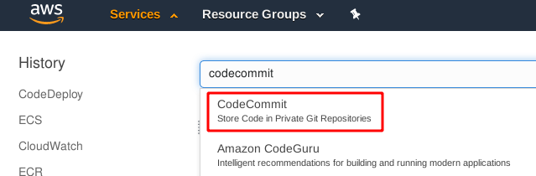

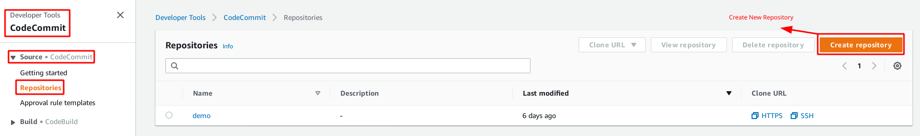

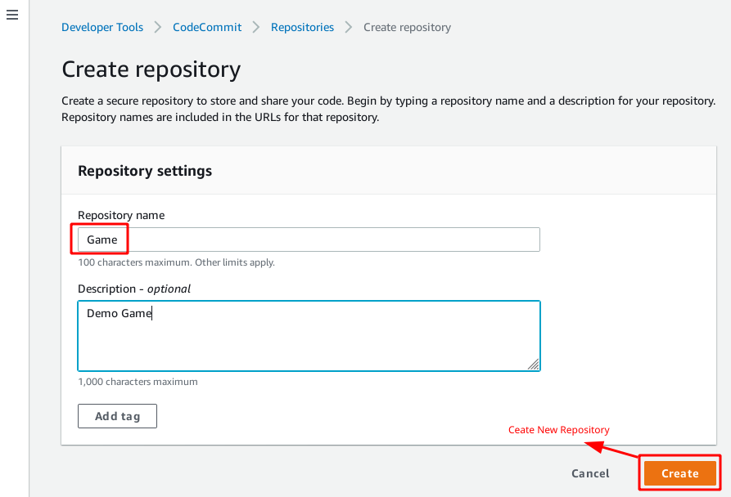

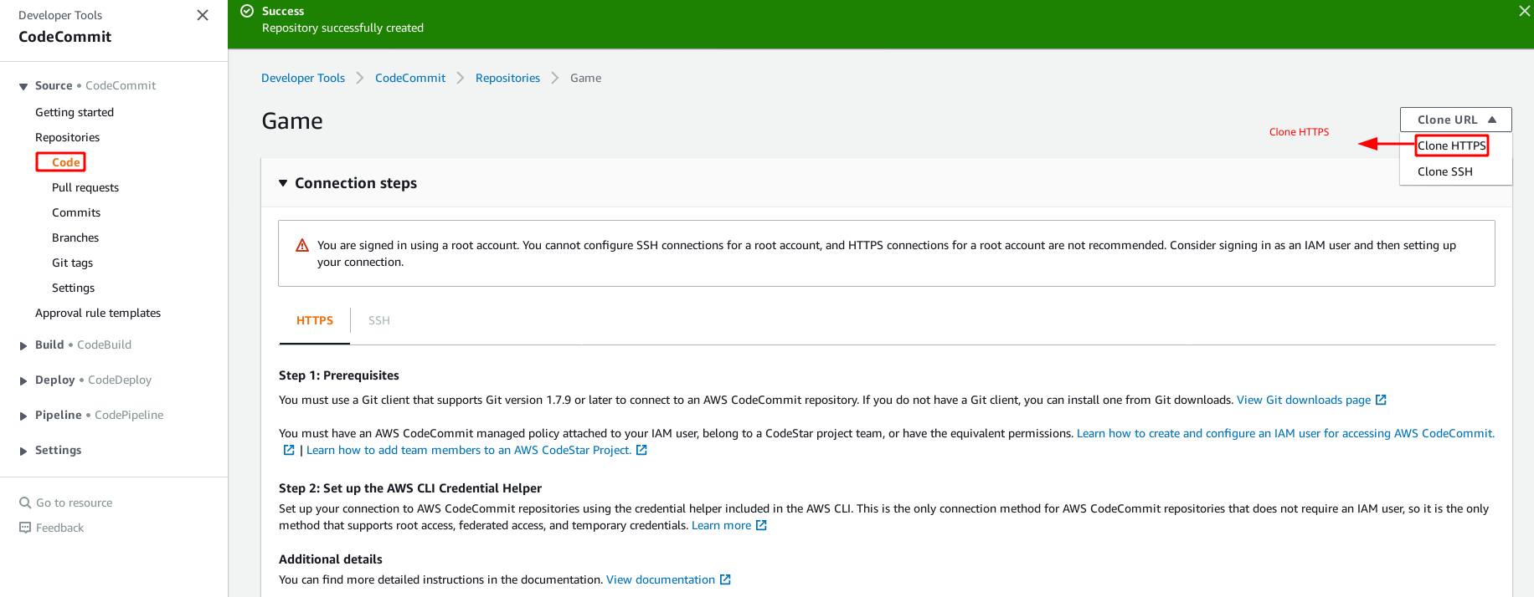

|  |
| --- |
| **$ git clone** [**https://git-codecommit.ap-south-1.amazonaws.com/v1/repos/Game**](https://git-codecommit.ap-south-1.amazonaws.com/v1/repos/Game)  **$ cd Game**  **$ ls -al**  **Add Your Project**  **$ git add .**  **$ git commit -m “Add Project”**  **$ git push origin master** |

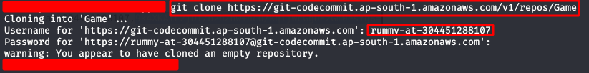

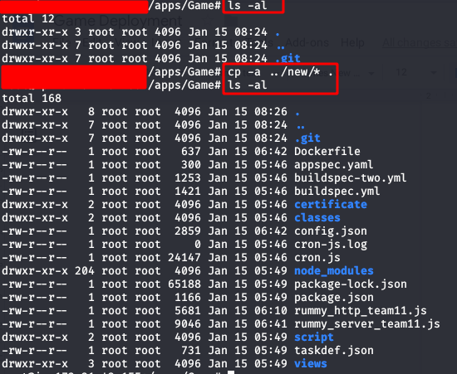



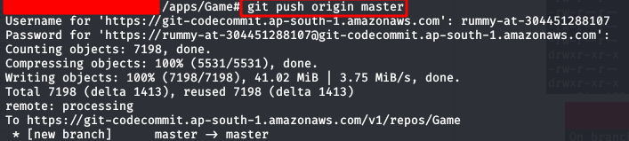

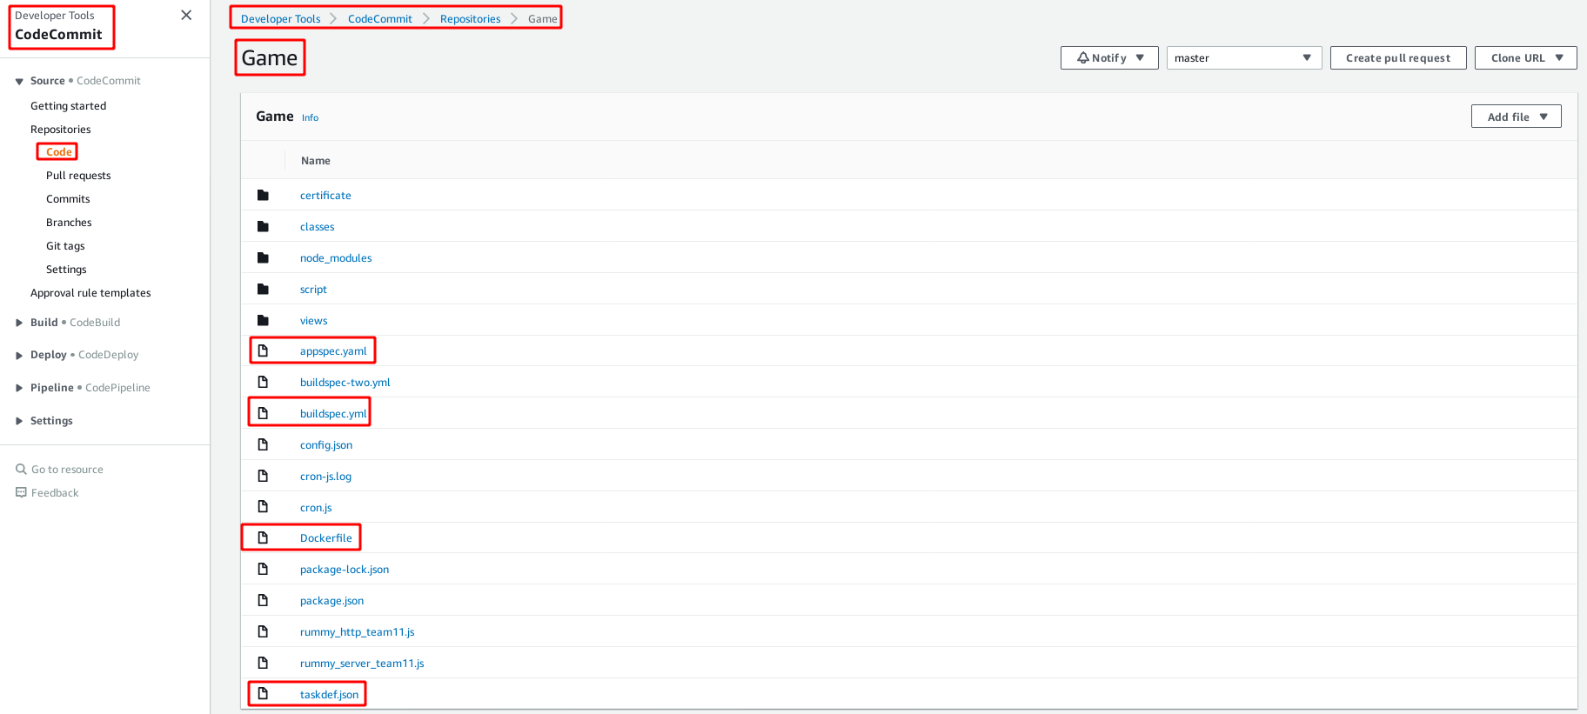

**4. Create and Configure CodePipeLine For BlueGreen Deployment**

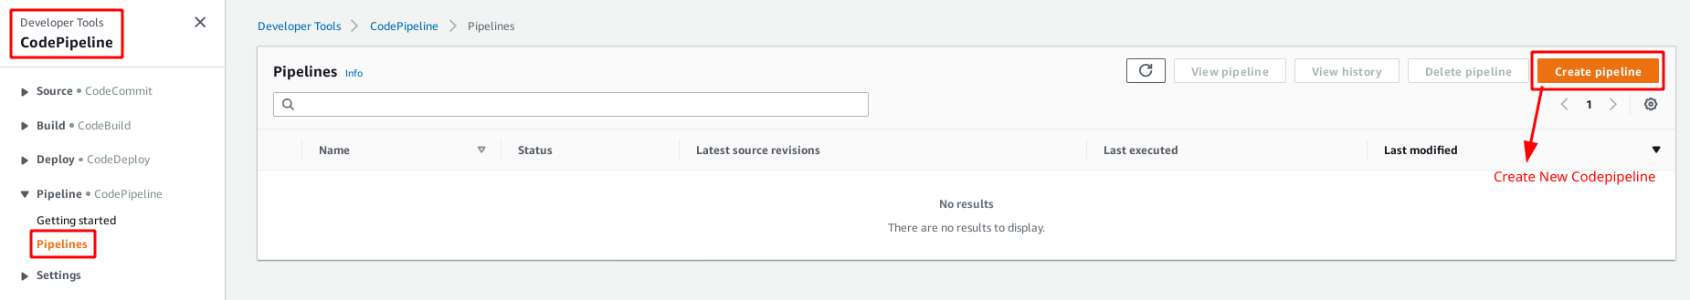

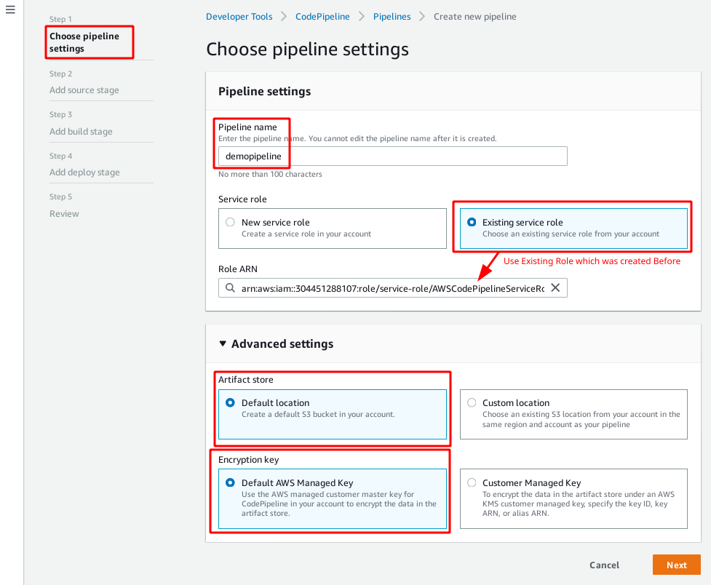

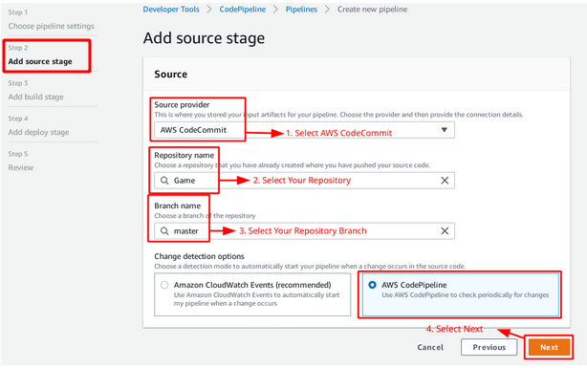

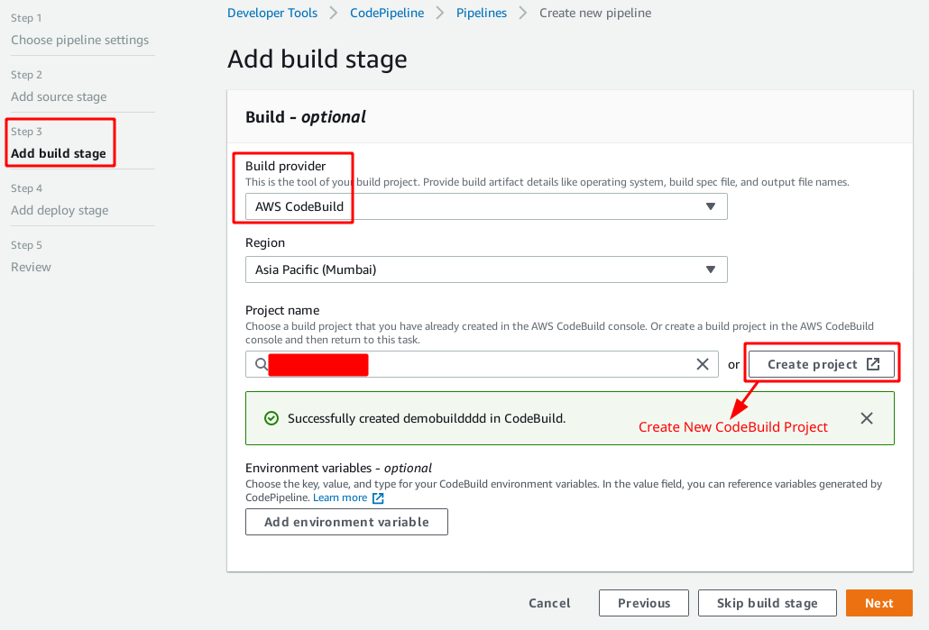

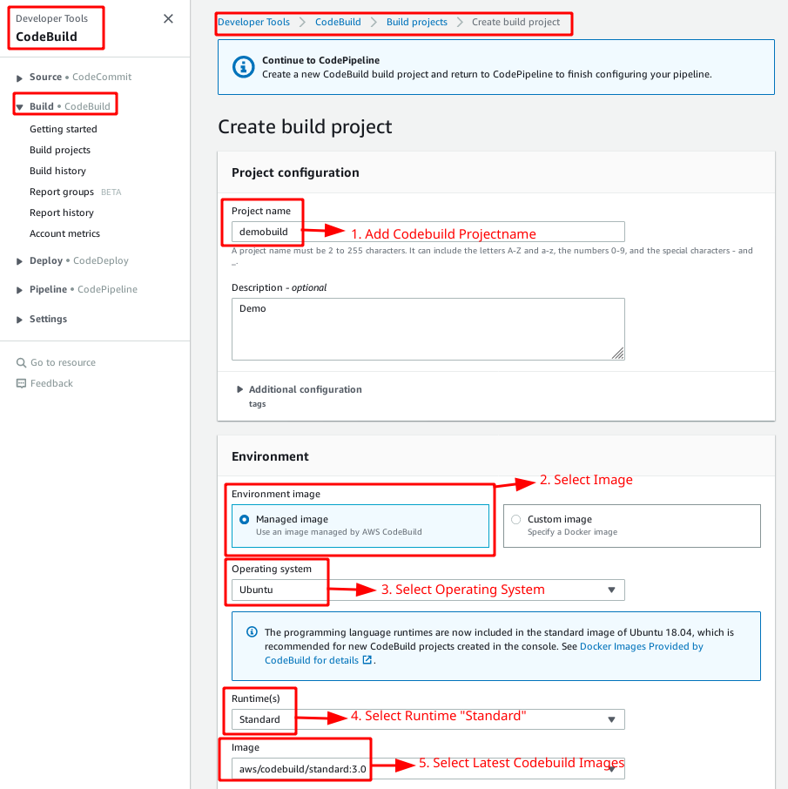

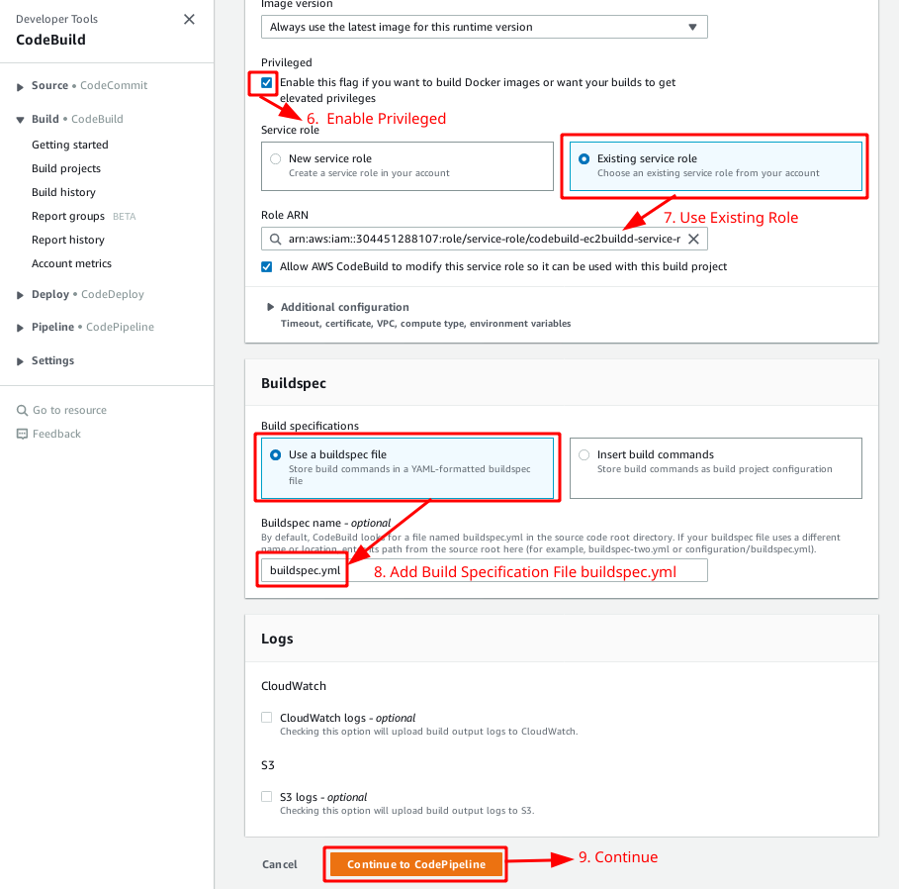

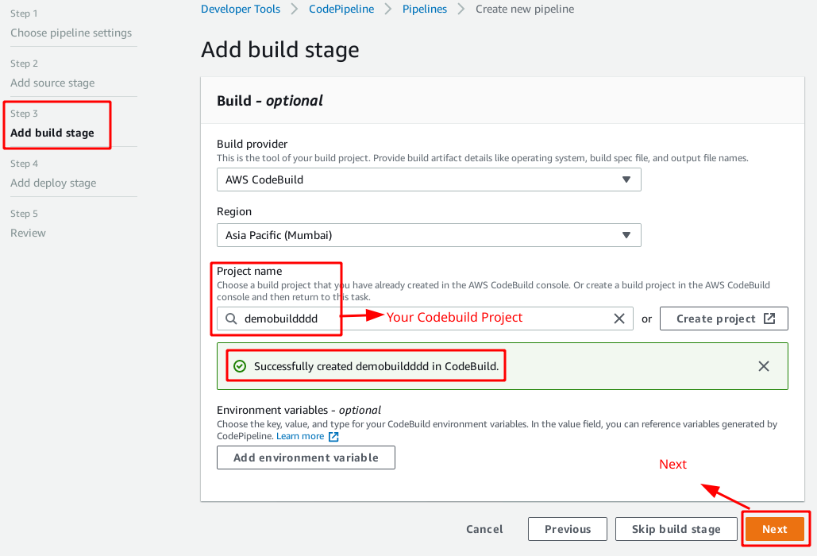

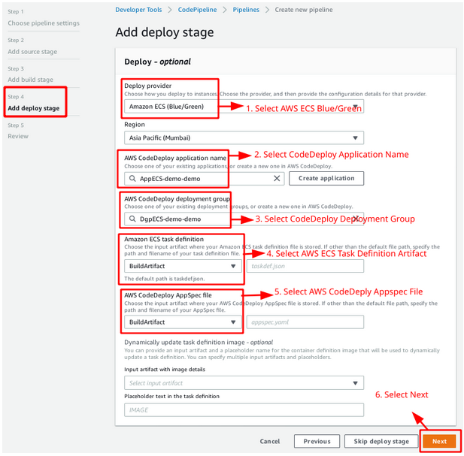

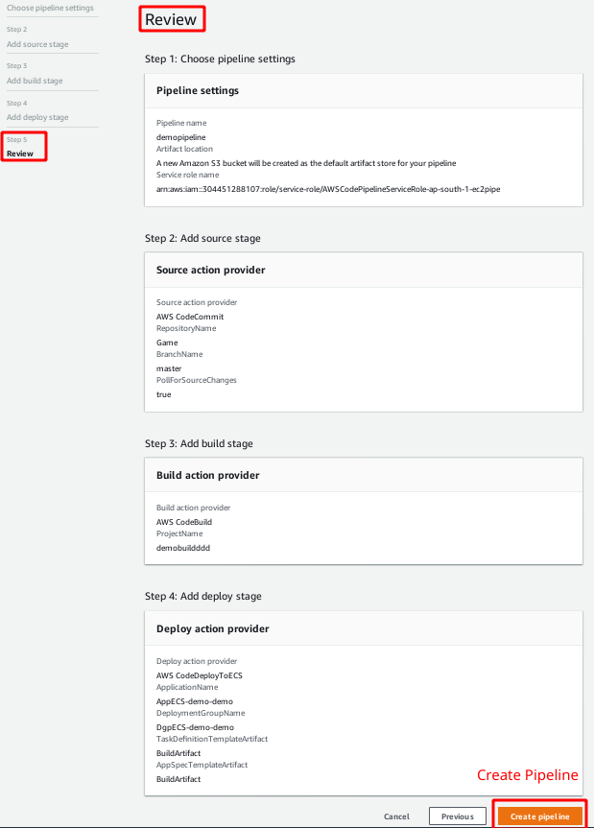

**5. Check and Verify CodePipeline**

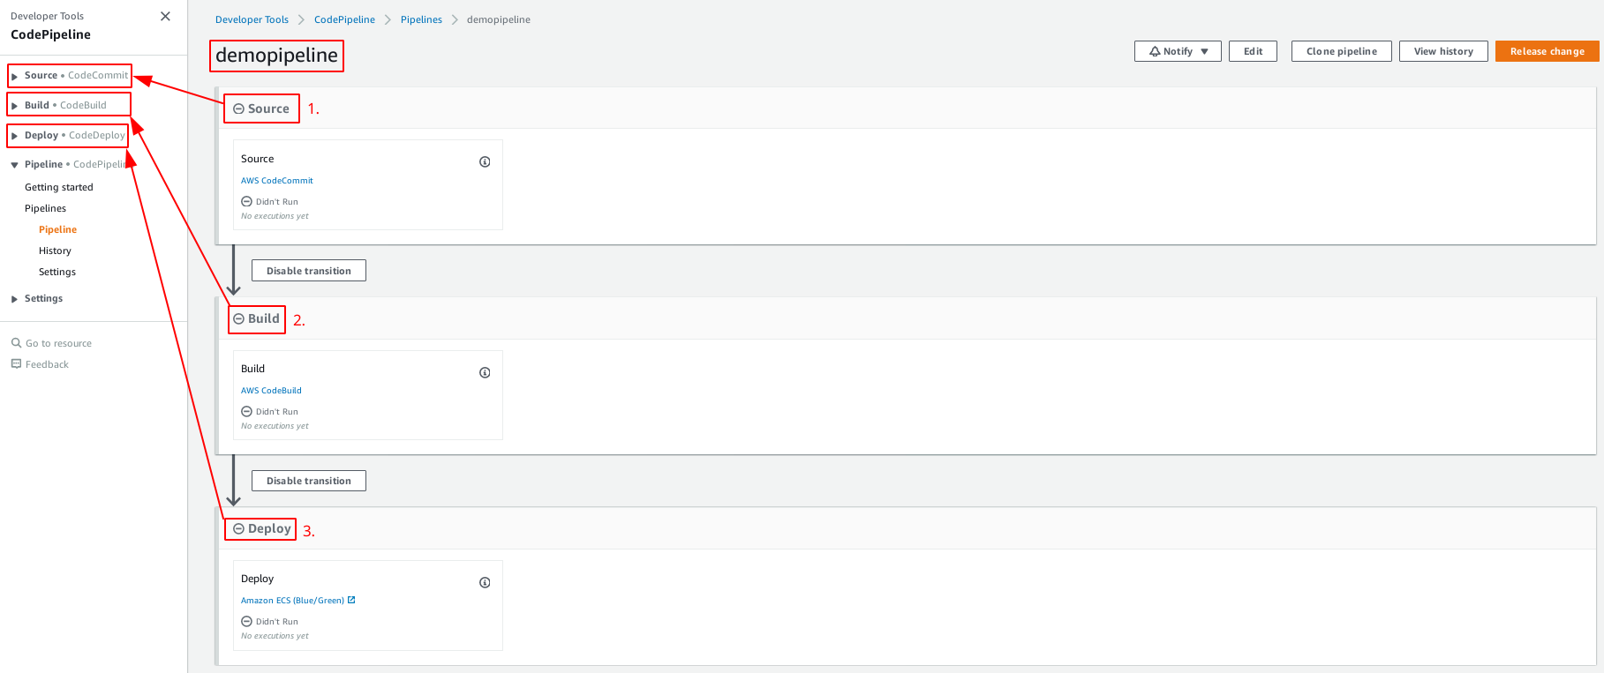

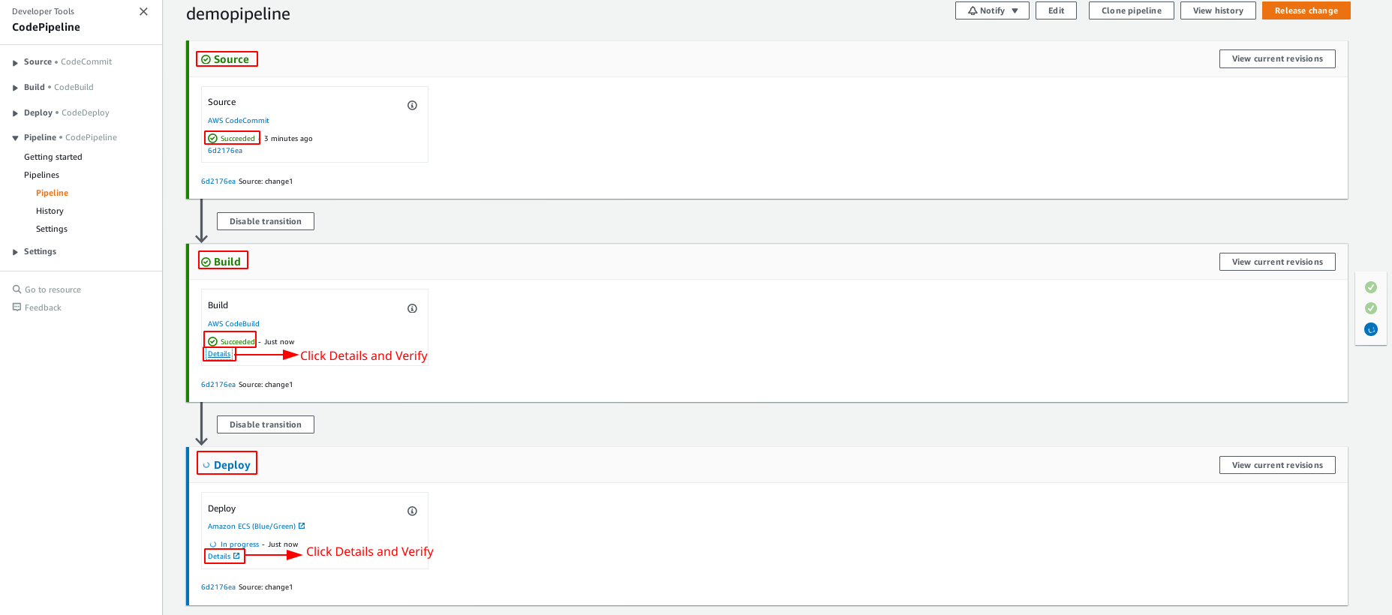

**Check CodeBuild Service**

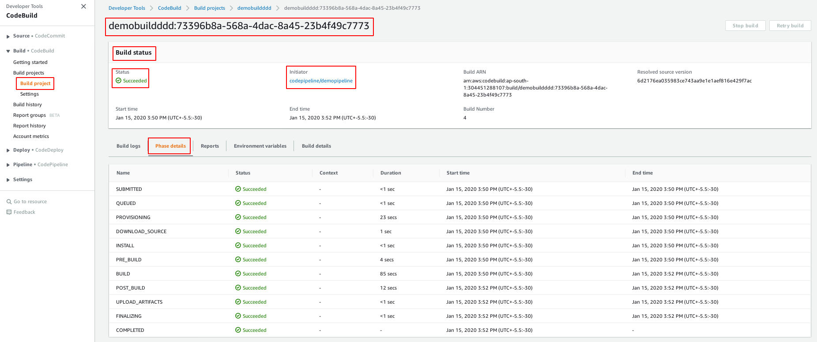

**Check CodeDeploy Service**

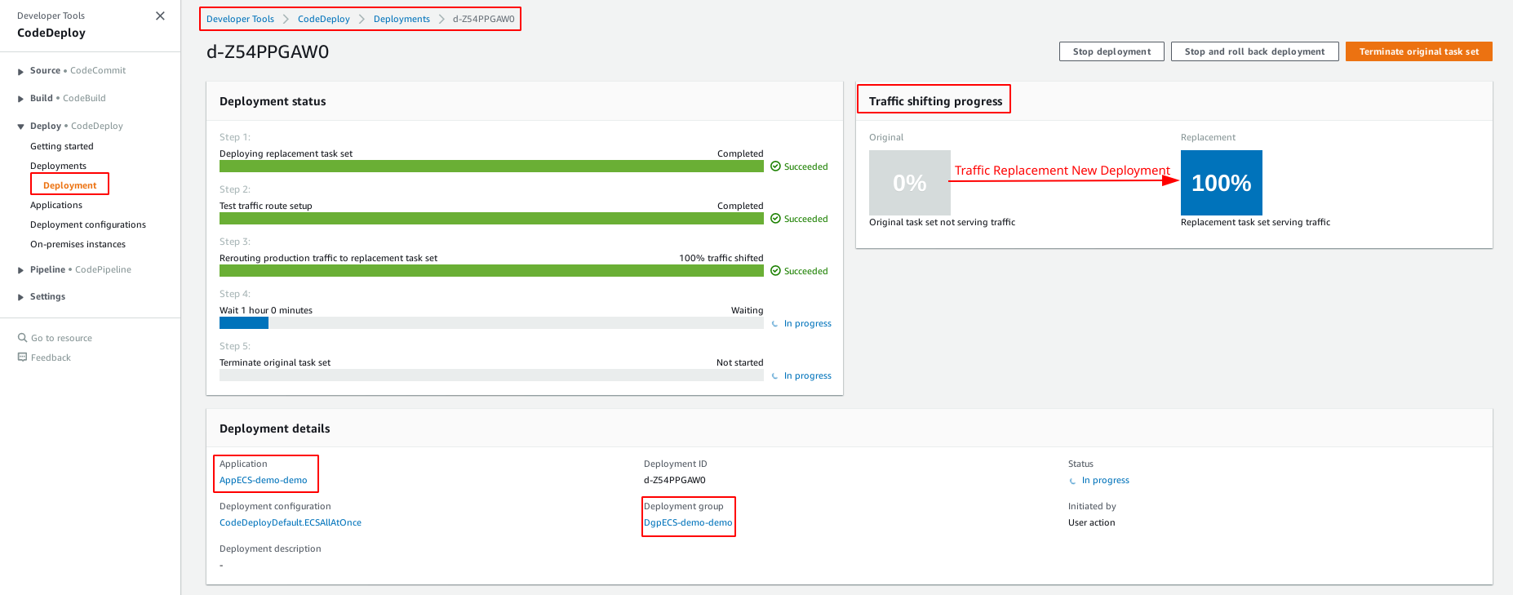

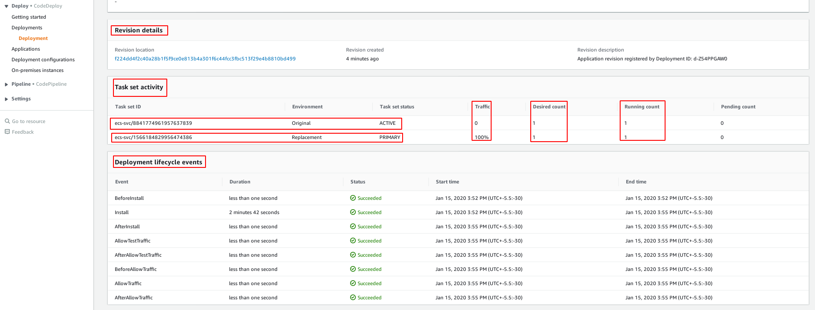

**Check ECS Service**

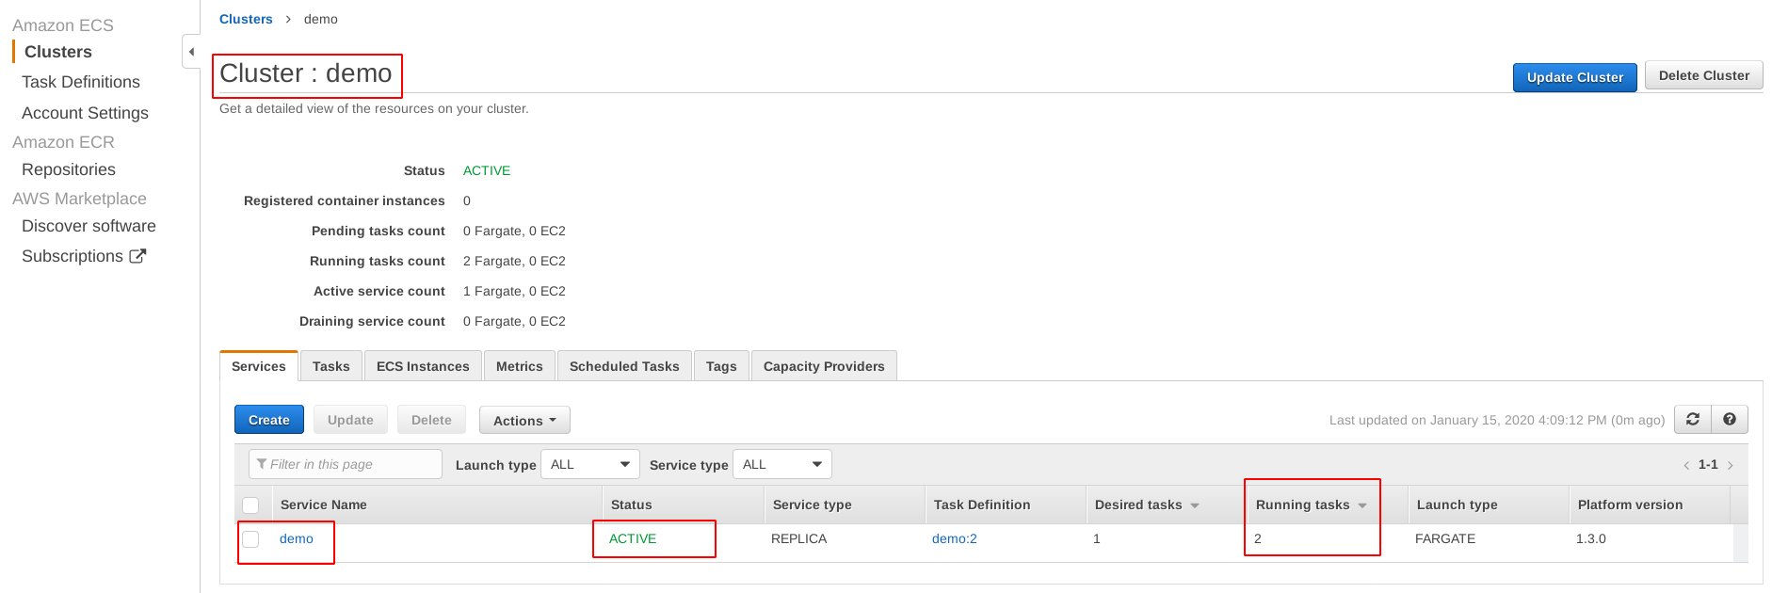

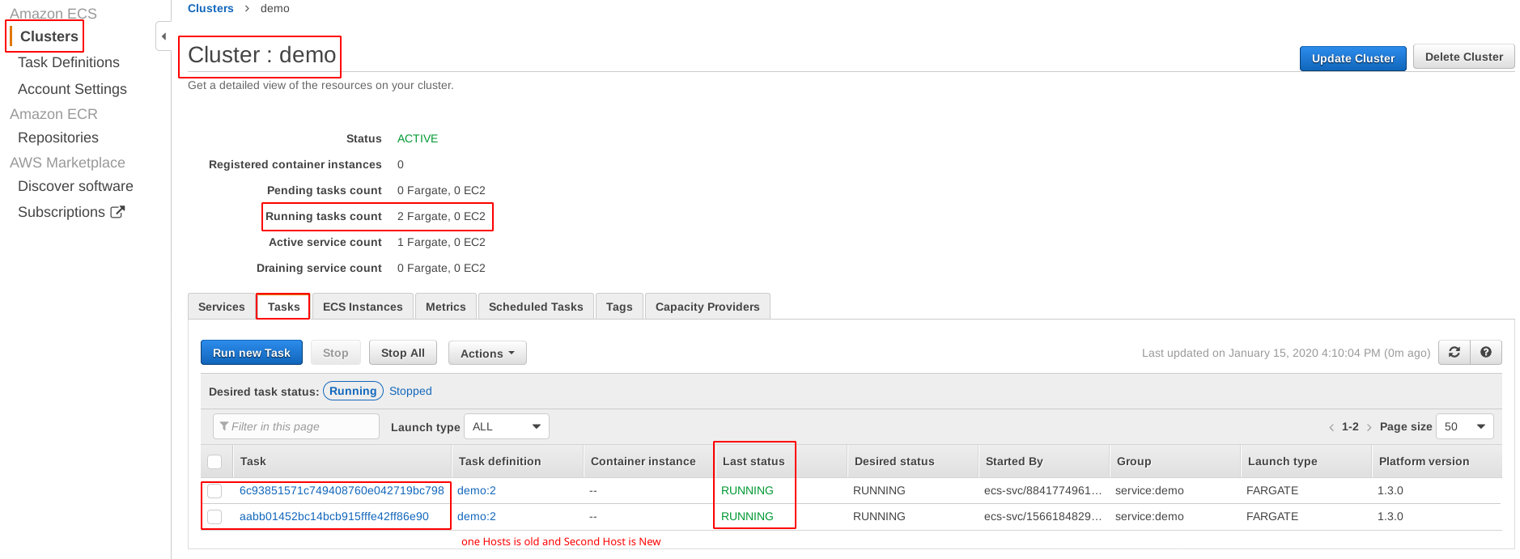

**Check ECS Task Definitions**

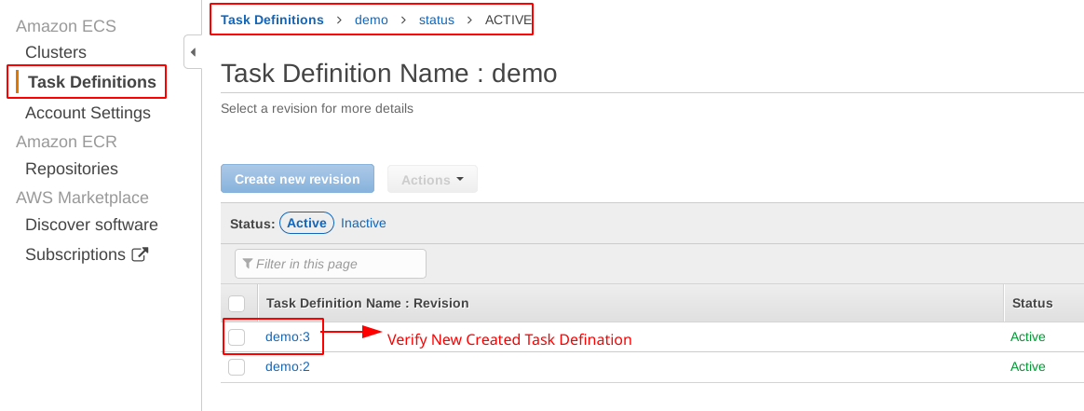

**Check ECR Service**

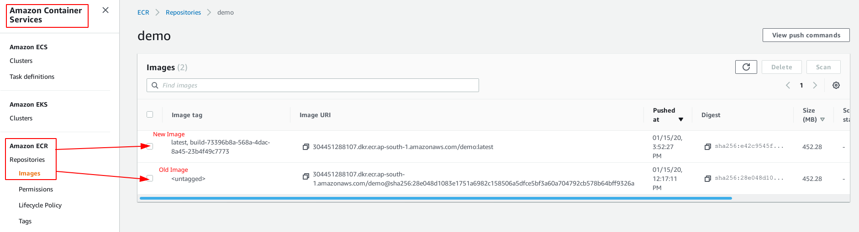

**Check Load Balancing and Target Group**

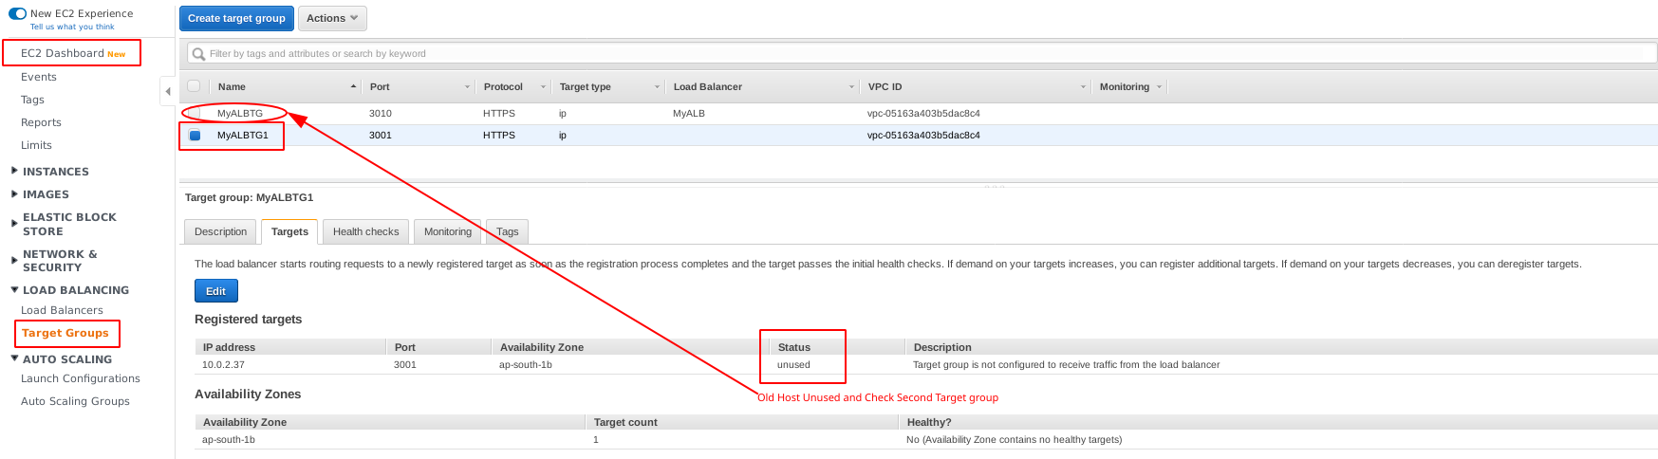

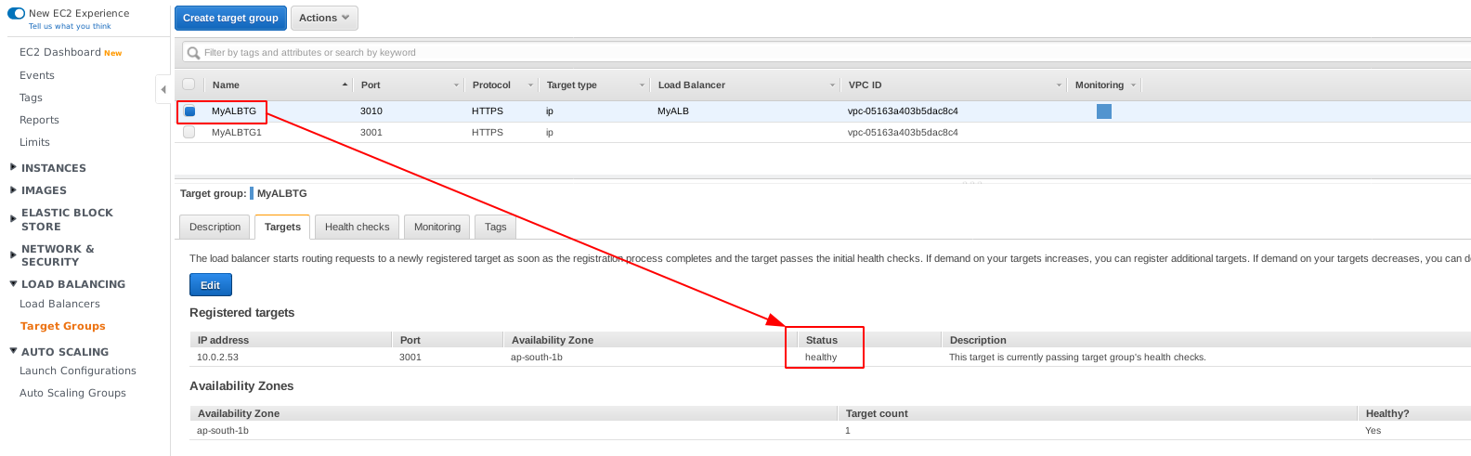

**Check S3 Bucket**

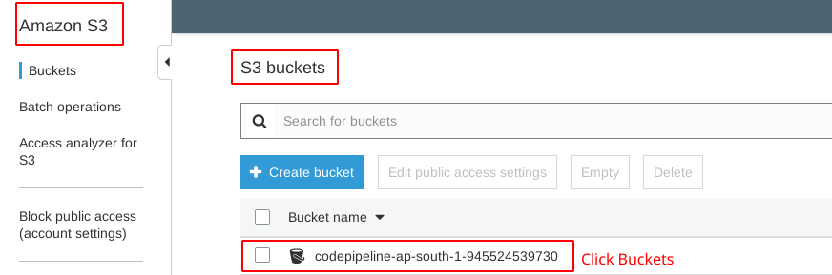

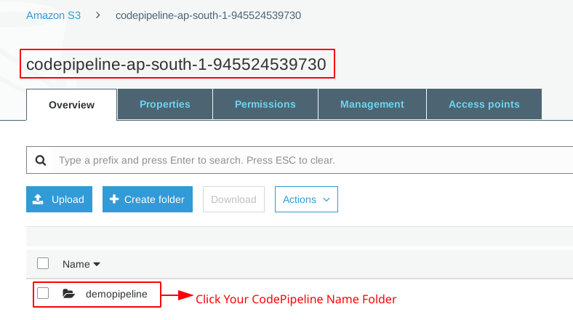

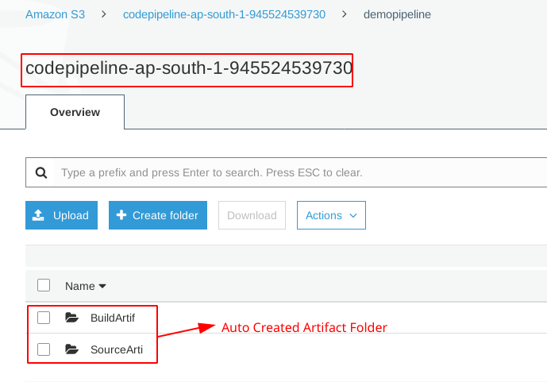

|  |
| --- |
| **IMPORTANT NOTE: AFTER CONFIGURING CODEPIPELINE, IF YOU DO NEW PRODUCTION THEN YOU HAVE TO DO IS JUST CODE PUSH AND CHECK/VERIFY PART 5 OF STEP NO 14.** |

**Reference**

<https://www.bogotobogo.com/>

<https://medium.com/>

<https://github.com>  **---> Different Example Like AWS ECS / ECR / Cloudformation**

<https://codeburst.io/perform-canary-deployments-with-aws-app-mesh-on-amazon-ecs-fargate-2dd090601bb7>

<https://serverless-stack.com/chapters/create-an-iam-user.html>

<https://utoolity.atlassian.net/wiki/spaces/TAWS/pages/37650444/Deploying+to+AWS+CodeDeploy>

<https://medium.com/@avijitsarkar123/seamless-blue-green-deployment-using-aws-codedeploy-4c36c0bbeef4>

<https://stelligent.com/blog/>

<https://www.sourceallies.com/2018/07/node-reference-fargate/>

**Create Network Load balancing or Application load balancing**

**What is NLB and ALB**

<https://www.nclouds.com/blog/what-type-of-aws-elastic-load-balancing-aws-elb-is-right-for-you/>

<https://www.linuxtechi.com/how-to-configure-vpc-in-aws/>

<https://linuxacademy.com/guide/21655-aws-network-load-balancer-basics/>

<https://aws.amazon.com/blogs/aws/new-network-load-balancer-effortless-scaling-to-millions-of-requests-per-second/>

**Create Repository and Pull Docker image To ECR**

<https://docs.aws.amazon.com/AmazonECR/latest/userguide/docker-basics.html>

**Run Containers on AWS Fargate**

<https://itnext.io/run-your-containers-on-aws-fargate-c2d4f6a47fda>

**B**[**lue-Green-deployment-using-aws-codedeploy**](https://medium.com/capital-one-tech/seamless-blue-green-deployment-using-aws-codedeploy-4c36c0bbeef4)

<https://medium.com/capital-one-tech/seamless-blue-green-deployment-using-aws-codedeploy-4c36c0bbeef4>